

CAPSTONE PROJECT REPORT
Report 3 – Software Requirement Specification

– Hanoi, January 2026 –
Table of Contents
I. Record of Changes 3
II. Software Requirement Specification 4
1. Product Overview 4
1.1. Context Diagram 4
1.2. Main WorkFlow 5
2. User Requirements 8
2.1 Actors 8
2.2 Use Cases 10
3. Functional Requirements 41
3.1 System Functional Overview 41
3.2 Authentication 63
3.4 Customer Account Management 98
3.5 Clinical Department Structure Management 108
3.6 Work Shift Management 123
3.7 Patient Visit Scheduling 132
3.8 Appointment Management 147
3.9 Send General Feedback to Clinic 147
3.10 Payments & Receipts 148
3.11 Daily Patient Queue Management 148
4. Non-Functional Requirements 156
4.1 External Interfaces 156
4.2 Quality Attributes 158
5. Requirement Appendix 161
5.1 Business Rules 161
5.2 Common Requirements 166
5.3 Application Messages List 166
5.4 Other Requirements… 171

I. Record of Changes
Date | A*  M, D | In charge | Change Description
27/01/2026 | A | TungLB | Initial SRS draft created based on Function List.
31/01/2026 | M | TungLB | Update Function List
01/02/2026 | A | TungLB | Add 3 Functional Requirement and description for all screen
06/02/2026 | M | TungLB, GiangNXT | Update workflow
06/02/2026 | M | TungLB | Update Usecase
06/02/2026 | M | GiangNXT | Update 3.1.5 Entity Relationship Diagram
07/02/2026 | M | TungLB | Update Context diagram, Main flow description, Usecase
15/02/2026 | M | TungLB | Update Usecase, screen description
09/03/2026 | M | TungLB | Update Function Requirement
13/03/2026 | M | TungLB | Update Function Requirement
14/03/2026 | M | TungLB | Update Function Requirement
15/03/2026 | M | TungLB | Update Function Requirement
23/03/2026 | M | TungLB | Update Function Requirement

*A - Added M - Modified D - Deleted

II. Software Requirement Specification

1. Product Overview

1.1. Context Diagram
Clinic Examination Process Management System is a web-based information system to manage the end-to-end examination process in a clinic, including appointment booking, reception check-in and payment, queue ordering, clinical examination, paraclinical indications and result files, and patient health records. The system supports multiple user roles (Patient, Receptionist, Doctor, Nurse, System Admin, Director, Administrative Staff) and integrates with external services for email notifications (OTP, generated passwords, reminders), insurance verification (BHYT), and bank transfer/QR payment confirmation.
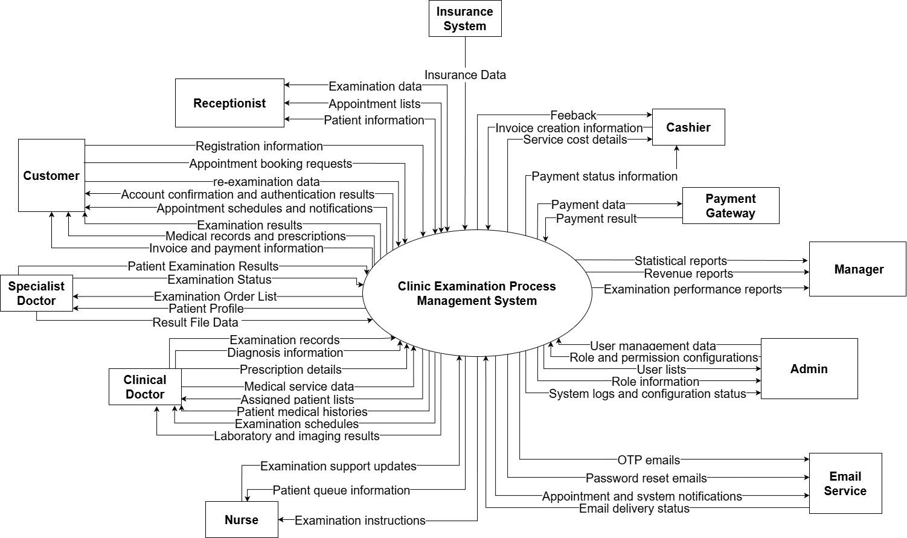
Figure 1: Context diagram for Clinic Examination Process Management System
The link of the context diagram : Context diagram.jpg

1.2. Main WorkFlow

1.2.1 Patient Admission and Registration Process
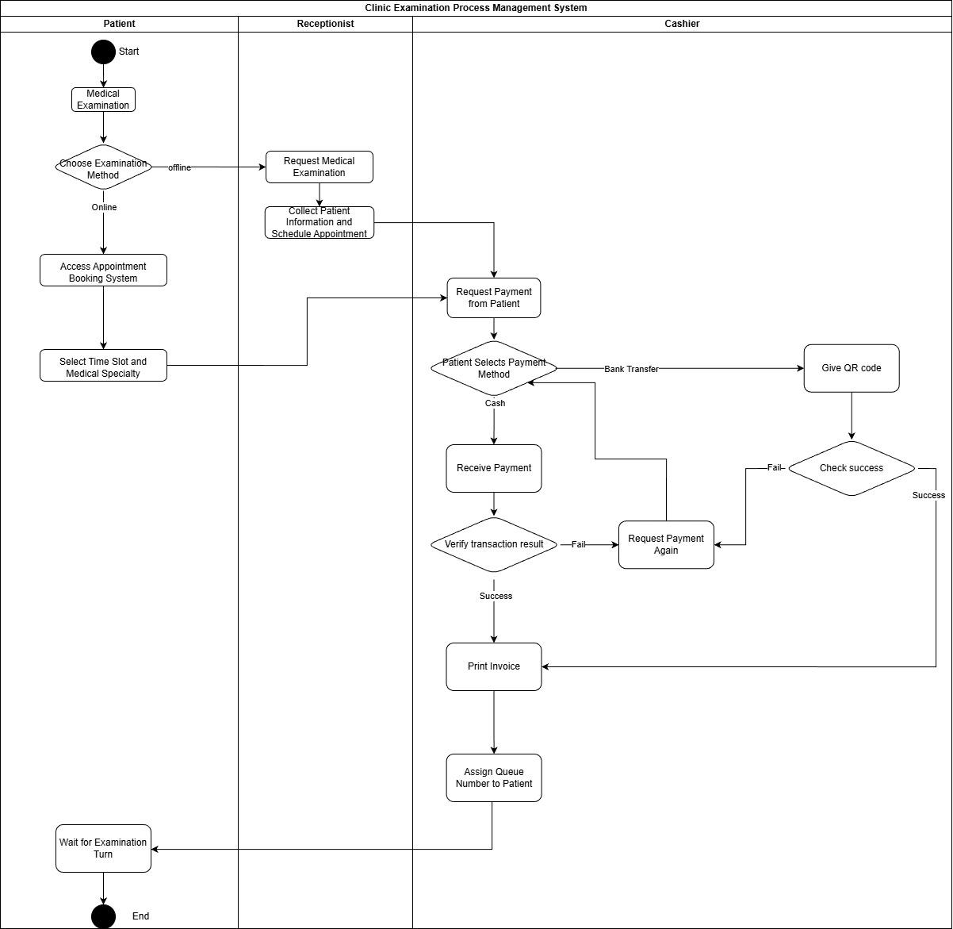
Figure 2: WorkFlow diagram for Patient Admission and Registration Process
The link of the diagram : WorkFlow1.jpg
Description:
This workflow is designed to streamline the patient appointment booking, payment collection, and queue management process. It ensures that each step from patient appointment creation to payment verification and queue assignment is efficiently managed, improving the overall patient experience in the clinic.
Steps in the Workflow:
- Patient starts the process by selecting a method of examination:
  - Offline: Patient requests medical examination manually (by phone or in-person).
  - Online: Patient accesses the appointment booking system.
- Patient chooses the time slot and medical specialty for the appointment.
- Receptionist handles the medical examination request:
  - Collects patient information and schedules the appointment.
- Patient is then asked to make a payment:
  - Payment method selection: Patient chooses the payment method (either cash or bank transfer).
- Cashier handles the payment process:
  - If the payment is cash: Cashier receives the payment and proceeds to verify the transaction.
  - If the payment is by bank transfer: Cashier provides the QR code for the patient to complete the payment.
- Verification Process:
  - The cashier verifies the payment transaction. If it’s successful, they proceed to print the invoice.
  - If the payment fails, the cashier asks the patient to make the payment again.
- After the successful payment:
  - Print invoice and assign a queue number to the patient for the examination.
- Patient waits for their turn to be examined.
End of Process:
- The process ends after the patient waits for their examination turn and the appointment is completed.

1.2.1 Patient examination process
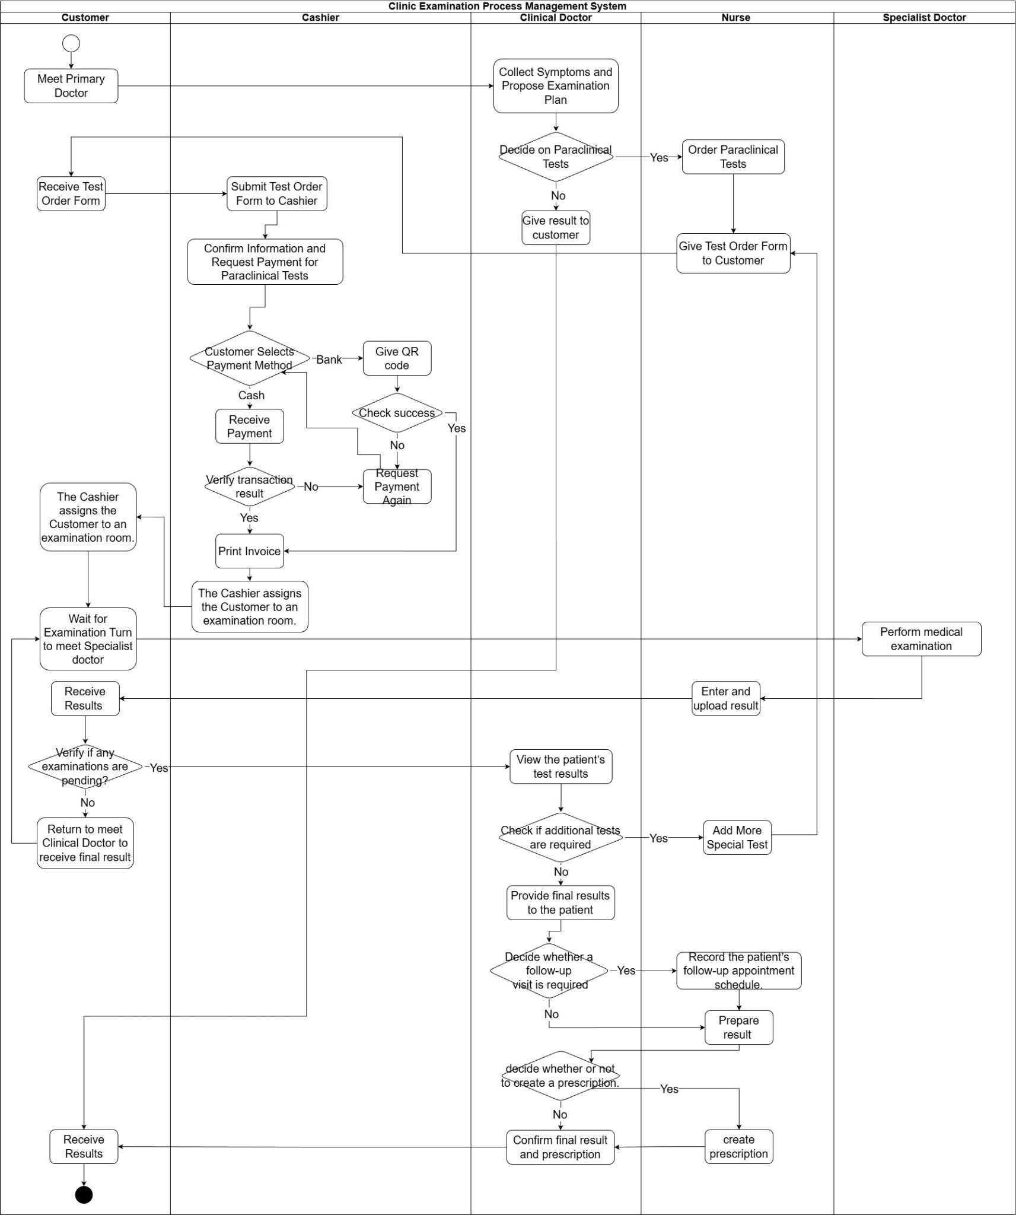
Figure 3: WorkFlow diagram for Patient examination process
The link of the diagram : WorkFlow2.jpg
Description:
This is the workflow for the clinical examination process with paraclinical test orders in the Clinic Examination Process Management System, describing the collaborative flow between Customer – Cashier – Clinical Doctor – Nurse – Specialist Doctor from the initial consultation to the final result delivery.
Summary of the Main Flow:
- Customer meets the Primary Doctor → The doctor collects symptoms and proposes an examination plan.
- If paraclinical tests are needed: The doctor orders tests → Nurse provides the test order form to the customer.
- The Customer submits the order form to Cashier → Cashier confirms the information & requests payment (cash/QR), verifies the transaction, prints the invoice, and assigns the customer to an examination room.
- Customer waits for examination/consultation with Specialist Doctor → Specialist Doctor performs examination; Nurse enters and uploads results.
- Clinical Doctor reviews the test results → if additional tests are required, the doctor orders more tests; if not, the doctor provides final results to the customer.
- The doctor decides whether a follow-up visit is necessary (schedules an appointment) and/or whether to create a prescription → confirms final results & prescription → Customer receives the results and concludes the process.

2. User Requirements

2.1 Actors

# | Actor | Description
1 | Guest (Unauthenticated User) | A user who has not logged into the system. They can view clinic introduction information, and perform Login/Registration actions.
2 | Customers | A user who utilizes medical services. Has permissions to book appointments, view personal medical records, view prescriptions, and submit feedback.
3 | Receptionist | Creates/updates patient accounts, creates appointments, collects payment, issues queue numbers, generates invoices and itineraries.
4 | Clinical Doctor | Conducts general/clinical examinations, orders lab/paraclinical tests and/or specialist consultations, views specialist examination results, consolidates findings for final assessment; creates/updates prescriptions and schedules follow-up visits.
5 | Specialist doctor | Receives test orders (lab/paraclinical), performs them, and updates test results in the system.
6 | Nurse | Assists doctor during examination; can view schedules and update information/status as permitted.
7 | Admin | Configures system master data (users, departments, paraclinical categories, rooms, shifts) and assigns staff to departments.
8 | Manager | Monitors clinic performance and revenue dashboards; reviews and responds to customer feedback.
9 | Cashier | Manages finance records, insurance-related transactions, staff working schedules, collects payment, issues queue numbers, generates invoices and itineraries and customer feedback responses.
10 | Email Service | External service used to send OTP codes, initial passwords, and reminder emails.
11 | Insurance API | External API used to validate insurance code and calculate discount amounts.
12 | Bank/Payment | External payment channel used to confirm transfer payments and show QR code for payment.
Table 1: Actors’ Description

2.2 Use Cases

2.2.1 Diagram(s)

2.2.1.1 Use cases for All User
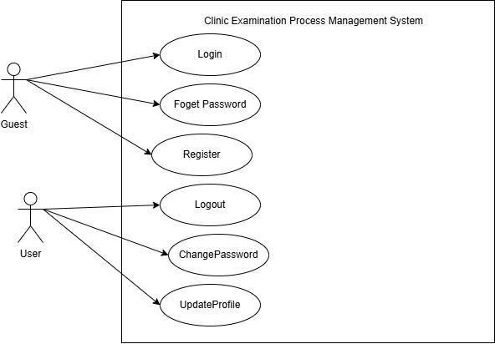

Figure 4: Use cases Diagram for User
The link of the use case diagram : Ucs for All User.jpg

Descriptions
ID | Group Function | Use Case | Actors | Use Case Description & Main Flow
UC-01 | Authentication | Login | User | Description: Allows an actor to access the system.  Main Flow: User enters credentials; system verifies and grants access.
UC-02 | Authentication | Change Password | User | Description: Allows a user to update their security credentials.  Main Flow: User provides current and new password; system executes Authenticate User and updates the database.
UC-03 | Authentication | Forget Password | User | Description: Provides a recovery method for lost credentials.  Main Flow: User enters email/ID; system sends a reset link or temporary code.
UC-04 | Authentication | Update Profile | User | Description: Allows users to modify personal information.  Main Flow: User edits details; system executes Authenticate User and saves changes.
UC-72 |  | Register | User | Description: Allows users to register new account with role is Customer.  Main Flow: User
Table 2.

2.2.1.2 Use cases for Cashier
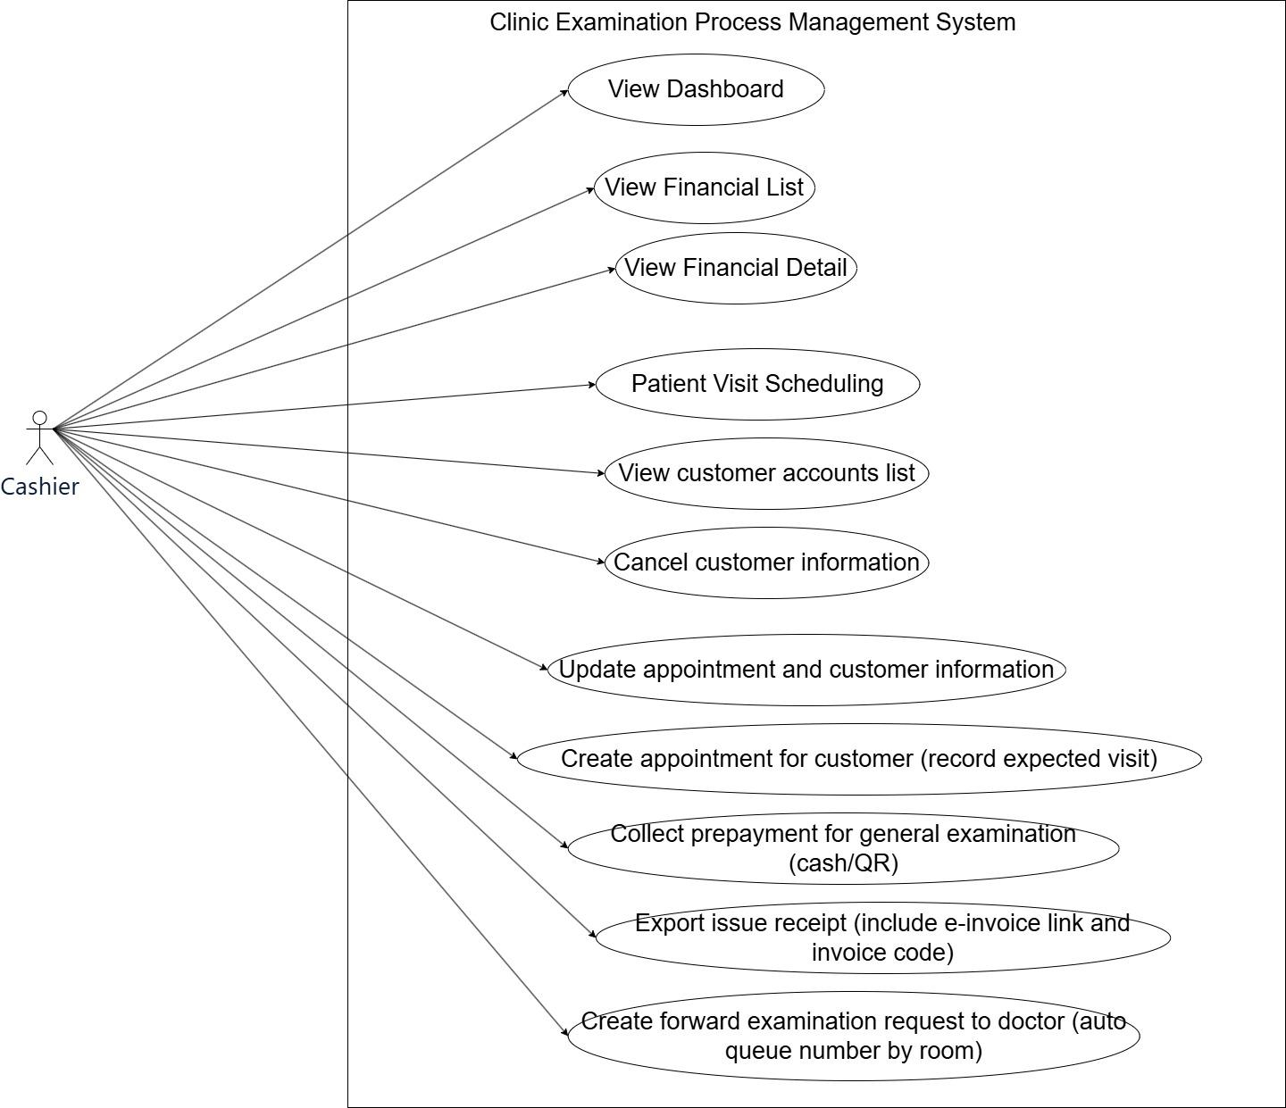
Figure 5: Use cases Diagram for Cashier
The link of the use case diagram : Ucs for Cashier.jpg
Descriptions
ID | Group Function | Use Case | Actors | Use Case Description & Main Flow
UC-05 | Dashboard | View Dashboard | Cashier | Description: Displays a dashboard with key metrics and activities.  Main Flow: Cashier opens the dashboard to view all the critical metrics of the clinic.
UC-06 | Financial Management | View Financial List | Cashier | Description: Lists all financial transactions, including payments and invoices.  Main Flow: Cashier views, filters, or sorts the financial transaction list.
UC-07 | Financial Management | View Financial Detail | Cashier | Description: Shows detailed information for a specific financial record.  Main Flow: Cashier selects an item from the financial list to view detailed data.
UC-08 | Patient Visit Scheduling | View customer accounts list | Cashier | Display customer accounts list with search/filter/sort; open details; show key columns as per feature.
UC-09 | Patient Visit Scheduling | Cancel customer information | Cashier | Implement 'Cancel customer information' for feature 'Customer Account Management'; include basic validations, error handling, and audit logging.
UC-10 | Patient Visit Scheduling | Update appointment and customer information | Cashier | Update appointment and customer information; load existing data, allow edit, validate constraints, and save changes.
UC-11 | Patient Visit Scheduling | Create Forward Examination Request to Doctor | Cashier | Description: Forwards a patient’s examination request to the assigned doctor.  Main Flow: Cashier sends the examination request and automatically adds it to the doctor’s queue.
UC-12 | Patient Visit Scheduling | Collect Prepayment for General Examination (cash/QR) | Cashier | Description: Collects prepayment for a general examination via cash or QR code.  Main Flow: Cashier processes the prepayment and records the transaction.
UC-13 | Patient Visit Scheduling | Export issue Receipt (Include e-invoice Link and Invoice Code) | Cashier | Description: Issues a receipt for payments, including e-invoice link and invoice code.  Main Flow: Cashier generates the receipt and sends it to the customer.
Table 3.

2.2.1.3 Use cases for Customer

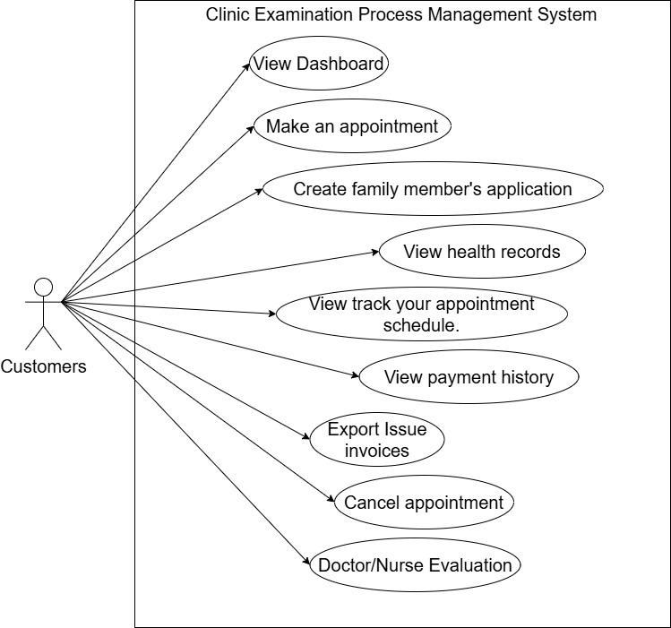
Figure 6: Use cases Diagram for Customer
The link of the use case diagram : Ucs for Customer.jpg
Descriptions
ID | Group Function | Use Case | Actors | Use Case Description & Main Flow
UC-14 | Dashboard | View Dashboard | Customer | Description: Provides an overview of key metrics and user-specific information.  Main Flow: Customer logs in and accesses the dashboard with their details.
UC-15 | Appointment Management | Make an Appointment | Customer | Description: Allows customers to book an appointment with a doctor.  Main Flow: Customer selects available times, doctor, and reasons for the appointment.
UC-16 | Appointment Management | View Health Records | Customer | Description: Displays a customer’s health records including past visits, treatments, and diagnoses.  Main Flow: Customer accesses their health history and records.
UC-17 | Appointment Management | View Your Appointment Schedule | Customer | Description: Allows customers to track their upcoming and past appointments.  Main Flow: Customer views their appointment history, with details on each.
UC-18 | Appointment Management | Cancel Appointment | Customer | Description: Allows customers to cancel previously scheduled appointments.  Main Flow: Customer requests cancellation and is notified about the outcome.
UC-19 | Appointment Management | Create Family Member's Application | Customer | Description: Allows customers to process appointments for family members.  Main Flow: Customer enters family member details, selects treatment, and schedules the visit.
UC-20 | Payments & Receipts | View Payment History | Customer | Description: Displays a record of payments made by the customer for their medical services.  Main Flow: Customer views payment transactions and receipts.
UC-21 | Payments & Receipts | Export Issue Invoices | Customer | Allows the customer to view and download the invoices for the payments made for appointments or medical services.
UC-22 | Send General Feedback to Clinic | Doctor/Nurse Evaluation | Customer | Description: Allows customers to rate their doctors and nurses after appointments.  Main Flow: Customer fills out an evaluation form and submits feedback.
Table 4.

2.2.1.4 Use cases for Clinical Doctor
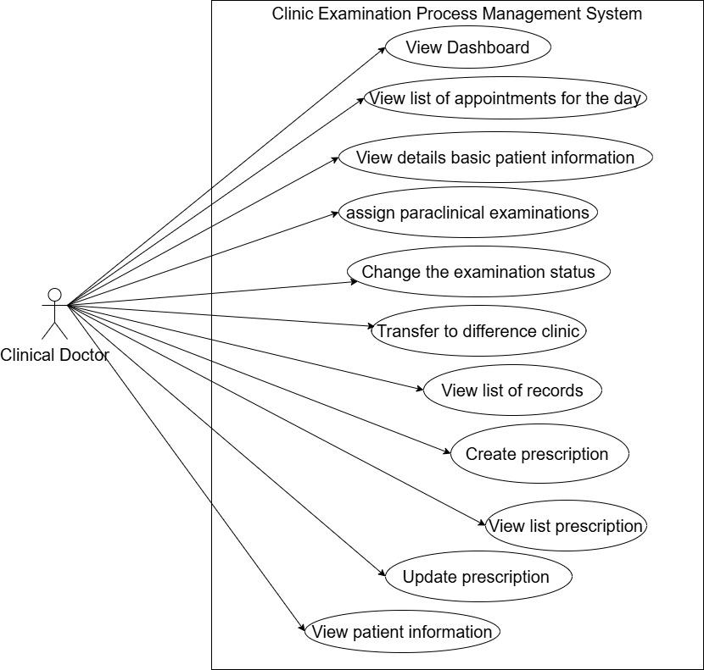
Figure 7: Use cases Diagram for Clinical Doctor
The link of the use case diagram : Ucs for Clinical Doctor.jpg
ID | Group function | Use Case | Actors | Use Case Description & Main Flow
UC-23 | Dashboard | View Dashboard | Clinical Doctor, Nurse | Description: Provides an overview of key metrics and user-specific information for the doctor.  Main Flow: Doctor accesses their personal dashboard.
UC-24 | Daily Patient Queue Manager | View List of Appointments for the Day | Clinical Doctor, Nurse | Description: Displays all appointments scheduled for the day, providing details about the patient and their appointment.  Main Flow: Doctor reviews the list of appointments for the day.
UC-25 | Daily Patient Queue Manager | Transfer to Different Clinic | Clinical Doctor, Nurse | Description: Allows the doctor to transfer a patient to a different clinic for specialized care.  Main Flow: Doctor selects a patient and initiates the transfer process.
UC-26 | Medical Record Management | View List of Records | Clinical Doctor, Nurse | Description: Displays a list of all available patient records for review.  Main Flow: Doctor selects a patient and views their medical history and records.
UC-27 | Medical Record Management | View Details of Basic Patient Information | Clinical Doctor, Nurse | Description: Displays basic details about the patient, including demographics, medical history, and current status.  Main Flow: Doctor selects a patient and views the basic information.
UC-28 | Medical Record Management | Assign Paraclinical Examinations | Clinical Doctor, Nurse | Description: Allows the doctor to assign paraclinical examinations (e.g., lab tests, imaging) to the patient.  Main Flow: Doctor selects the required tests and assigns them to the patient.
UC-29 | Medical Record Management | Change the Examination Status | Clinical Doctor, Nurse | Description: Enables the doctor to update the examination status of a patient (e.g., pending, completed, in-progress).  Main Flow: Doctor updates the status and confirms the changes.
UC-30 | Prescription Management | View List of Prescriptions | Clinical Doctor, Nurse | Description: Displays a list of all prescriptions assigned to patients.  Main Flow: Doctor views a list of prescriptions for patients under their care.
UC-31 | Prescription Management | Create Prescription | Clinical Doctor, Nurse | Description: Allows the doctor to create a new prescription for a patient.  Main Flow: Doctor enters prescription details (medication, dosage, frequency), and the system generates a prescription.
UC-32 | Prescription Management | Update Prescription | Clinical Doctor, Nurse | Description: Enables the doctor to update an existing prescription.  Main Flow: Doctor modifies prescription details, such as medication changes or dosage adjustments.
Table 5.

2.2.1.5 Use cases for Specialist Doctor
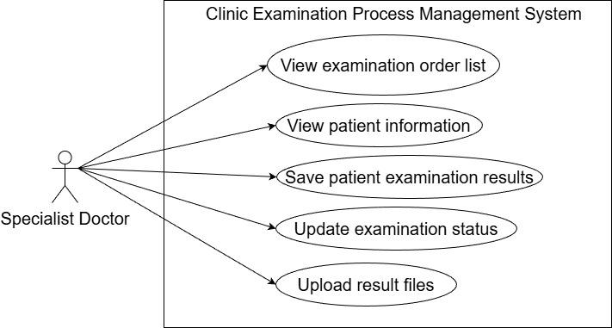
Figure 8: Use cases Diagram for Specialist Doctor
The link of the use case diagram : Ucs for Specialist Doctor.jpg
ID | Group function | Use Case | Actors | Use Case Description & Main Flow
UC-33 | Daily Patient Queue Management | View Patient Information | Specialist Doctor, Nurse, Clinical Doctor | Description: Allows the specialist doctor to view basic patient information such as demographics, health history, and previous treatments.  Main Flow: Specialist doctor selects a patient to view detailed information.
UC-34 | Daily Patient Queue Management | View Examination Order List | Specialist Doctor, Nurse, Clinical Doctor | Description: Displays a list of all examination orders assigned to the specialist doctor.  Main Flow: Specialist doctor reviews the examination orders for each patient and proceeds with necessary actions.
UC-35 | Daily Patient Queue Management | Save Patient Examination Results | Specialist Doctor, Nurse | Description: Allows the specialist doctor to save examination results after reviewing the test outcomes.  Main Flow: Specialist doctor enters results and saves them to the patient’s record.
UC-36 | Daily Patient Queue Management | Update Examination Status | Specialist Doctor, Nurse | Description: Updates the examination status to indicate whether it is pending, completed, or requires further attention.  Main Flow: Specialist doctor updates the status, and the system reflects the changes.
UC-37 |  | Upload Result Files | Specialist Doctor, Nurse | Description: Enables the specialist doctor to upload medical examination files (e.g., test results, scans).  Main Flow: Specialist doctor selects the appropriate files and uploads them to the system.
Table 6.

2.2.1.6 Use cases for Nurse
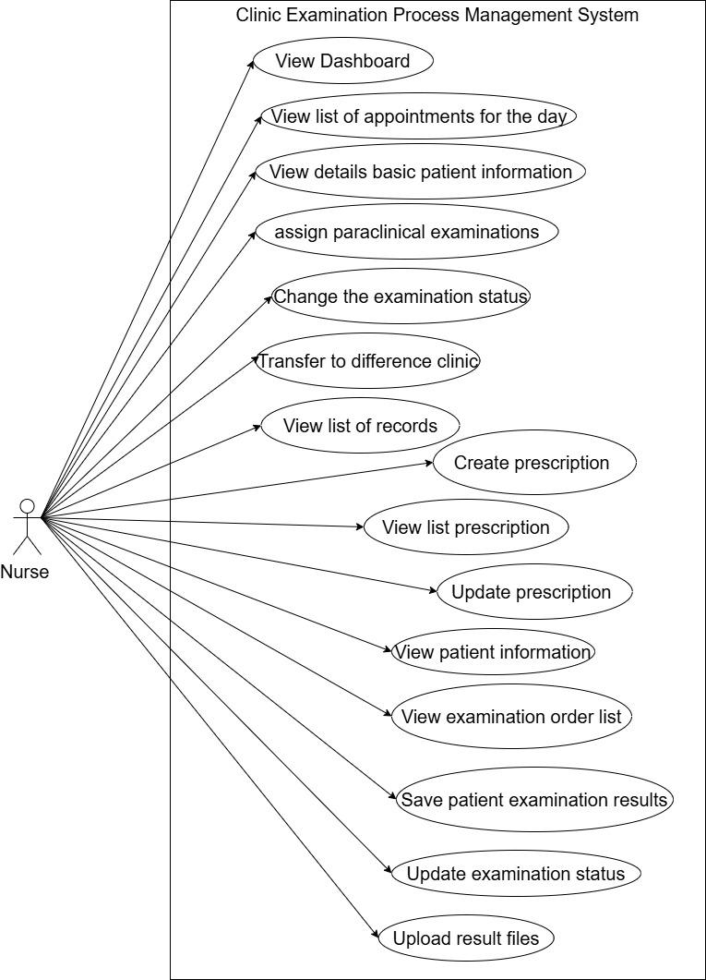
Figure 9: Use cases Diagram for Nurse
The link of the use case diagram :Ucs for Nurse.jpg
ID | Group Function | Use Case | Actors | Use Case Description & Main Flow
UC-38 | Dashboard | View Dashboard | Clinical Doctor, Nurse | Description: Provides an overview of key metrics and user-specific information for the doctor.  Main Flow: Doctor accesses their personal dashboard.
UC-24 | Daily Patient Queue Manager | View List of Appointments for the Day | Clinical Doctor, Nurse | Description: Displays all appointments scheduled for the day, providing details about the patient and their appointment.  Main Flow: Doctor reviews the list of appointments for the day.
UC-25 | Daily Patient Queue Manager | Transfer to Different Clinic | Clinical Doctor, Nurse | Description: Allows the doctor to transfer a patient to a different clinic for specialized care.  Main Flow: Doctor selects a patient and initiates the transfer process.
UC-33 | Daily Patient Queue Manager | View Patient Information | Specialist Doctor, Nurse, Clinical Doctor | Description: Allows the specialist doctor to view basic patient information such as demographics, health history, and previous treatments.  Main Flow: Specialist doctor selects a patient to view detailed information.
UC-34 | Daily Patient Queue Manager | View Examination Order List | Specialist Doctor, Nurse, Clinical Doctor | Description: Displays a list of all examination orders assigned to the specialist doctor.  Main Flow: Specialist doctor reviews the examination orders for each patient and proceeds with necessary actions.
UC-35 | Daily Patient Queue Manager | Save Patient Examination Results | Specialist Doctor, Nurse | Description: Allows the specialist doctor to save examination results after reviewing the test outcomes.  Main Flow: Specialist doctor enters results and saves them to the patient’s record.
UC-36 | Daily Patient Queue Manager | Update Examination Status | Specialist Doctor, Nurse | Description: Updates the examination status to indicate whether it is pending, completed, or requires further attention.  Main Flow: Specialist doctor updates the status, and the system reflects the changes.
UC-37 | Daily Patient Queue Manager | Upload Result Files | Specialist Doctor, Nurse | Description: Enables the specialist doctor to upload medical examination files (e.g., test results, scans).  Main Flow: Specialist doctor selects the appropriate files and uploads them to the system.
UC-26 | Medical Record Management | View List of Records | Clinical Doctor, Nurse | Description: Displays a list of all available patient records for review.  Main Flow: Doctor selects a patient and views their medical history and records.
UC-27 | Medical Record Management | View Details of Basic Patient Information | Clinical Doctor, Nurse | Description: Displays basic details about the patient, including demographics, medical history, and current status.  Main Flow: Doctor selects a patient and views the basic information.
UC-28 | Medical Record Management | Assign Paraclinical Examinations | Clinical Doctor, Nurse | Description: Allows the doctor to assign paraclinical examinations (e.g., lab tests, imaging) to the patient.  Main Flow: Doctor selects the required tests and assigns them to the patient.
UC-29 | Medical Record Management | Change the Examination Status | Clinical Doctor, Nurse | Description: Enables the doctor to update the examination status of a patient (e.g., pending, completed, in-progress).  Main Flow: Doctor updates the status and confirms the changes.
UC-30 | Prescription Management | View List of Prescriptions | Clinical Doctor, Nurse | Description: Displays a list of all prescriptions assigned to patients.  Main Flow: Doctor views a list of prescriptions for patients under their care.
UC-31 | Prescription Management | Create Prescription | Clinical Doctor, Nurse | Description: Allows the doctor to create a new prescription for a patient.  Main Flow: Doctor enters prescription details (medication, dosage, frequency), and the system generates a prescription.
UC-32 | Prescription Management | Update Prescription | Clinical Doctor, Nurse | Description: Enables the doctor to update an existing prescription.  Main Flow: Doctor modifies prescription details, such as medication changes or dosage adjustments.
Table 7.

2.2.1.7 Use cases for Admin
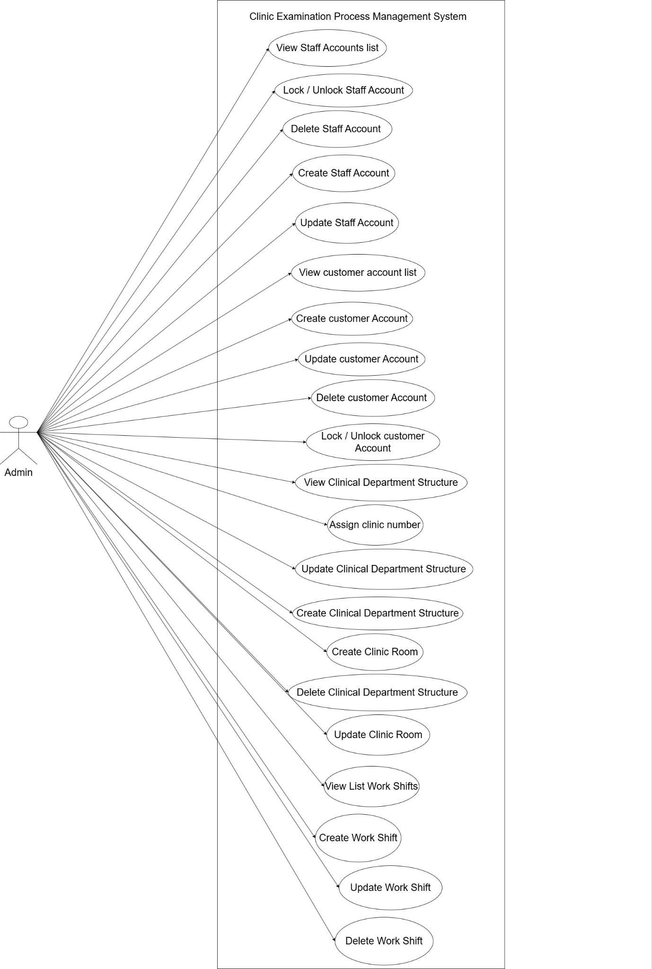
Figure 10: Use cases Diagram for Admin
The link of the use case diagram : Ucs for Manager.jpg

ID | Group Function | Use Case | Actors | Use Case Description & Main Flow
UC-38 | Staff Account Management | View List Staff Accounts | Cashier, Admin, Manager | Description: Displays a list of all staff accounts in the system.  Main Flow: Cashier views and manages staff accounts.
UC-39 | Staff Account Management | Create Staff Account | Cashier, Admin, Manager | Description: Creates a new staff account.  Main Flow: Cashier enters required information to create a new staff account and save it.
UC-40 | Staff Account Management | Update Staff Account | Cashier, Admin, Manager | Description: Updates an existing staff account.  Main Flow: Cashier selects an account to update, modifies details, and saves changes.
UC-41 | Staff Account Management | Delete Staff Account | Cashier, Admin, Manager | Description: Deletes a staff account.  Main Flow: Cashier selects an account to delete, confirms the action, and soft-deletes the account.
UC-42 | Staff Account Management | Lock/Unlock Staff Account | Cashier, Admin, Manager | Description: Locks or unlocks a staff account.  Main Flow: Cashier locks or unlocks a staff account, preventing login until unlocked.
UC-43 | Customer Account Management | View List Customer Accounts | Admin | Description: Lists all patient accounts.  Main Flow: Admin views and manages the accounts of all clinic patients.
UC-44 | Customer Account Management | Create Customer Account | Admin | Description: Creates a new patient account.  Main Flow: Admin enters patient details and saves the new account record.
UC-45 | Customer Account Management | Update Customer Account | Admin | Description: Updates the details of an existing patient account.  Main Flow: Admin selects the patient account to update and modifies the details.
UC-46 | Customer Account Management | Delete Customer Account | Admin | Description: Deletes a patient account.  Main Flow: Admin selects a patient account to delete, confirms the deletion, and removes the account.
UC-47 | Customer Account Management | Lock/Unlock Customer Account | Admin | Description: Locks or unlocks a patient account.  Main Flow: Admin locks or unlocks the account based on status, restricting or allowing access.
UC-48 | Clinical Department Management | View Clinical Department Structure | Admin | Description: Lists all clinical department structures in the clinic.  Main Flow: Admin views and manages the departments within the clinic.
UC-49 | Clinical Department Management | Create Clinical Department Structure | Admin | Description: Creates a new clinical department structure.  Main Flow: Admin enters details to create a new department and assigns staff.
UC-50 | Clinical Department Management | Update Clinical Department Structure | Admin | Description: Updates the details of an existing clinical department.  Main Flow: Admin modifies the department's details and saves the changes.
UC-51 | Clinical Department Management | Delete Clinical Department Structure | Admin | Description: Deletes a clinical department structure.  Main Flow: Admin selects the department to delete, confirms, and removes the structure from the system.
UC-52 | Clinical Department Management | Create Clinic Room | Admin | Description: Creates a new clinic room within a department.  Main Flow: Admin enters room details and assigns it to the appropriate department.
UC-53 | Clinical Department Management | Update Clinic Room | Admin | Description: Updates the details of an existing clinic room.  Main Flow: Admin modifies room details and saves changes.
UC-54 | Clinical Department Management | Delete Clinic Room | Admin | Description: Deletes a clinic room from the system.  Main Flow: Admin selects a room to delete and confirms the action.
UC-55 | Work Shift Management | View List Work Shifts | Admin | Description: Lists all work shifts assigned to staff members.  Main Flow: Admin views and manages the shifts of all clinic staff.
UC-56 | Work Shift Management | Create Work Shift | Admin | Description: Creates a new work shift for staff members.  Main Flow: Admin enters details for a new shift and assigns it to staff.
UC-57 | Work Shift Management | Update Work Shift | Admin | Description: Updates an existing work shift.  Main Flow: Admin selects a shift to update and modifies details such as time, staff, etc.
UC-58 | Work Shift Management | Delete Work Shift | Admin | Description: Deletes a work shift from the system.  Main Flow: Admin selects a shift to delete, confirms, and removes it from the schedule.
Table 8.

2.2.1.8 Use cases for Manager

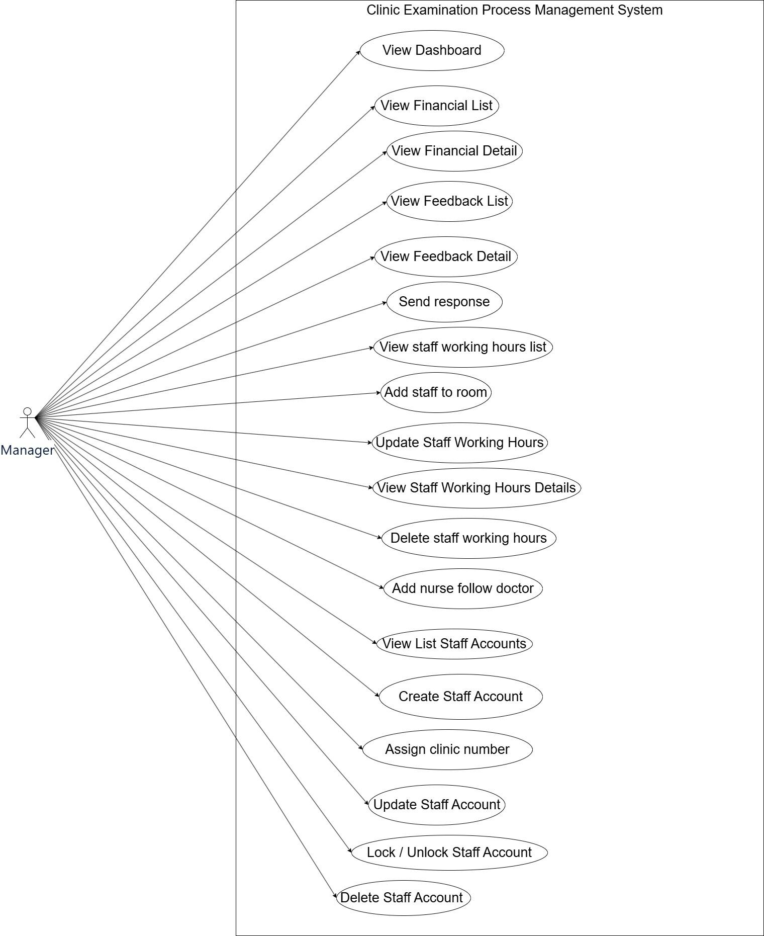
Figure 11: Use cases Diagram for Manager
The link of the use case diagram : Ucs for Manager.jpg
ID | Group Function | Use Case | Actors | Use Case Description & Main Flow
UC-06 | Financial Management | View Financial List | Cashier, Manager | Description: Lists all financial transactions, including payments and invoices.  Main Flow: Cashier, Manager views, filters, or sorts the financial transaction list.
UC-07 | Financial Management | View Financial Detail | Cashier, Manager | Description: Shows detailed information for a specific financial record.  Main Flow: Cashier, Manager selects an item from the financial list to view detailed data.
UC-59 | Feedback  Management | View Feedback List | Manager | Description: Displays a list of all customer feedback.  Main Flow: Manager views the list of feedback received from customers.
UC-60 | Feedback  Management | View Feedback Detail | Manager | Description: Shows detailed feedback from customers.  Main Flow: Manager opens a specific feedback item to view detailed feedback content.
UC-61 | Feedback  Management | Send Response | Manager | Description: Allows cashier to respond to customer feedback.  Main Flow: Manager replies to a feedback item and sends a response to the customer.
UC-38 | Staff Account Management | View List Staff Accounts | Admin, Manager | Description: Displays a list of all staff accounts in the system.  Main Flow: Admin, Manager views and manages staff accounts.
UC-39 | Staff Account Management | Create Staff Account | Admin, Manager | Description: Creates a new staff account.  Main Flow: Admin, Manager enters required information to create a new staff account and save it.
UC-40 | Staff Account Management | Update Staff Account | Admin, Manager | Description: Updates an existing staff account.  Main Flow: Admin, Manager selects an account to update, modifies details, and saves changes.
UC-41 | Staff Account Management | Delete Staff Account | Admin, Manager | Description: Deletes a staff account.  Main Flow: Admin, Manager selects an account to delete, confirms the action, and soft-deletes the account.
UC-42 | Staff Account Management | Lock/Unlock Staff Account | Admin, Manager | Description: Locks or unlocks a staff account.  Main Flow: Admin, Manager locks or unlocks a staff account, preventing login until unlocked.
UC-62 | Staff Account hours Management | View Staff Working Hours | Manager | Description: Lists all working hours of the clinic staff.  Main Flow: Manager views and manages the working hours schedule for each staff member.
UC-63 | Staff Account hours Management | View Staff Working Hours Detail | Manager | Description: Shows detailed information about a specific staff member's working hours.  Main Flow: Manager selects a staff member to view their working hours.
UC-64 | Staff Account hours Management | Assign Staff from Room | Manager | Description: The "Assign Staff to Room" function allows the manager to allocate doctors and nurses to specific rooms based on available time slots, ensuring proper staffing for each room.  Main Flow: Manager assigns staff to the room and time.
UC-65 | Staff Account hours Management | Delete Staff Working Hours | Manager | Description: Deletes an existing staff working hours record.  Main Flow: Manager selects the staff and deletes their working hours record.
UC-66 | Staff Account hours Management | Update Staff Working Hours | Manager | Description: Updates the working hours of a staff member.  Main Flow: Manager modifies the staff member’s working hours and updates the schedule.
Table 9.

2.2.1.9 Use cases for Receptionist
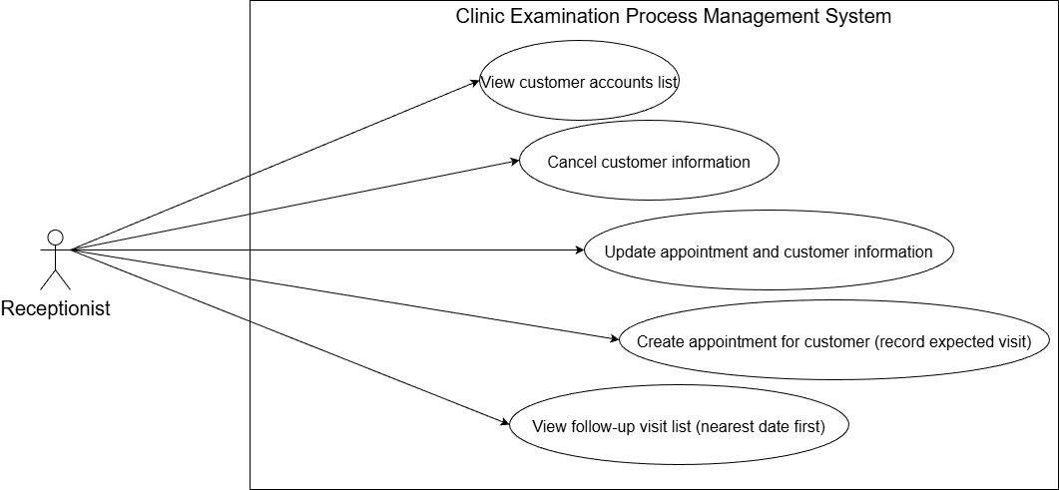
Figure 12: Use cases Diagram for Receptionist
The link of the use case diagram : Ucs for Receptionist.jpg

ID | Group Function | Use Case | Actors | Use Case Description & Main Flow
UC-67 | Customer Account Management | View Customer Accounts List | Receptionist | Description: Displays a list of all customer accounts.  Main Flow: Receptionist can view and manage customer accounts within the system.
UC-68 | Customer Account Management | Cancel Customer Information | Receptionist | Description: Allows the receptionist to cancel an existing appointment for a customer.  Main Flow: Receptionist selects a customer’s appointment from the list and cancels it in the system.
UC-69 | Customer Account Management | Update Appointment and Customer Information | Receptionist | Description: Allows the receptionist to update customer appointment and profile information.  Main Flow: Receptionist selects the customer and modifies the necessary details.
UC-70 | Customer Account Management | Create Appointment for Customer (Record Expected Visit) | Receptionist | Description: Enables the receptionist to create a new appointment for a customer.  Main Flow: Receptionist enters the customer's details and schedules the appointment.
UC-71 | Customer Account Management | View Follow-up Visit List (Nearest Date First) | Receptionist | Description: Displays a list of follow-up visits, sorted by the nearest date.  Main Flow: Receptionist reviews the list of follow-up appointments and organizes them by date.
Table 10.

3. Functional Requirements

3.1 System Functional Overview

3.1.1 Screens Flow

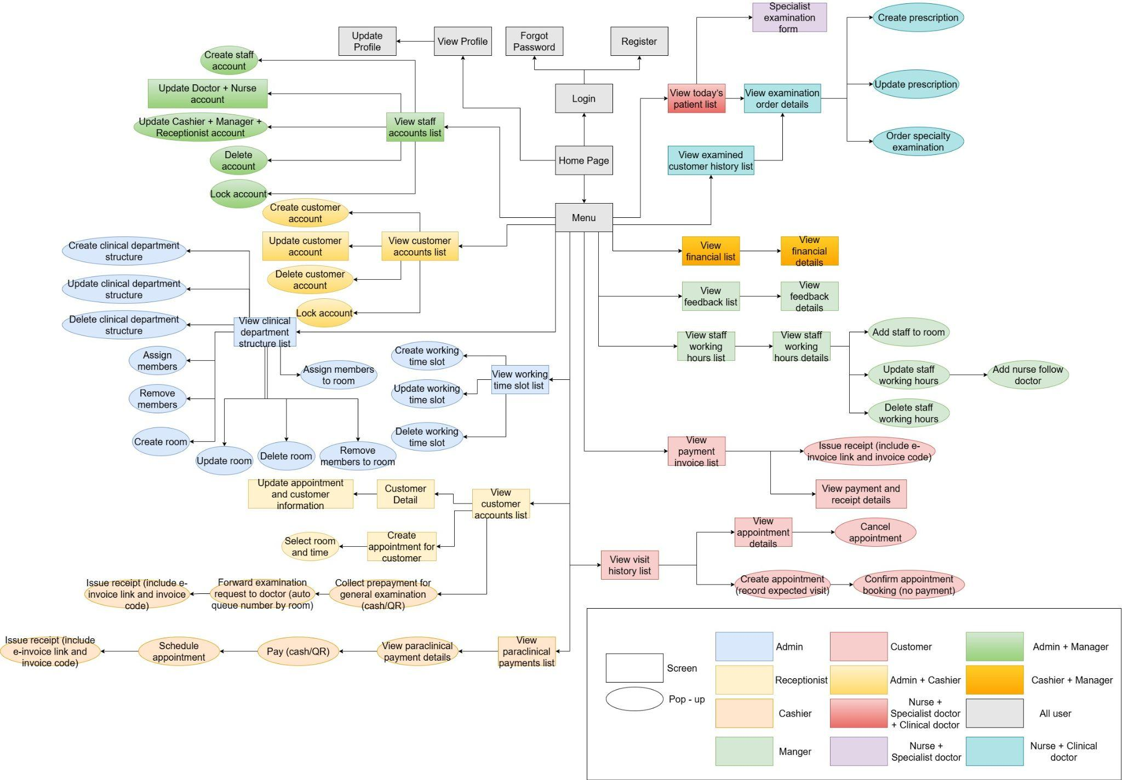
Figure 13: Screen flow diagram
The link of the diagram : ISP490-Screen flow.jpg

3.1.2 Screen Descriptions
# | Feature | Screen | Description
1 | Authentication | Login | Users input their email or phone number and password to access the system. If credentials are correct, they proceed to the main interface.
2 | Authentication | Register + Confirm OTP | New users register by entering their details and receive an OTP to verify their identity via email or phone.
3 | Authentication | Forgot Password + Confirm OTP and Email | Forgotten password recovery process, where users enter their email or phone for OTP and can reset their password upon validation.
4 | Authentication | Module Change Password | Users change their password after logging in. They need to provide the old password and a new one for security.
5 | Authentication | Profile Doctor + Nurse + Customers | Displays and allows users to update their personal profile, including health data for doctors and customers.
6 | Authentication | Main Menu | Provides easy navigation to various system modules such as appointments, customer management, and reports.
7 | Staff Account Management | User List | Displays a list of all staff accounts with roles, statuses, and options for editing or viewing detailed information.
8 | Staff Account Management | Module Create User ,Role Management | Allows the creation of new staff accounts and role assignment, ensuring proper access control.
9 | Staff Account Management | Edit Doctor, Nurse, Cashier, Manager, Receptionist  (Doctor , Nurse is screen) (Cashier, Manager, Receptionist are pop-up) | Allows the admin to edit specific roles and permissions for staff members like doctors and receptionists.
10 | Staff Account Management | Popup Confirm | Confirms the deletion or locking of a staff account to prevent accidental removal or deactivation.
11 | Customer Account Management | Customer List | Shows a list of all customer accounts with options to view and manage their personal and medical data.
12 | Customer Account Management | Create Customer | Allows the creation of new customer accounts by entering personal details, with the option for national ID inclusion.
13 | Customer Account Management | Edit Customer | Enables administrators to update customer information, such as contact details and health records.
14 | Customer Account Management | Popup Confirm | Confirms the deletion or locking of a customer account, ensuring actions are intentional and properly verified.
15 | Customer Account Management | Edit User | Lets the admin cancel changes made to a customer's information before saving them.
16 | Clinical Department Structure Management | Professional Structure List | Displays a list of departments in the clinic, allowing actions such as viewing, assigning, and deleting departments.
17 | Clinical Department Structure Management | Create Professional Structure | Allows the creation of new departments in the clinic, including assigning staff and rooms to the department.
18 | Clinical Department Structure Management | Edit Professional Structure | Allows for editing the details of existing departments, such as changing department names, reassigning staff, or adding rooms.
19 | Clinical Department Structure Management | Create Room | Allows the creation of new rooms within a department, designated for various medical treatments or other clinical activities.
20 | Clinical Department Structure Management | Edit Room | Enables editing of room details, such as its purpose, capacity, or assigned department.
21 | Clinical Department Structure Management | Popup Confirm | Confirms the deletion of a room within a department to prevent accidental data loss.
22 | Working Time Slot Management | Working Time List | Shows a list of staff working time slots, allowing for efficient scheduling and time management.
23 | Working Time Slot Management | Create Working Time | Enables the creation of new working time slots for clinical staff, managing shift timings effectively.
24 | Working Time Slot Management | Edit Working Time | Allows modification of existing working time slots, accommodating schedule changes or staff availability.
25 | Working Time Slot Management | Popup Confirm | Confirms the deletion of a working time slot, preventing accidental removals.
26 | Patient Visit Scheduling | Customer Detail | Displays detailed customer information, including their appointment history and medical details.
27 | Patient Visit Scheduling | Create Medical Appointment | Allows the creation of medical appointments for customers, ensuring all required fields like date, doctor, and treatment are recorded.
28 | Patient Visit Scheduling | General Examination Payment | Handles the collection of payment for general examination services, allowing for cash or QR code payment methods.
29 | Patient Visit Scheduling | Transfer Examination Request | Transfers examination requests from reception to the appropriate doctor, automatically adding patients to a queue.
30 | Patient Visit Scheduling | Medical Invoice | Issues receipts for medical services rendered, including electronic invoice links and codes for customer reference.
31 | Patient Visit Scheduling | Re-examination List | Displays a list of patients scheduled for follow-up or re-examinations, sorted by the nearest upcoming date.
32 | Paraclinical Payment | Paraclinical Invoice List | Shows a list of invoices for paraclinical services, enabling tracking of payments for diagnostic procedures.
33 | Paraclinical Payment | Paraclinical Invoice Detail | Displays detailed information about individual paraclinical payments, including treatment and payment methods.
34 | Paraclinical Payment | Paraclinical Payment | Allows the processing of payments for paraclinical services, including options for cash or QR code payment.
35 | Paraclinical Payment | Paraclinical Appointment | Allows scheduling of paraclinical appointments, linking lab tests and other diagnostics to specific customers.
36 | Paraclinical Payment | Paraclinical Invoice | Issues invoices for paraclinical services, including payment details and relevant medical information.
37 | Dashboard | Dashboard | Provides an overview of key metrics such as appointments, payments, and staff activity for the clinic's operations.
38 | Appointment Management | Appointment List | Displays a list of all upcoming, completed, and cancelled appointments for customers, allowing staff to manage schedules.
39 | Appointment Management | Create Appointment | Allows the creation of new appointments, capturing relevant details like customer information, doctor, and visit purpose.
40 | Appointment Management | Appointment Confirmation | Confirms the booking of an appointment. The customer is notified once the appointment is confirmed by the staff.
41 | Appointment Management | Appointment Detail | Displays detailed information about a specific appointment, including customer details and the visit's status.
42 | Appointment Management | Cancel Appointment | Allows the cancellation of scheduled appointments, updating the system and notifying customers accordingly.
43 | Customer Profile | Profile - Health Records | Displays a customer's health records, including visit history and medical notes, sorted by date.
44 | Customer Profile | Profile - Health Record Download | Allows customers to download their health records in a secure format for sharing with other medical providers.
45 | Customer Profile | Profile - Health Record Notification | Sends notifications to customers via email, updating them on changes or updates to their health records.
46 | Send General Feedback to Clinic | Create Review | Allows customers to submit feedback or ratings based on their experiences with the clinic's services.
47 | Send General Feedback to Clinic | Review Response | Enables administrators to respond to customer feedback or reviews, addressing concerns or thanking customers for their input.
48 | Payments & Receipts | History Payment List | Displays a list of all historical payments made by customers, including details about services rendered and payment status.
49 | Payments & Receipts | Payment Detail | Shows detailed payment information, including the amount, method, and the services paid for.
50 | Payments & Receipts | Receipt Issue | Issues receipts for completed payments, including links to e-invoices and invoice codes for reference.
51 | Daily Patient Queue Management | Daily Customer List | Displays a list of patients for the day, allowing for sorting by examination status and updates for the day's schedule.
52 | Daily Patient Queue Management | Daily Customer Detail | Displays the examination details for each customer, allowing for updates to their examination results or file uploads.
53 | Daily Patient Queue Management | Daily Customer Detail -> Create prescription | Allows the creation of prescriptions for patients after their examination.
54 | Daily Patient Queue Management | Daily Customer Detail -> Prescription Update | Lets users update existing prescriptions for patients, ensuring accuracy and adjustments to medication as needed.
55 | Daily Patient Queue Management | Daily Customer Detail -> Prescription Export | Exports a patient's prescription details for external use or sharing with other healthcare providers.
56 | Daily Patient Queue Management | Daily Customer Detail -> specialty examination list | Orders specialty examinations for patients when necessary, coordinating between departments and medical staff.
57 | Daily Patient Queue Management | Specialty Examination list | Allows for the addition of specialty examination orders to the patient's treatment plan.
58 | Medical Record Management | Customer profile -> Medical Record List | Displays a list of all examined customers’ histories, helping doctors track patient progress and past treatments.
59 | Medical Record Management | Daily Customer Detail | Allows detailed viewing and updating of medical records, including confirming examination results.
60 | Financial Management | Financial List | Displays a list of financial transactions and summaries for the clinic, aiding in budget and expense management.
61 | Financial Management | View Financial Transaction Details | Shows detailed financial information for transactions, allowing financial managers to review payments, services, and more.
62 | Feedback Management | View Feedback Details | Displays all customer feedback submissions, helping administrators track ratings, comments, and overall satisfaction.
63 | Feedback Management | Feedback Detail | Allows for the viewing of detailed information about each piece of feedback submitted by customers.
64 | Feedback Management | Feedback Response | Enables administrators to reply to customer feedback or comments, addressing concerns or thanking for positive feedback.
65 | Staff Working Hours Management | Staff Working Time List | Displays a list of staff working hours, making it easier to manage shifts and employee availability.
66 | Staff Working Hours Management | Staff Working Time Detail | Provides detailed views of each staff member's working hours, helping managers track attendance and shifts.
67 | Staff Working Hours Management | Assign Staff to room | Allows administrators to assign specific staff members to shifts, optimizing workforce management.
68 | Staff Working Hours Management | Edit Staff Shift | Provides the option to modify existing staff shifts as needed, improving scheduling flexibility.
69 | Staff Working Hours Management | Delete Staff Shift | Deletes a staff member's shift from the schedule, ensuring up-to-date records.
70 | Staff Working Hours Management | NurseWorking Time Detail | Allows for the assignment and modification of working hours for nurses, based on their shifts and departmental requirements.
Table 11: Screen Description

3.1.3 Screen Authorization
Screen | Admin | Manager | Cashier | Clinical Doctor | Specialist Doctor | Nurse | Customer | Receptionist
Home Page / Dashboard | X | X | X | X | X | X | X | X
Sidebar / Main Menu | X | X | X | X | X | X | X | X
Authentication & Authorization
Login | X | X | X | X | X | X | X | X
Register + Confirm OTP |  |  |  |  |  |  | X
Forgot Password + Confirm OTP and Email | X | X | X | X | X | X | X | X
Module Change Password | X | X | X | X | X | X | X | X
Profile User | X | X | X | X | X | X | X | X
Staff Account Management
User List | X | X
Module Create User ,Role Management | X | X
Edit Doctor, Nurse, Cashier, Manager, Receptionist  (Doctor , Nurse is screen) (Cashier, Manager, Receptionist are pop-up) | X | X
Popup Confirm | X | X
Customer Account Management
Customer List | X
Create Customer | X
Edit Customer | X
Popup Confirm | X
Edit User | X
Clinical Department Structure Management
Professional Structure List | X
Create Professional Structure | X
Edit Professional Structure | X
Create Room | X
Edit Room | X
Popup Confirm | X
Working Time Slot Management
Working Time List | X
Create Working Time | X
Edit Working Time | X
Popup Confirm | X
Patient Visit Scheduling
Customer Detail |  |  | X |  |  |  |  | X
Create Medical Appointment |  |  | X |  |  |  |  | X
General Examination Payment |  |  | X |  |  |  |  | X
Transfer Examination Request |  |  | X |  |  |  |  | X
Medical Invoice |  |  | X |  |  |  |  | X
Re-examination List |  |  | X |  |  |  |  | X
Paraclinical Payment
Paraclinical Invoice List |  |  | X
Paraclinical Invoice Detail |  |  | X
Paraclinical Payment |  |  | X
Paraclinical Appointment |  |  | X
Paraclinical Invoice |  |  | X
Appointment Management
Appointment List |  |  |  |  |  |  | X
Create Appointment |  |  |  |  |  |  | X
Appointment Confirmation |  |  |  |  |  |  | X
Appointment Detail |  |  |  |  |  |  | X
Cancel Appointment |  |  |  |  |  |  | X
Profile - Health Records |  |  |  |  |  |  | X
Profile - Health Record Download |  |  |  |  |  |  | X
Profile - Health Record Notification |  |  |  |  |  |  | X
Send General Feedback to Clinic
Create Review |  |  |  |  |  |  | X
Review Response |  |  |  |  |  |  | X
Payments & Receipts
History Payment List |  |  |  |  |  |  | X
Payment Detail |  |  |  |  |  |  | X
Receipt Issue |  |  |  |  |  |  | X
Daily Patient Queue Management
Daily Customer List |  |  |  | X | X | X
Daily Customer Detail |  |  |  | X | X | X
Daily Customer Detail -> Create prescription |  |  |  | X |  | X
Daily Customer Detail -> Prescription Update |  |  |  | X |  | X
Daily Customer Detail -> Prescription Export |  |  |  | X |  | X
Daily Customer Detail -> specialty examination list |  |  |  |  | X | X
Specialty Examination list |  |  |  |  | X | X
Medical Record Management
Customer profile -> Medical Record List |  |  |  | X |  | X
Financial Management
Financial List |  | X | X
View Financial Transaction Details |  | X | X
Feedback Management
View Feedback Details |  | X
Feedback Detail |  | X
Feedback Response |  | X
Staff Working Hours Management
Staff Working Time List |  | X
Staff Working Time Detail |  | X
Edit Staff Shift |  | X
Delete Staff Shift |  | X
NurseWorking Time Detail |  | X
Assign Staff to Room |  | X
Table 12: Screen Authorization

3.1.4 Non-Screen Functions
# | Feature | System Function | Description
1 | Authentication & Authorization | Role-based Access Control Service | Validate user roles and permissions for all system functions and screens. Ensure that users can only access features according to their assigned roles (Admin, Manager, Doctor, Nurse, Specialist Doctor, Cashier, etc.).
2 | Authentication & Authorization | Token / Session Management | Generate, validate, and expire authentication tokens or sessions to maintain secure user login states across the system.
3 | Account Management | Password Encryption Service | Encrypt and securely store user passwords using standard hashing algorithms to protect user credentials.
4 | Account Management | Password Reset Service | Handle forgot-password requests, generate reset tokens, and send password reset instructions via email or internal notification.
5 | Medical Records | Medical Record Status Management | Automatically update medical record status (e.g. Created, In Progress, Completed, Approved) based on user actions and system rules.
6 | Examination Management | Examination Order Processing Service | Process examination orders assigned by doctors, manage execution flow, and synchronize status between clinical doctors and specialist doctors.
7 | File Management | File Upload & Storage Service | Handle uploading, storing, and retrieving examination result files, prescriptions, and medical documents securely.
8 | Notification | System Notification Service | Send system notifications to users (e.g. examination assigned, results updated, status changed).
9 | Reporting | Report Generation Service | Generate system reports such as appointment statistics, examination results, medical record summaries, and user activity reports.
10 | Audit & Logging | Activity Logging Service | Log user activities (create, update, delete, approve actions) for audit, monitoring, and troubleshooting purposes.
11 | Integration | Payment Integration Service | Handle integration with external payment systems, validate transactions, and update payment status in the system.
12 | Background Processing | Scheduled Job / Batch Processing | Execute background jobs such as data cleanup, report generation, notification sending, and system maintenance tasks.
Table 13: Non-Screen Functions

3.1.5 Entity Relationship Diagram
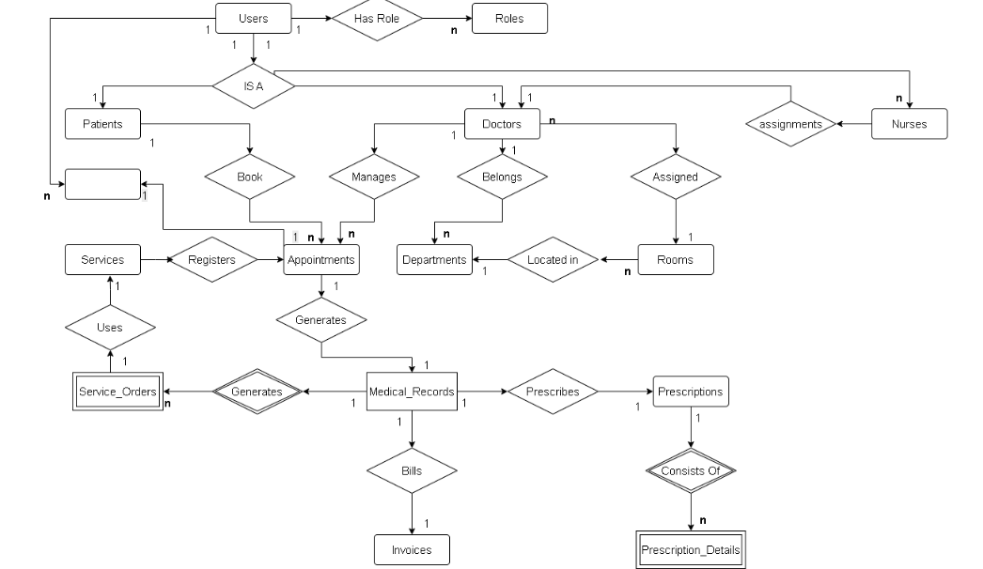
Figure 14: Clinic entity relationship diagram
The link of the diagram : Clinic entity relationship diagram.drawio.png

Entities Description
# | Entity | Description
1 | Users | Stores identity information (username, password, full name, citizen ID) for all system users. Acts as the parent entity (Supertype).
2 | Patients | A subtype of Users. Stores patient-specific medical information such as blood type, health insurance ID, and allergy history.
3 | Doctors | A subtype of Users. Stores professional information such as degrees, specialty, and medical practice certificates/licenses.
4 | Roles | Defines permission groups in the system (e.g., Admin, Doctor, Patient, Cashier, Pharmacist).
5 | Departments | Manages the list of departments (Clinical, Paraclinical, Pharmacy, etc.) to organize staff and services.
6 | Rooms | Manages physical facilities (consultation rooms, functional rooms) linked to a specific department.
7 | Services | Catalog of technical services (consultation, lab tests, X-ray, etc.), including service name and listed price.
8 | Appointments | Stores appointment information, including date/time, assigned doctor, patient, and initially registered services.
9 | Medical_Records | Detailed medical record for each visit. Contains symptoms, diagnosis, and doctor’s conclusion. Serves as the central hub linking all examination results.
10 | Service_Orders | Orders/results for paraclinical services. Stores lab results and attached imaging files (ultrasound/X-ray) when additional services are ordered.
11 | Prescriptions | The overall prescription created by the doctor within a medical record. Includes general notes/instructions.
12 | Prescription_Details | A weak entity. Stores medication line items (drug name, dosage, quantity) for each prescription. Fully depends on Prescriptions.
13 | Invoices | Financial invoice. Calculates total cost (service fees, medication fees) and records payment status and insurance-covered amount.
14 | Nurses | Child entity (Subtype) of Users. Stores nursing professional information such as certificate number, education level, clinical support skills, and work history.
15 | Feedbacks | Stores patient service quality evaluations after visit completion, including rating score (1–5 stars) and feedback comments
Table 14: Entities Description

3.2 Authentication

3.2.1 Login

3.2.1.1 Screen Mock-up
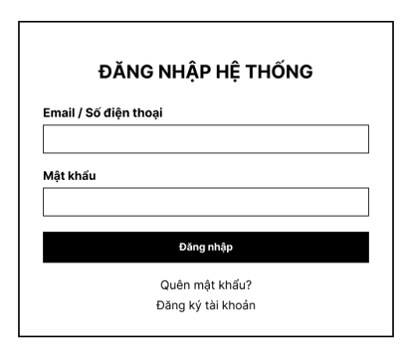
Figure 15: Login screen

# | Field Name | Type | Mandatory | Max Length | Description
1 | Email / Số điện thoại | Text | Yes | 30 | This field is mandatory and accepts either a valid email address or a valid Vietnamese phone number. If the input is an email, the system validates the correct email format and displays “Email không đúng định dạng” when invalid. If the input is a phone number, the system only accepts valid Vietnamese phone numbers, removes spaces, normalizes the country code when needed, and displays “Số điện thoại không hợp lệ” when invalid.
2 | Mật khẩu | Password | Yes | 50 | Entered characters are masked. When the user enters data, the system displays an eye icon with tooltip “Xem mật khẩu” and allows the password to be shown in plain text when clicked. If the password is incorrect, the system displays the toast message “Mật khẩu không đúng. Vui lòng nhập lại”.
3 | Đăng nhập | Button | No |  | Performs the login function when the user has entered valid information. The system checks the account credentials and navigates the user into the system if login is successful.
4 | Quên mật khẩu? | Link / Button | No |  | Redirects the user to the forgot password screen or function to recover the account.
5 | Đăng ký tài khoản | Link / Button | No |  | Redirects the user to the account registration screen to create a new account.
6 | Close (X) | Icon Button | No |  | Closes the current login window or screen.

3.2.1.2 Use Case Description

UC ID and Name | UC-01 – Login
Created By | TungLB | Date Created | February 1, 2026
Primary Actor | All Users | Secondary Actors | N/A
Description | This use case allows users to log in to the system using their registered email address or phone number and password. The system authenticates the user and grants access based on the user’s role.
Trigger | The user clicks the “Đăng nhập/Đăng ký” button on the menu.
Preconditions | PRE-1: The user has a valid and authorized account.  PRE-2: The account status is Active.
Postconditions | POST-1: The user is successfully authenticated and logged into the  system.  POST-2: The user is redirected to the appropriate system  corresponding to their role.
Normal Flow | - The user enters email or phone number and password.  - The user clicks the “Đăng nhập” button.  - The system validates the input data.  - The system authenticates the user credentials.  - The system creates a session and assigns user permissions.  - The system redirects the user to the main dashboard.
Alternative Flows | N/A
Exceptions | E1 Invalid Credentials  1. If the email/phone or password is incorrect, the system displays  “Đăng nhập thất bại. Vui lòng kiểm tra lại email/tên đăng nhập hoặc mật khẩu.”  2. The user is prompted to re-enter or use “Forgot password?”  E2 Account Inactive  1. If the account is inactive, the system displays “Tài khoản của bạn đã bị khóa. Vui lòng liên hệ quản trị hệ thống.”  2. The user cannot proceed until the account is reactivated by Admin.
Priority | High
Frequency of Use | High
Business Rules | BR-01, BR-02, BR-03, BR-04, BR-05, BR-06, BR-07, BR-08, BR-09, BR-10, BR-11
Other Information | The login form supports login via username/email and password. Error messages are supported.
Assumptions | The system automatically redirects authenticated users to the  appropriate dashboard .
Table 15: Login function description

3.2.2 Register

3.2.2.1 Screen Mock-up
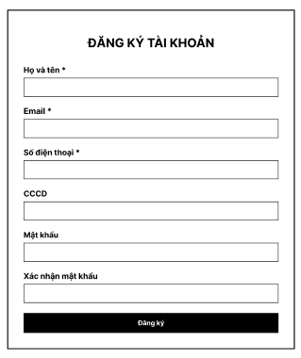
Figure 16: Register screen

# | Field Name | Type | Mandatory | Max Length | Description
1 | Họ và tên | Text | Yes | 100 | The field only accepts alphabetic characters and spaces. If it contains numbers or special characters, the system displays “Họ và tên không đúng định dạng.”
2 | Email | Text | Yes | 30 | The system accepts only valid email format. If the format is invalid, the system displays “Email không đúng định dạng”. If the email already exists, the system displays the toast message “Email đã tồn tại vui lòng nhập lại!” and disables the Đăng ký button.
3 | Số điện thoại | Text | Yes | 11 | The system accepts only valid Vietnamese phone numbers, removes spaces, and normalizes country code when needed. If invalid, the system displays “Số điện thoại không hợp lệ”. If the phone number already exists, the system displays the toast message “Số điện thoại đã tồn tại vui lòng nhập lại!” and disables the Đăng ký button.
4 | CCCD | Text | Yes | 12 | The system accepts only valid CCCD format. If invalid, the system displays “CCCD không hợp lệ”. If the CCCD already exists, the system displays the toast message “CCCD đã tồn tại vui lòng nhập lại!” and disables the Đăng ký button.
5 | Mật khẩu | Password | Yes | 50 | Entered characters are masked. The system shows an eye icon with tooltip “Xem mật khẩu” and allows showing the password in plain text when clicked. The password must contain at least 8 characters, including uppercase, lowercase, numeric, and special characters. Corresponding validation messages are displayed when the rule is not satisfied.
6 | Xác nhận mật khẩu | Password | Yes | 50 | The system shows an eye icon with tooltip “Xem mật khẩu” and allows showing the password in plain text when clicked. This field must match Mật khẩu. If not matched, the system displays “Mật khẩu xác nhận không khớp! Vui lòng nhập lại!” and disables the Đăng ký button.
7 | Đăng ký | Button | No |  | This button is enabled only when all required fields are valid. When registration is successful, the system redirects the user to the OTP verification screen and displays the toast message “Đăng ký thành công, vui lòng truy cập email cá nhân để nhập mã xác thực.”
8 | Close (X) | Icon Button | No |  | Closes the registration screen and returns the user to the login screen. When the user comes back again, previously entered data is cleared.

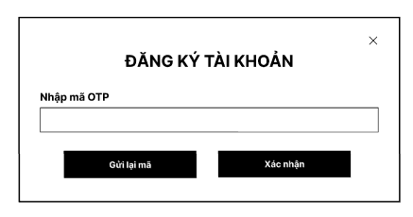
Figure 17.

# | Field Name | Type | Mandatory | Max Length | Description
1 | Nhập mã OTP | Text | Yes |  | This field is mandatory. It allows the user to enter the OTP code sent to the registered email.
2 | Gửi lại mã | Button | No |  | This button is disabled when the user is first redirected to the OTP screen. It becomes available after the OTP expires. When clicked after the allowed time, the system sends a new OTP to the user’s email. If clicked too early, the button remains disabled.
3 | Xác nhận | Button | No |  | This button submits the entered OTP for verification. If the OTP is valid, the system displays the toast message “Xác thực thành công” and redirects the user to the login screen. If the OTP has expired, the system displays “Mã OTP đã hết hạn vui lòng nhận mã mới.”
4 | Close (X) | Icon Button | No |  | Closes the OTP screen and returns the user to the login screen.

3.2.2.2 Use Case Description

UC ID and Name | UC-72 Register
Created By | TungLB | Date Created | February 1, 2026
Primary Actor | User | Secondary Actors | System
Description | This use case allows a guest user to register a new Customer account on the Register screen. The account is activated only after the user enters a valid OTP. If OTP verification is not completed, the account remains Unverified and OTP verification is required again on the next login attempt.
Trigger | The user selects “Đăng ký tài khoản” from the login screen.
Preconditions | PRE-1: The user is not authenticated.  PRE-2: The registration function is available.  PRE-3: The provided email address and phone number have not been registered in the system.
Postconditions | POST-1: If the user enters a valid OTP, the account is verified and activated successfully.  POST-2: If OTP verification is not completed, the account remains in Unverified status.  POST-3: An unverified account is required to complete OTP verification upon the next login attempt.
Normal Flow | 1. The user opens the Register screen and enters Full Name, Email, Phone Number, CCCD, Password, and Confirm Password.  2. The system validates required fields, field formats, password complexity, confirm-password matching, and inline error conditions.  3. The system normalizes the Phone Number where applicable (for example, removing embedded spaces or converting prefix “+84” to leading “0”).  4. The system checks whether Email, Phone Number, or CCCD already exists in the system.  5. When all data is valid, the system enables the “Đăng ký” button.  6. The user clicks the “Đăng ký” button.  7. The system encrypts the password and creates a new account with status Unverified.  8. The system generates an OTP and sends it to the registered email address.  9. The system displays the OTP verification screen; the “Gửi lại mã” button is disabled when the screen is first opened.  10. The user enters the received OTP and clicks “Xác nhận”.  11. The system validates OTP correctness and expiration time.  12. If the OTP is valid, the system activates the account, displays a success message, and redirects the user to the Login screen.
Alternative Flows | A1 – Missing or Invalid Field Data  - The user leaves one or more required fields blank, or enters data that does not satisfy the input rules.  - The system displays the corresponding inline validation message below the related field and keeps the “Đăng ký” button disabled.  A2 – Duplicate Registration Data  - The user enters an Email, Phone Number, or CCCD that already exists in the system.  - The system rejects the value, displays the corresponding duplicate warning, and does not allow registration.  A3 – Skip OTP Verification  - The user does not complete OTP verification after registration.  - The system keeps the account in Unverified status.  - When the user attempts to log in later, the system redirects the user to the OTP verification screen and sends a new OTP email automatically.  A4 – Invalid or Expired OTP  - The user enters an incorrect OTP or an OTP that has expired.  - The system rejects the verification request and displays the corresponding error message.  - If the OTP has expired, the “Gửi lại mã” button becomes available according to the OTP resend rule.  A5 – Resend OTP  - The user selects “Gửi lại mã OTP” after the resend condition is satisfied.  - The system generates a new OTP and sends it to the registered email address.  A6 – Close Register or OTP Screen  - If the user clicks icon “X” on the Register or OTP screen, the system returns to the Login screen.  - Any unsaved input on the closed registration screen is cleared.
Exceptions | E1 – OTP Delivery Failure  - The system fails to send the OTP email.  - The system notifies the user of the issue.  - The user may retry sending OTP or attempt verification later.
Priority | High
Frequency of Use | Medium
Business Rules | BR-Register-01: Register is used to create Customer accounts only.  BR-Register-02: Full Name, Email, Phone Number, CCCD, Password, and Confirm Password are all mandatory fields.  BR-Register-03: Full Name accepts alphabetic characters and spaces only; digits and special characters are invalid.  BR-Register-04: Email must be in valid format, must contain “@” and a valid domain, must not contain consecutive dots, and must have total length from 6 to 30 characters.  BR-Register-05: Phone Number is validated as a Vietnamese phone number; after normalization it must start with “0” and contain 9 to 11 digits only.  BR-Register-06: Phone Number may be normalized by removing embedded spaces and converting prefix “+84” to leading “0”.  BR-Register-07: CCCD must contain 12 numeric digits, must start with “0”, and must not contain letters, spaces, or special characters.  BR-Register-08: Password is masked by default, supports show/hide toggle, and must contain at least 8 characters, including uppercase, lowercase, numeric, and special characters.  BR-Register-09: Confirm Password must exactly match Password.  BR-Register-10: The “Đăng ký” button is enabled only when all field-level validations pass.  BR-Register-11: Email, Phone Number, and CCCD must be unique in the system.  BR-Register-12: Duplicate Email, Phone Number, or CCCD prevents registration and must be reported to the user.  BR-Register-13: After successful registration, the account is created with status Unverified and OTP is sent to the registered email address.  BR-Register-14: OTP verification is mandatory for account activation; OTP validity period is 5 minutes.  BR-Register-15: The “Gửi lại mã” button is disabled when the OTP screen is first opened and is enabled only after the current OTP expires / after 5 minutes.  BR-Register-16: When an unverified user logs in again, the system must require OTP verification and automatically send a new OTP email.  BR-Register-17: Clicking icon “X” on the Register or OTP screen returns the user to the Login screen; transient entered data is cleared.
Other Information | Register just used to register account Customer. Other account role like Clinical Doctor, Specialist Doctor, Nurse, …… will be assigned by admin, manager or cashier created.
Assumptions | OTP verification is mandatory for account activation.  Email delivery service is available and operational during the registration process.
Table 16: Register function description

3.2.1.3 Forgot Password
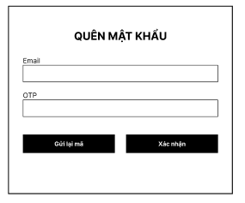
Figure 18: 1: Forgot Password screen

# | Field Name | Type | Mandatory | Max Length | Description
1 | Email | Text | Yes | 30 | This field is mandatory. The system accepts only valid email format. If the email format is invalid, the system shall display “Email không đúng định dạng” and disable the Xác nhận button. After the user enters a valid email and clicks Xác nhận, the system shall check whether the email exists in the system. If the email does not exist, the system shall display “Email không tồn tại trong hệ thống” and shall not send OTP.
2 | OTP | Text | No |  | This field is used to enter the OTP sent to the user’s email for password recovery. After the user enters a valid existing email and submits it, the system sends an OTP and allows the user to input the code. If the OTP is valid, the system redirects the user to the Đổi mật khẩu screen.
3 | Gửi lại mã | Button | No |  | This button is used to resend a new OTP to the registered email. It is disabled immediately after an OTP is sent and becomes available again after 5 minutes when the OTP expires.
4 | Xác nhận | Button | No |  | This button validates the entered information. When the email is valid and exists in the system, the system sends an OTP for verification. When the entered OTP is correct, the system displays the toast message “Xác thực thành công” and redirects the user to the Đổi mật khẩu screen.

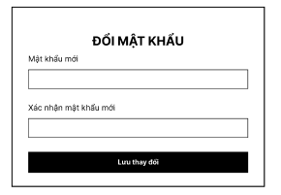
Figure 19.

# | Field Name | Type | Mandatory | Max Length | Description
1 | Mật khẩu mới | Password | Yes |  | This field is mandatory. Entered characters are masked. The system shows an eye icon with tooltip “Xem mật khẩu” and allows the password to be shown in plain text when clicked. The password must contain at least 8 characters, including uppercase letters, lowercase letters, numbers, and at least 1 special character. If invalid, the system shall display the corresponding validation message and disable the Lưu thay đổi button.
2 | Xác nhận mật khẩu mới | Password | Yes |  | This field is mandatory. Entered characters are masked. The system shows an eye icon with tooltip “Xem mật khẩu” and allows the password to be shown in plain text when clicked. This field must match Mật khẩu mới. If it does not match, the system shall display “Mật khẩu xác nhận không khớp! Vui lòng nhập lại!” and disable the Lưu thay đổi button.
3 | Lưu thay đổi | Button | No |  | This button is enabled only when Mật khẩu mới and Xác nhận mật khẩu mới are both valid. When the user clicks this button successfully, the system updates the password, redirects the user to the login screen, and displays the toast message “Đổi mật khẩu thành công!”.

3.2.1.4 Change Password
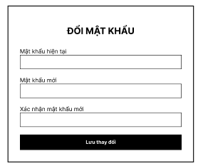
Figure 20: Change Password screen

# | Field Name | Type | Mandatory | Max Length | Description
1 | Mật khẩu hiện tại | Password | Yes |  | This field is mandatory and entered characters are masked. The system only checks whether Mật khẩu hiện tại matches the user’s current password after the user clicks Lưu thay đổi.If the password is incorrect, the system shall display “Mật khẩu hiện tại không đúng! Vui lòng nhập lại!” and stop the validation process.
2 | Mật khẩu mới | Password | Yes |  | This field is mandatory and entered characters are masked. The system shows an eye icon with tooltip “Xem mật khẩu” and allows the password to be shown in plain text when clicked. This field is validated only after Mật khẩu hiện tại is correct. The password must contain at least 8 characters, including uppercase letters, lowercase letters, numbers, and at least 1 special character. If invalid, the system shall display the corresponding validation message and shall not allow password change.
3 | Xác nhận mật khẩu mới | Password | Yes |  | This field is mandatory and entered characters are masked. The system shows an eye icon with tooltip “Xem mật khẩu” and allows the password to be shown in plain text when clicked. This field is validated only after Mật khẩu hiện tại is correct and Mật khẩu mới is valid. This value must match Mật khẩu mới. If it does not match, the system shall display “Mật khẩu xác nhận không khớp! Vui lòng nhập lại!” and shall not allow password change.
4 | Lưu thay đổi | Button | No |  | When the user clicks this button, the system validates data in order: Mật khẩu hiện tại, then Mật khẩu mới, then Xác nhận mật khẩu mới. If all fields are valid, the system updates the password, redirects the user to the login screen, and displays the toast message “Đổi mật khẩu thành công!”.

3.2.1.5 User Profile

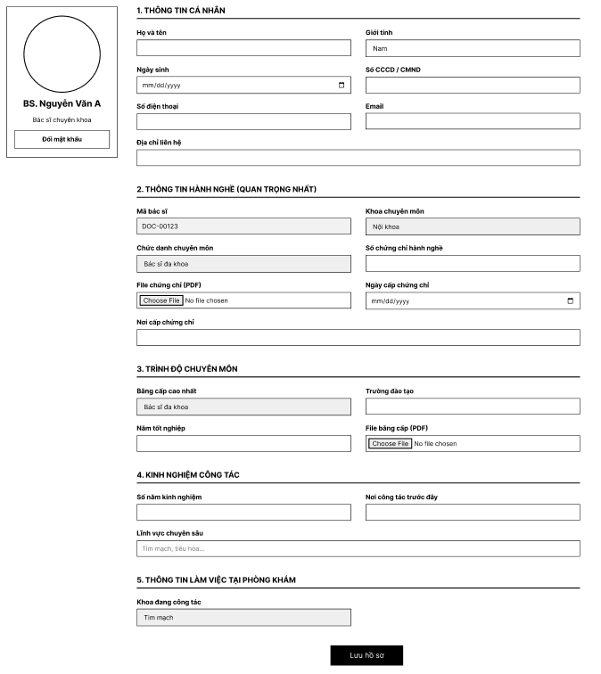
Figure 21: 1: Doctor profile screen

# | Field Name | Type | Mandatory | Max Length | Description
1 | Avatar | Image Upload / Display | No |  | Displays the doctor’s profile image and allows the user to upload an avatar image. Only PNG and IMG file formats are accepted. If the uploaded file is not in an allowed format, the system shall display a validation error and shall not save the file.
2 | BS. Nguyễn Văn A | Label | No |  | Displays the doctor’s full name.
3 | Bác sĩ chuyên khoa | Label | No |  | Displays the doctor’s title or role.
4 | Đổi mật khẩu | Button | No |  | Redirects the user to the Đổi mật khẩu screen.
5 | Họ và tên | Text | Yes | 100 | This field is mandatory. The system shall trim leading and trailing spaces before validation and saving. The value must not be blank or contain only spaces. If blank, the system shall display a required error message. The field shall not exceed 100 characters. The field shall only accept valid personal name format. If the value contains numeric characters or invalid special characters, the system shall display a format validation error.
6 | Giới tính | Dropdown | Yes |  | This field is mandatory. The user can only select one of the following values: Nam, Nữ, or Khác.
7 | Ngày sinh | Date | Yes | 10 | This field is mandatory. The user selects date of birth using the date picker. The displayed format shall be dd/MM/yyyy.
8 | Số CCCD / CMND | Text | Yes | 12 | This field is mandatory. The field must not be blank. The field accepts digits only and must contain exactly 12 digits. If the value contains letters or special characters, the system shall display an error indicating that only numeric characters are allowed. If the length is not equal to 12 digits, the system shall display “CCCD phải gồm 12 chữ số”. If the CCCD already exists in the system, the system shall display “CCCD đã tồn tại”.
9 | Số điện thoại | Text | Yes | 11 | This field is mandatory. The system accepts only valid Vietnamese phone numbers. If blank, the system shall display “Số điện thoại không được để trống!”. The system shall remove spaces and normalize country code when needed. If the value contains letters, invalid special characters, does not start with 0 after normalization, or has fewer than 9 digits or more than 11 digits, the system shall display “Số điện thoại không hợp lệ”.
10 | Email | Text | Yes | 30 | This field is mandatory. The system shall trim leading and trailing spaces before validation and saving. If blank, the system shall display “Email không được để trống!”. The system accepts only valid email format. If the format is invalid, the system shall display “Email không đúng định dạng”. If the email already exists in the system, the system shall display “Email đã tồn tại”.
11 | Địa chỉ liên hệ | Text | No | 255 | This field allows the user to enter contact address information. Maximum length is 255 characters.
12 | Mã bác sĩ | Text | No |  | The system automatically generates this data when creating an account, and it cannot be changed.
13 | Khoa chuyên môn | Text | Yes | 255 | This field is displayed as read-only. The user is not allowed to edit this field.
14 | Chức danh chuyên môn | Text | Yes | 255 | This field is used to enter professional title information. Maximum length is 255 characters.
15 | Số chứng chỉ hành nghề | Text | Yes | 255 | This field is used to enter professional practice certificate number. Maximum length is 255 characters.
16 | File chứng chỉ (PDF) | File Upload | No |  | This field allows the user to upload a certificate file. Only PDF format is accepted.
17 | Ngày cấp chứng chỉ | Date | Yes | 10 | This field is used to enter the certificate issue date. The user selects the date using the date picker. The displayed format shall be dd/MM/yyyy.
18 | Nơi cấp chứng chỉ | Text | Yes | 255 | This field is used to enter the place where the certificate was issued. Maximum length is 255 characters.
19 | Bằng cấp cao nhất | Text | Yes | 255 | This field is used to enter the highest academic qualification. Maximum length is 255 characters.
20 | Trường đào tạo | Text | Yes | 255 | This field is used to enter the training institution name. Maximum length is 255 characters.
21 | Năm tốt nghiệp | Text | Yes | 255 | This field is used to enter graduation year information. Maximum length is 255 characters.
22 | File bằng cấp (PDF) | File Upload | No |  | This field allows the user to upload a degree file. Only PDF format is accepted.
23 | Số năm kinh nghiệm | Text | Yes | 255 | This field is used to enter total years of working experience. Maximum length is 255 characters.
24 | Nơi công tác trước đây | Text | No | 255 | This field is used to enter previous workplace information. Maximum length is 255 characters.
25 | Lĩnh vực chuyên sâu | Text | No | 255 | This field is used to enter specialization information. Maximum length is 255 characters.
26 | Khoa đang công tác | Text | Yes | 255 | This field is used to display or enter the current working department. Maximum length is 255 characters.
27 | Lưu hồ sơ | Button | No |  | Saves all updated profile information when the entered data is valid. The system shall validate all editable fields before saving.

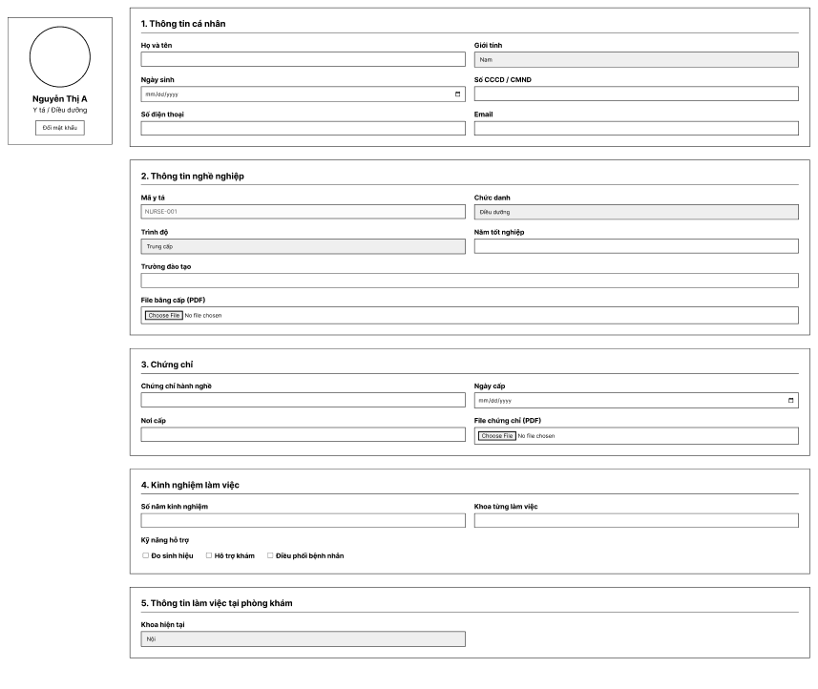
Figure 22.

# | Field Name | Type | Mandatory | Max Length | Description
1 | Avatar | Image Upload / Display | No |  | Displays the staff profile image and allows the user to upload an avatar image. Only PNG and IMG file formats are accepted. If the uploaded file is not in an allowed format, the system shall display a validation error and shall not save the file.
2 | Nguyễn Thị A | Label | No |  | Displays the full name of the current staff.
3 | Y tá / Điều dưỡng | Label | No |  | Displays the current staff role or title.
4 | Đổi mật khẩu | Button | No |  | Redirects the user to the Đổi mật khẩu screen.
5 | Họ và tên | Text | Yes | 100 | This field is mandatory. The system shall trim leading and trailing spaces before validation and saving. The value must not be blank or contain only spaces. The field shall not exceed 100 characters. The field shall only accept valid personal name format. If the value contains numeric characters or invalid special characters, the system shall display a format validation error.
6 | Giới tính | Dropdown | Yes |  | This field is mandatory. The user can only select one of the following values: Nam, Nữ, or Khác.
7 | Ngày sinh | Date | Yes | 10 | This field is mandatory. The user selects date of birth using the date picker. The displayed format shall be dd/MM/yyyy.
8 | Số CCCD / CMND | Text | Yes | 12 | This field is mandatory. The field accepts digits only and must contain exactly 12 digits. If the value contains letters or special characters, the system shall display an error indicating that only numeric characters are allowed. If the length is not equal to 12 digits, the system shall display “CCCD phải gồm 12 chữ số”.
9 | Số điện thoại | Text | Yes | 11 | This field is mandatory. The system accepts only valid Vietnamese phone numbers. The system shall remove spaces and normalize country code when needed. If the value contains letters, invalid special characters, does not start with 0 after normalization, or has fewer than 9 digits or more than 11 digits, the system shall display “Số điện thoại không hợp lệ”.
10 | Email | Text | Yes | 30 | This field is mandatory. The system shall trim leading and trailing spaces before validation and saving. The system accepts only valid email format. If the format is invalid, the system shall display “Email không đúng định dạng”.
11 | Mã y tá | Text | No |  | The system automatically generates this data when creating an account, and it cannot be changed.
12 | Chức danh | Text | Yes | 255 | This field is mandatory and is used to enter or display position information. Maximum length is 255 characters.
13 | Trình độ | Text | Yes | 255 | This field is mandatory and is used to enter educational level information. Maximum length is 255 characters.
14 | Năm tốt nghiệp | Text | Yes | 255 | This field is mandatory and is used to enter graduation year information. Maximum length is 255 characters.
15 | Trường đào tạo | Text | Yes | 255 | This field is mandatory and is used to enter the training institution name. Maximum length is 255 characters.
16 | File bằng cấp (PDF) | File Upload | No |  | This field allows the user to upload a degree file. Only PDF format is accepted. If the uploaded file is not a PDF file, the system shall display a validation error and shall not save the file.
17 | Chứng chỉ hành nghề | Text | Yes | 255 | This field is mandatory and is used to enter certificate or practice license information. Maximum length is 255 characters.
18 | Ngày cấp | Date | Yes | 10 | This field is mandatory and is used to enter the certificate issue date. The user selects the date using the date picker. The displayed format shall be dd/MM/yyyy.
19 | Nơi cấp | Text | Yes | 255 | This field is mandatory and is used to enter the certificate issuing place. Maximum length is 255 characters.
20 | File chứng chỉ (PDF) | File Upload | No |  | This field allows the user to upload a certificate file. Only PDF format is accepted. If the uploaded file is not a PDF file, the system shall display a validation error and shall not save the file.
21 | Số năm kinh nghiệm | Text | Yes | 255 | This field is mandatory and is used to enter total years of working experience. Maximum length is 255 characters.
22 | Khoa từng làm việc | Text | No | 255 | This field is used to enter previous departments or workplaces. Maximum length is 255 characters.
23 | Kỹ năng hỗ trợ | Checkbox Group | No |  | This field allows the user to select one or more support skills. Multiple values can be selected at the same time. The displayed options shall follow system configuration.
24 | Đo sinh hiệu | Checkbox | No |  | Allows the user to select the support skill Đo sinh hiệu.
25 | Hỗ trợ khám | Checkbox | No |  | Allows the user to select the support skill Hỗ trợ khám.
26 | Điều phối bệnh nhân | Checkbox | No |  | Allows the user to select the support skill Điều phối bệnh nhân.
27 | Khoa hiện tại | Text | Yes | 255 | This field is mandatory and is used to display or enter the current working department. Maximum length is 255 characters.

3.2.2.3 Forgot Password

UC ID and Name | UC-03 Forgot Password
Created By | TungLB | Date Created | February 1, 2026
Primary Actor | All User | Secondary Actors | System
Description | This use case allows users to reset their password when they forget their current one.  The user must enter an email address that already exists in the system. The system sends a one-time password (OTP) to the provided email address for verification.  After the user successfully verifies the OTP, the system allows the user to create a new password.  The new password must satisfy defined security requirements and match the confirmation password.  Upon successful password reset, the system encrypts the new password, updates it in the database, and redirects the user to the Login screen to sign in again.
Trigger | The user selects “Quên mật khẩu” from the Login screen.
Preconditions | PRE-1: The user has a registered account in the system.  PRE-2: The provided email address exists in the system.  PRE-3: The email service is available.
Postconditions | POST-1: The user’s password is successfully updated in the system.  POST-2: The new password is securely encrypted and stored in the database.  POST-3: The user is redirected to the Login screen to log in with the new password.
Normal Flow | - The user enters a email address.  - The user requests OTP verification.  - The system validates that the email exists in the system.  - The system generates an OTP and sends it to the user’s email address.  - The system displays the OTP input screen.  - The user enters the received OTP.  - The system validates the OTP.  - Upon successful OTP verification, the system redirects the user to the Reset Password screen.  - The user enters a new password and confirms the new password.  - The system validates password complexity requirements.  - The system verifies that the new password matches the confirmation password.  - The system encrypts the new password and updates it in the database.  - The system displays a success message.  - The system redirects the user to the Login screen.
Alternative Flows | A1 – Email Not Found  - The user enters an email address that does not exist in the system.  - The system displays an error message indicating that the email is not registered.  A2 – Invalid or Expired OTP  - The user enters an incorrect or expired OTP.  - The system rejects the OTP verification.  - The system displays an error message and allows the user to re-enter the OTP.  A3 – Resend OTP  - The user selects “Gửi lại mã”.  - The system generates a new OTP.  - The system sends the new OTP to the registered email address.  A4 – Password Validation Failure  - The new password does not meet complexity requirements or does not match the confirmation password.  The system displays a validation error message and requests re-entry.
Exceptions | E1 – OTP Delivery Failure  - The system fails to send the OTP email.  - The system notifies the user of the issue.  - The user may retry sending the OTP or attempt the process later.
Priority | High
Frequency of Use | Medium
Business Rules
Other Information | Validation messages are displayed clearly to guide users during the process.
Assumptions | OTP verification is mandatory for resetting the password.  Users must log in again after successfully resetting their password.
Table 17: Forgot password function description

3.2.2.4 Change Password

UC ID and Name | UC-02 Change Password
Created By | TungLB | Date Created | February 1, 2026
Primary Actor | Authenticated User | Secondary Actors | System
Description | This use case allows an authenticated user to change their current password.  The user must be logged into the system and access the Profile page to initiate the change password function.  The system verifies whether the entered current password matches the password stored in the system.  If the current password is valid, the system validates the new password according to security requirements and confirms that it matches the confirmation password.  Upon successful validation, the system encrypts the new password, updates it in the database, and confirms the password change.
Trigger | The user selects “Đổi mật khẩu” from the Profile page.
Preconditions | PRE-1: The user is authenticated and logged into the system.  PRE-2: The user account is active.  PRE-3: The Change Password function is available.
Postconditions | POST-1: The user’s password is successfully updated.  POST-2: The new password is securely encrypted and stored in the database.  POST-3: The user remains logged in after the password change.
Normal Flow | - The user accesses the Profile page.  - The user selects the “Đổi mật khẩu” function.  - The user enters the current password.  - The user enters a new password.  - The user enters the confirmation of the new password.  - The system verifies that the current password matches the stored password.  - The system validates the new password against security requirements.  - The system checks that the new password matches the confirmation password.  - The system encrypts the new password.  - The system updates the password in the database.  - The system displays a success message indicating the password has been changed.
Alternative Flows | A1 – Incorrect Current Password  - The user enters an incorrect current password.  - The system rejects the request.  - The system displays the message:  - “Mật khẩu hiện tại không đúng, hãy nhập lại.”  A2 – New Password Validation Failure  - The new password does not meet complexity requirements or does not match the confirmation password.  - The system displays a validation error message.  - The user is requested to re-enter the new password information.
Exceptions | E1 – System Error  - A system or database error occurs during the password update process.  - The system fails to update the password.  - The system displays a general error message and requests the user to try again later.
Priority | High
Frequency of Use | Medium
Business Rules | BR-01, BR-02, BR-03, BR-04, BR-05, BR-06, BR-07, BR-08, BR-09, BR-10, BR-11
Other Information | The Change Password screen supports the Vietnamese language.  Password input fields are masked for security purposes.
Assumptions | The user has knowledge of their current password.  The system does not require OTP verification for changing the password while logged in.
Table 18: Change password function description

3.2.2.5 User Profile

Figure 23.
UC ID and Name | UC-04 Update Profile
Created By | TungLB | Date Created | February 1, 2026
Primary Actor | Doctor / Nurse / Customer | Secondary Actors | Admin
Description | This use case allows authenticated users (doctor, nurse, customer) to view and update their personal profile information. Users access the profile screen by clicking their avatar from the main menu. The system allows users to update required and optional profile information based on their role.
Trigger | The user clicks the avatar icon on the navigation menu and selects the Profile option.
Preconditions | PRE-1: The user is authenticated and logged into the system. PRE-2: The user account exists and is active in the system.
Postconditions | POST-1: The user profile information is updated successfully and saved to the database. POST-2: The system displays a success message after saving the profile.
Normal Flow | 1. The user logs into the system.  2. The user clicks the avatar icon on the main menu.  3. The system displays the Profile screen corresponding to the user role (doctor, nurse, or customer).  4. The system displays existing profile information.  5. The user updates profile information.  6. The user clicks the “Save Profile” button.  7. The system validates required fields.  8. The system saves updated information to the database.  9. The system displays a success confirmation message.
Alternative Flows | A1 – Missing required information If one or more required fields are empty, the system displays a validation message requesting the user to complete the missing information.  A2 – Invalid input format If the user enters invalid data (email, phone number, date format), the system displays an appropriate error message and does not save the profile.
Exceptions | E1 – Unauthorized access If an unauthenticated user attempts to access the profile screen, the system redirects the user to the login page.  E2 – System error If a system error occurs during saving, the system displays a user-friendly error message and does not update the data.
Priority | High
Frequency of Use | High
Business Rules | BR-Profile-01: Required fields must not be empty.  BR-Profile-02: Email must be unique and valid.  BR-Profile-03: Phone number must follow system format.  BR-Profile-04: Only authenticated users can update their own profile.
Other Information | Different roles (doctor, nurse, customer) may have additional optional fields such as professional information, certificates, or medical data.
Assumptions | Users are responsible for ensuring the accuracy of their profile information.
Table 19: Profile function description

3.3 Staff Account Management
3.3.1 Screen Mock-up

3.3.1 Staff List
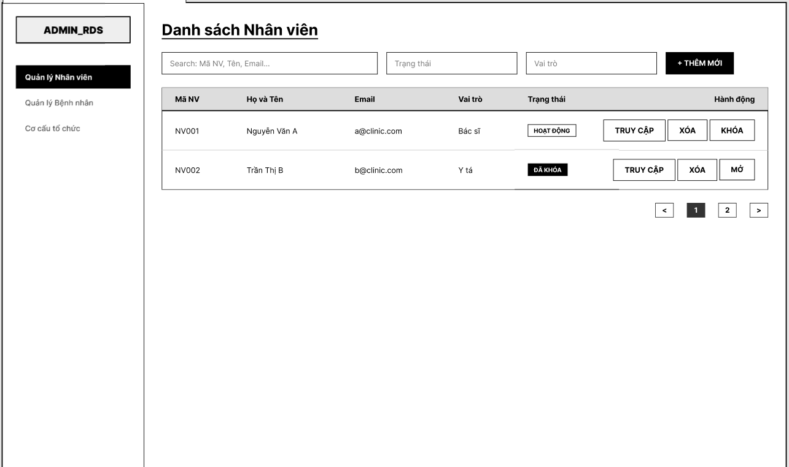
Figure 24: Staff account list screen

# | Field Name | Type | Mandatory | Max Length | Description
1 | Search: Mã NV, Tên, Email... | Search Textbox | No | 255 | This field allows the user to search employee records by Mã NV, Họ và Tên, or Email. The system shall trim leading and trailing spaces before searching.
2 | Trạng thái | Dropdown / Filter | No |  | This field allows the user to filter the employee list by status, such as HOẠT ĐỘNG or ĐÃ KHÓA.
3 | Vai trò | Dropdown / Filter | No |  | This field allows the user to filter the employee list by role, such as Bác sĩ, Y tá, or other configured roles.
4 | + THÊM MỚI | Button | No |  | Opens the modal THÊM MỚI NHÂN VIÊN to create a new employee record.
5 | Mã NV | Table Column | No |  | Displays the employee code of each record in the employee list.
6 | Họ và Tên | Table Column | No |  | Displays the full name of the employee.
7 | Email | Table Column | No |  | Displays the email address of the employee.
8 | Vai trò | Table Column | No |  | Displays the assigned role of the employee.
9 | Trạng thái | Status Badge / Table Column | No |  | Displays the current status of the employee, such as HOẠT ĐỘNG or ĐÃ KHÓA.
10 | TRUY CẬP | Button | No |  | Redirects the user to the detailed profile or information screen of the selected employee.
11 | XÓA | Button | No |  | Deletes the selected employee record from the list after confirmation, according to system permission and business rules.
12 | KHÓA | Button | No |  | Changes the employee status from HOẠT ĐỘNG to ĐÃ KHÓA. This button is displayed when the employee account is currently active.
13 | MỞ | Button | No |  | Changes the employee status from ĐÃ KHÓA to HOẠT ĐỘNG. This button is displayed when the employee account is currently locked.
14 | < | Pagination Button | No |  | Moves to the previous page of the employee list.
15 | 1 / 2 / ... | Pagination Index | No |  | Displays the current page number and allows the user to navigate to a specific page.
16 | > | Pagination Button | No |  | Moves to the next page of the employee list.

UC ID and Name | UC-38 View List Staff Account
Created By | TungLB | Date Created | February 1, 2026
Primary Actor | Admin | Secondary Actors | Manager, Cashier
Description | This use case allows authorized users (Admin, Manager, and Cashier) to view and manage the list of employees in the system. Users can search, filter, view employee details, and perform permitted management actions based on their assigned role.
Trigger | The user clicks the “Quản lý nhân viên” menu item after logging into the system.
Preconditions | PRE-1: The user is authenticated and logged into the system. PRE-2: The user has one of the following roles: Admin, Manager, or Cashier.
Postconditions | POST-1: The system displays the employee list with relevant information. POST-2: Any permitted management action performed by the user is processed and reflected in the list.
Normal Flow | 1. The user logs into the system with a valid account.  2. The user clicks “Quản lý nhân viên” from the sidebar menu.  3. The system verifies the user’s role and access permission.  4. The system displays the Employee List screen.  5. The system shows a paginated list of employees including employee ID, full name, email, role, and status.  6. The user may search employees by employee ID, name, or email.  7. The user may filter the list by role or status.  8. The user may perform allowed actions such as view details, lock, unlock, or delete employee accounts depending on role permissions.  Sub UseCase 1: Delete  1. The user accesses the Employee List screen.  2. The user clicks the “Xóa” (Delete) button for a selected staff account.  3. The system displays a confirmation popup asking the user to confirm the deletion.  4. The user clicks the “Xóa ngay” (Confirm Delete) button.  5. The system performs a soft delete on the staff account.  6. The system updates the account status to “Deleted”.  7. The system refreshes the Employee List screen and removes or marks the deleted account accordingly.  Sub Usecase 2: Lock Unlock  1. The user accesses the Employee List screen.  2. The user clicks the “Khóa” (Lock) or “Mở” (Unlock) button for a selected staff account.  3. The system displays a confirmation popup asking the user to confirm the lock or unlock action.  4. The user clicks the “Xác nhận” (Confirm) button.  5. The system updates the account status accordingly (Locked or Active).  6. The system refreshes the Employee List screen and displays the updated account status.
Alternative Flows | A1 – No employees found If no employees match the search or filter criteria, the system displays a message indicating that no data is found.  A2 – Add new employee If the user has sufficient permission, the user clicks the “Thêm mới” button and is redirected to the Create Employee screen.  A3 – Pagination If the number of employees exceeds one page, the user navigates through pages using the pagination controls.
Exceptions | E1 – Unauthorized role If a user without Admin, Manager, or Cashier role attempts to access this screen, the system denies access and redirects the user to an appropriate page.  E2 – System error If an error occurs while retrieving employee data, the system displays a user-friendly error message.
Priority | High
Frequency of Use | High
Business Rules | BR-Emp-01: Only users with Admin, Manager, or Cashier roles can access the Employee List screen.  BR-Emp-02: Available actions depend on the user’s role and assigned permissions.  BR-Emp-03: Locked employee accounts cannot access the system.  BR-Emp-04: Search supports employee ID, name, and email.
Other Information | The employee list supports pagination and role-based access control for actions.
Assumptions | User permissions are predefined and correctly assigned by the system administrator.
Table 20: Staff account list function description

3.3.2 Module Create User ,Role Management
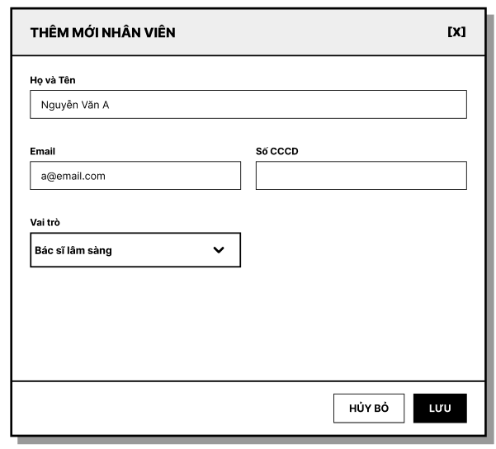

# | Field Name | Type | Mandatory | Max Length | Description
1 | THÊM MỚI NHÂN VIÊN | Modal Title | No |  | Displays the title of the modal for creating a new employee.
2 | Họ và Tên | Text | Yes | 100 | This field is mandatory. The system shall trim leading and trailing spaces before validation and saving. The value must not be blank or contain only spaces. The field shall not exceed 100 characters. The field shall only accept valid personal name format. If the value contains numeric characters or invalid special characters, the system shall display a format validation error and shall not save data.
3 | Email | Text | Yes | 255 | This field is mandatory. The system shall trim leading and trailing spaces before validation and saving. The value must not be blank. The system shall validate correct email format. If the format is invalid, the system shall display “Email không hợp lệ” and shall not save data. If the email already exists in the system, the system shall display “Email đã tồn tại” and shall not create a new record.
4 | Số CCCD | Text | Yes | 12 | This field is mandatory. The value must not be blank. The field accepts digits only and must contain exactly 12 digits. If the value contains letters or special characters, the system shall display a numeric-only validation error. If the length is not equal to 12 digits, the system shall display “CCCD phải gồm 12 chữ số”. If the CCCD already exists in the system, the system shall display “CCCD đã tồn tại” and shall not create a new record.
5 | Vai trò | Dropdown | Yes |  | This field is mandatory. The dropdown shall display the full list of roles configured in the system/database, with correct label mapping, no blank item, and no duplicate item. The selected value shall remain correct when the user changes selection or clicks outside. If the user does not select a role and clicks LƯU, the system shall display “Vai trò là bắt buộc”, shall not save data, and shall focus on this field.
6 | HỦY BỎ | Button | No |  | Closes the modal without saving data. No new employee record shall be created when this button is clicked.
7 | LƯU | Button | No |  | When clicked, the system shall validate all fields in the modal. Data shall be saved only when all required fields are valid. If validation passes, the system shall create exactly one new employee record, close the modal, display a success message, add the new employee to the employee list, and set the default status to “HOẠT ĐỘNG”. The system shall prevent duplicate record creation when the user double-clicks the button.
8 | [X] | Icon Button | No |  | Closes the modal without saving data. No record shall be inserted when this icon is clicked.

Figure 25: Create Staff account module
UC ID and Name | UC-39 Create staff account
Created By | TungLB | Date Created | February 1, 2026
Primary Actor | Admin | Secondary Actors | Cashier, Manager
Description | This use case allows authorized users to create a new employee account in the system by entering required personal information and selecting a role. The system validates the input data, checks for duplicate email and identification number, and sends a system-generated password to the employee’s email upon successful creation.
Trigger | The user clicks the “+ Thêm mới” button on the Staff accounts List screen.
Preconditions | PRE-1: The user is authenticated and logged into the system.  PRE-2: The user has Admin or Manager role.
Postconditions | POST-1: A new employee account is created successfully in the system.  POST-2: A random password is generated and sent to the employee’s email address.
Normal Flow | 1. The user clicks the “+ Thêm mới” button on the Employee List screen.  2. The system displays the “Thêm mới nhân viên” popup.  3. The user enters all required information including full name, email, identification number (CCCD), and role.  4. The user selects a role from the dropdown list (Clinical Doctor, Specialist Doctor, Nurse, Administrative Staff, Manager).  5. The user clicks the “Lưu” button.  6. The system validates that all required fields are filled.  7. The system checks whether the email and CCCD already exist in the system.  8. If the information is valid, the system creates a new employee account.  9. The system generates a random password.  10. The system sends the generated password to the employee’s email address.  11. The system closes the popup and refreshes the Employee List.
Alternative Flows | A1 – Cancel creation The user clicks the “Hủy bỏ” button or closes the popup. The system closes the popup without saving any data.  A2 – Missing required information If any required field is empty, the system displays a validation message and requires the user to complete all required fields.
Exceptions | E1 – Duplicate email If the entered email already exists in the system, the system displays an error message indicating that the email is already in use and requests the user to enter a different email.  E2 – Duplicate CCCD If the entered identification number already exists in the system, the system displays an error message indicating that the CCCD already exists and requests the user to enter a different value.  E3 – Email delivery failure If the system fails to send the password email, the account is still created, and the system logs the error for further handling.
Priority | High
Frequency of Use | Medium
Business Rules | BR-Emp-05: All fields in the Create Employee popup are mandatory.  BR-Emp-06: Email and CCCD must be unique across the system.  BR-Emp-07: The system must generate a random password for new employee accounts.  BR-Emp-08: The generated password must be sent to the employee’s registered email address.
Other Information | The role list is predefined and managed by the system.
Assumptions | The employee will log in for the first time using the system-generated password and change it after login.
Table 21: Create account staff function description

3.3.3 Edit Doctor, Nurse, Cashier, Manager, Receptionist
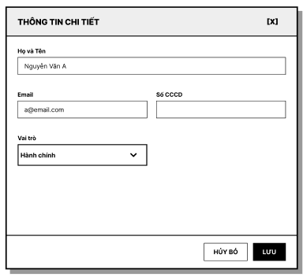
Figure 26: Update Staff account module

# | Field Name | Type | Mandatory | Max Length | Description
1 | THÔNG TIN CHI TIẾT | Modal Title | No |  | Displays the title of the modal for viewing and updating employee information.
2 | Họ và Tên | Text | Yes | 100 | This field is mandatory. The system shall trim leading and trailing spaces before validation and saving. The value must not be blank or contain only spaces. The field shall not exceed 100 characters. The field shall only accept valid personal name format. If the value contains numeric characters or invalid special characters, the system shall display a format validation error and shall not save data.
3 | Email | Text | Yes | 255 | This field is mandatory. The system shall trim leading and trailing spaces before validation and saving. The value must not be blank. The system shall validate correct email format. If the format is invalid, the system shall display “Email không hợp lệ” and shall not save data. If the email already exists in another employee record, the system shall display “Email đã tồn tại” and shall not save data.
4 | Số CCCD | Text | Yes | 12 | This field is mandatory. The value must not be blank. The field accepts digits only and must contain exactly 12 digits. If the value contains letters or special characters, the system shall display a numeric-only validation error. If the length is not equal to 12 digits, the system shall display “CCCD phải gồm 12 chữ số”. If the CCCD already exists in another employee record, the system shall display “CCCD đã tồn tại” and shall not save data.
5 | Vai trò | Dropdown | Yes |  | This field is mandatory. The dropdown shall display the full list of roles configured in the system/database, with correct label mapping, no blank item, and no duplicate item. The selected value shall remain correct when the user changes selection or clicks outside. If the user does not select a role and clicks LƯU, the system shall display “Vai trò là bắt buộc”, shall not save data, and shall focus on this field.
6 | HỦY BỎ | Button | No |  | Closes the modal without saving updated data.
7 | LƯU | Button | No |  | When clicked, the system shall validate all editable fields in the modal. Data shall be updated only when all required fields are valid. If validation passes, the system shall save the updated employee information, close the modal, display a success message, and refresh the employee list with the latest data.
8 | [X] | Icon Button | No |  | Closes the modal without saving updated data.

UC ID and Name | UC-40 Update staff account
Created By | TungLB | Date Created | February 1, 2026
Primary Actor | Admin | Secondary Actors | Manager, Cashier
Description | This use case allows authorized users to view and update staff account information. Depending on the staff role, the system displays either a profile screen or a detail popup. Access permissions and editable fields vary based on the role of the logged-in user and the role of the selected staff account.
Trigger | The user clicks the “Truy cập” button from the Staff account List screen.
Preconditions | PRE-1: The user is authenticated and logged into the system.  PRE-2: The user has Admin, Manager, or Cashier role.
Postconditions | POST-1: Staff information is updated successfully if changes are saved.  POST-2: If no changes are saved, the system remains unchanged.
Normal Flow | 1. The user accesses the Employee List screen.  2. The user clicks the “Truy cập” button for a selected staff account.  3. The system checks the role of the selected staff.  4. If the staff role is Doctor or Nurse, the system navigates to the corresponding staff profile screen.  5. The system displays staff profile information without the “Change Password” function.  6. If the staff role is Administrative Staff, Receptionist, or Manager, the system displays the “Staff Detail” popup.  7. The system shows staff information including full name, email, identification number (CCCD), and role.  8. The user updates the allowed fields.  9. The user clicks the “Lưu” button.  10. The system validates the updated information.  11. The system saves the changes and closes the popup or refreshes the profile screen.
Alternative Flows | A1 – Cancel update The user clicks the “Hủy bỏ” button or closes the popup. The system discards all changes and closes the popup.  A2 – View-only access If the logged-in user does not have permission to edit the selected staff account, the system displays the information in read-only mode.
Exceptions | E1 – Unauthorized access If a user without sufficient permissions attempts to access staff information, the system denies access and displays an authorization error message.  E2 – Invalid update data If the updated information is invalid, the system displays validation messages and requires the user to correct the data before saving.
Priority | High
Frequency of Use | Medium
Business Rules | BR-Staff-10: Admin can view and update information of all staff accounts.  BR-Staff-11: Manager and Cashier can only view and update information of their own accounts.  BR-Staff-12: Doctor and Nurse accounts are displayed using the profile screen instead of the staff detail popup.  BR-Staff-13: The “Change Password” function is not available when viewing staff profiles from the Employee Management module.
Other Information | Role-based navigation and permissions are enforced by the system.
Assumptions | Staff profile screens for Doctor and Nurse already exist and follow the predefined profile layout.
Table 22: Update account staff function description

3.4 Customer Account Management

3.4.1 View customer accounts list
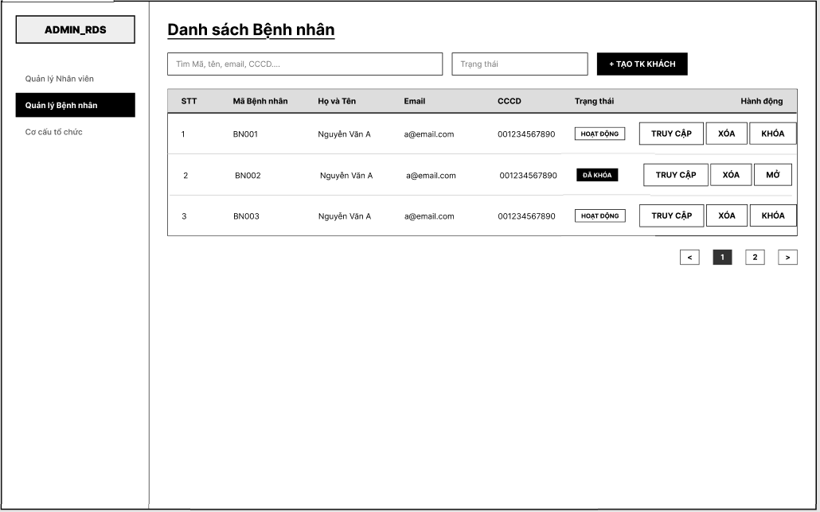
Figure 27: View customer accounts list

# | Field Name | Type | Mandatory | Max Length | Description
1 | Tìm Mã, tên, email, CCCD... | Search Textbox | No | 255 | This field allows the user to search patient records by Mã Bệnh nhân, Họ và Tên, Email, or CCCD. The system shall trim leading and trailing spaces before searching.
2 | Trạng thái | Dropdown / Filter | No |  | This field allows the user to filter the patient list by status, such as HOẠT ĐỘNG or ĐÃ KHÓA.
3 | + TẠO TK KHÁCH | Button | No |  | Opens the function or modal to create a new guest patient account.
4 | STT | Table Column | No |  | Displays the sequential number of each record in the patient list.
5 | Mã Bệnh nhân | Table Column | No |  | Displays the patient code of each record.
6 | Họ và Tên | Table Column | No |  | Displays the full name of the patient.
7 | Email | Table Column | No |  | Displays the email address of the patient.
8 | CCCD | Table Column | No |  | Displays the identification number of the patient.
9 | Trạng thái | Status Badge / Table Column | No |  | Displays the current status of the patient, such as HOẠT ĐỘNG or ĐÃ KHÓA.
10 | TRUY CẬP | Button | No |  | Redirects the user to the detailed profile or information screen of the selected patient.
11 | XÓA | Button | No |  | Deletes the selected patient record from the list after confirmation, according to system permission and business rules.
12 | KHÓA | Button | No |  | Changes the patient status from HOẠT ĐỘNG to ĐÃ KHÓA. This button is displayed when the patient account is currently active.
13 | MỞ | Button | No |  | Changes the patient status from ĐÃ KHÓA to HOẠT ĐỘNG. This button is displayed when the patient account is currently locked.
14 | < | Pagination Button | No |  | Moves to the previous page of the patient list.
15 | 1 / 2 / ... | Pagination Index | No |  | Displays the current page number and allows the user to navigate to a specific page.
16 | > | Pagination Button | No |  | Moves to the next page of the patient list.

UC ID and Name | UC-43 View List Customer Accounts
Created By | TungLB | Date Created | February 1, 2026
Primary Actor | Admin | Secondary Actors | Cashier
Description | This use case allows an administrator or cashier to view and manage the list of patients in the system. The patient list displays basic patient information and supports searching and filtering by account status to facilitate effective patient management.
Trigger | The admin selects “Quản lý Bệnh nhân” from the main menu.
Preconditions | PRE-1: The user is authenticated and logged into the system.  PRE-2: The user has the Admin role.
Postconditions | POST-1: The system displays the patient list with relevant information.  POST-2: The admin can perform further actions on a selected patient account.
Normal Flow | 1. The admin logs into the system successfully.  2. The admin selects “Quản lý Bệnh nhân” from the menu.  3. The system retrieves the list of patients from the database.  4. The system displays the patient list, including patient code, full name, email, CCCD, and account status.  5. The admin may search patients by patient code, name, email, or CCCD.  6. The admin may filter the patient list by account status (Active / Locked).  7. The system updates the displayed list based on the search or filter criteria.  Sub UseCase 1: Delete  1. The user accesses the Customer Management screen.  2. The user selects a customer and clicks the “Xóa” (Delete) button.  3. The system displays a confirmation popup asking the user to confirm deletion.  4. The user clicks the “Xóa ngay” (Confirm Delete) button.  5. The system performs a soft delete on the customer account.  6. The system updates the customer account status to “Deleted”.  7. The system refreshes the customer list screen.  Sub UseCase 2: Lock Unlock  1. The user accesses the Customer Management screen.  2. The user selects a customer and clicks the “Khóa” (Lock) or “Mở” (Unlock) button.  3. The system displays a confirmation popup asking the user to confirm the action.  4. The user clicks the “Xác nhận” (Confirm) button.  5. The system updates the customer account status accordingly (Locked or Active).  6. The system refreshes the Customer List screen and displays the updated status.
Alternative Flows | A1 – No matching results If no patients match the search or filter criteria, the system displays a “No data found” message.
Exceptions | E1 – Unauthorized access If a user without Admin role attempts to access the Patient Management screen, the system denies access and redirects the user to an appropriate page.
Priority | High
Frequency of Use | High
Business Rules | BR-Patient-01: Only users with Admin role are allowed to access the Patient Management screen.  BR-Patient-02: Patient list must support search by patient code, name, email, and CCCD.  BR-Patient-03: Patient list must support filtering by account status (Active, Locked).
Other Information | The patient list supports pagination to handle a large number of records.
Assumptions | Patient account status is managed using predefined status values (Active, Locked).
Table 23: View customer accounts list function description

3.4.2 Create customer account
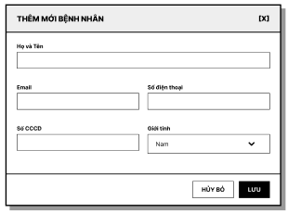
Figure 28: Create customer accounts module

# | Field Name | Type | Mandatory | Max Length | Description
1 | THÊM MỚI BỆNH NHÂN | Modal Title | No |  | Displays the title of the modal for creating a new patient record.
2 | Họ và Tên | Text | Yes | 100 | This field is mandatory. The system shall trim leading and trailing spaces before validation and saving. The value must not be blank or contain only spaces. The field shall not exceed 100 characters. The field shall only accept valid personal name format. If the value contains numeric characters or invalid special characters, the system shall display a format validation error and shall not save data.
3 | Email | Text | Yes | 30 | This field is mandatory. The system shall trim leading and trailing spaces before validation and saving. The value must not be blank. The system shall validate correct email format. If the format is invalid, the system shall display “Email không đúng định dạng” and shall not save data. If the email already exists in the system, the system shall display “Email đã tồn tại” and shall not create a new record.
4 | Số điện thoại | Text | Yes | 11 | This field is mandatory. The system accepts only valid Vietnamese phone numbers. The system shall remove spaces and normalize country code when needed. If the value contains letters, invalid special characters, does not start with 0 after normalization, or has fewer than 9 digits or more than 11 digits, the system shall display “Số điện thoại không hợp lệ” and shall not save data.
5 | Số CCCD | Text | Yes | 12 | This field is mandatory. The value must not be blank. The field accepts digits only and must contain exactly 12 digits. If the value contains letters or special characters, the system shall display a numeric-only validation error. If the length is not equal to 12 digits, the system shall display “CCCD phải gồm 12 chữ số”. If the CCCD already exists in the system, the system shall display “CCCD đã tồn tại” and shall not create a new record.
6 | Giới tính | Dropdown | Yes |  | This field is mandatory. The user can only select one of the following values: Nam, Nữ, or Khác.
7 | HỦY BỎ | Button | No |  | Closes the modal without saving data. No new patient record shall be created when this button is clicked.
8 | LƯU | Button | No |  | When clicked, the system shall validate all fields in the modal. Data shall be saved only when all required fields are valid. If validation passes, the system shall create exactly one new patient record, close the modal, display a success message, and add the new patient to the patient list. The system shall prevent duplicate record creation when the user double-clicks the button.
9 | [X] | Icon Button | No |  | Closes the modal without saving data. No record shall be inserted when this icon is clicked.

UC ID and Name | UC-44 Create customer account
Created By | TungLB | Date Created | February 1, 2026
Primary Actor | Admin | Secondary Actors | Cashier
Description | This use case allows an administrator to create a new patient account in the system by entering the required personal information. The system validates the input data to ensure uniqueness and automatically generates a patient code and a random system password, which is sent to the patient via email upon successful creation.
Trigger | The admin clicks the “+ Tạo TK Khách” button on the Patient Management screen.
Preconditions | PRE-1: The user is authenticated and logged into the system.  PRE-2: The user has the Admin role.
Postconditions | POST-1: A new patient account is created in the system.  POST-2: A unique patient code is generated automatically.  POST-3: A random system password is generated and sent to the patient’s email.
Normal Flow | 1. The admin accesses the Patient Management screen.  2. The admin clicks the “+ Tạo TK Khách” button.  3. The system displays the “Thêm mới Bệnh nhân” popup.  4. The admin enters patient information, including full name, email, phone number, CCCD, and gender.  5. The admin clicks the “Lưu” (Save) button.  6. The system validates that the email, phone number, and CCCD are not duplicated.  7. The system creates a new patient account.  8. The system automatically generates a unique patient code.  9. The system generates a random password for the patient account.  10. The system sends an email containing the generated password to the patient’s email address.  11. The system closes the popup and refreshes the patient list.
Alternative Flows | A1 – Cancel creation The admin clicks the “Hủy bỏ” (Cancel) button. The system closes the popup and no patient account is created.
Exceptions | E1 – Duplicate information If the entered email, phone number, or CCCD already exists in the system, the system displays an error message indicating duplicate information and requires the admin to re-enter the data.  E2 – Missing required fields If any required field is missing, the system displays a validation message and prevents account creation.
Priority | High
Frequency of Use | Medium
Business Rules | BR-Patient-04: Only Admin users are allowed to create patient accounts.  BR-Patient-05: Email, phone number, and CCCD must be unique across patient accounts.  BR-Patient-06: The system must automatically generate a unique patient code for each patient account.  BR-Patient-07: The system must generate a random password and send it to the patient via email upon successful account creation.
Other Information | The generated password must comply with the system’s password security requirements.
Assumptions | Email service is available and configured correctly to deliver system-generated passwords.
Table 24: Create customer account function description

3.4.3 Update customer account
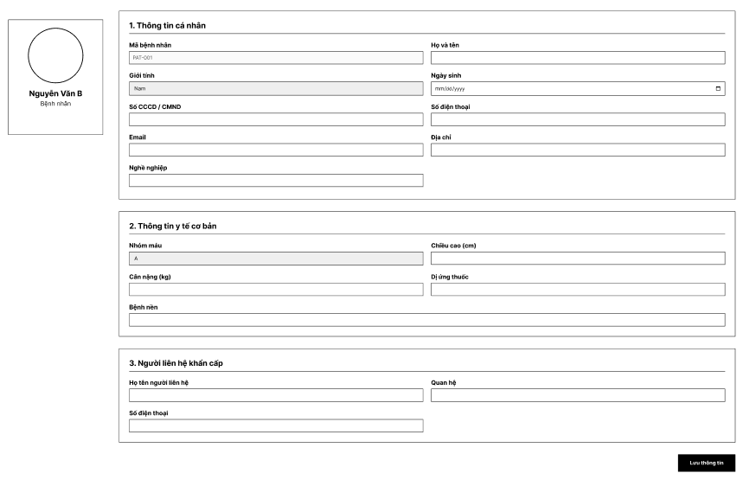
Figure 29: customer accounts detail list

# | Field Name | Type | Mandatory | Max Length | Description
1 | Avatar | Image Upload / Display | No |  | Displays the patient profile image and allows the user to upload an avatar image. Only PNG and IMG file formats are accepted. If the uploaded file is not in an allowed format, the system shall display a validation error and shall not save the file.
2 | Name | Label | No |  | Displays the full name of the current patient.
3 | Bệnh nhân | Label | No |  | Displays the current profile type.
4 | Mã bệnh nhân | Text | Yes | 255 | This field displays the patient code. This field is read-only and the user is not allowed to edit it.
5 | Họ và tên | Text | Yes | 100 | This field is mandatory. The system shall trim leading and trailing spaces before validation and saving. The value must not be blank or contain only spaces. The field shall not exceed 100 characters. The field shall only accept valid personal name format. If the value contains numeric characters or invalid special characters, the system shall display a format validation error.
6 | Giới tính | Dropdown | Yes |  | This field is mandatory. The user can only select one of the following values: Nam, Nữ, or Khác.
7 | Ngày sinh | Date | Yes | 10 | This field is mandatory. The user selects date of birth using the date picker. The displayed format shall be dd/MM/yyyy.
8 | Số CCCD / CMND | Text | Yes | 12 | This field is mandatory. The field accepts digits only and must contain exactly 12 digits. If the value contains letters or special characters, the system shall display an error indicating that only numeric characters are allowed. If the length is not equal to 12 digits, the system shall display “CCCD phải gồm 12 chữ số”.
9 | Số điện thoại | Text | Yes | 11 | This field is mandatory. The system accepts only valid Vietnamese phone numbers. The system shall remove spaces and normalize country code when needed. If the value contains letters, invalid special characters, does not start with 0 after normalization, or has fewer than 9 digits or more than 11 digits, the system shall display “Số điện thoại không hợp lệ”.
10 | Email | Text | Yes | 30 | This field is mandatory. The system shall trim leading and trailing spaces before validation and saving. The system accepts only valid email format. If the format is invalid, the system shall display “Email không đúng định dạng”.
11 | Địa chỉ | Text | No | 255 | This field is used to enter the patient address. Maximum length is 255 characters.
12 | Nghề nghiệp | Text | No | 255 | This field is used to enter occupation information. Maximum length is 255 characters.
13 | Nhóm máu | Text / Dropdown | No | 255 | This field is used to enter or select the patient blood group information. Maximum length is 255 characters.
14 | Chiều cao (cm) | Text | No | 255 | This field is used to enter the patient height in centimeters.
15 | Cân nặng (kg) | Text | No | 255 | This field is used to enter the patient weight in kilograms.
16 | Dị ứng thuốc | Text | No | 255 | This field is used to enter drug allergy information. Maximum length is 255 characters.
17 | Bệnh nền | Text | No | 255 | This field is used to enter underlying disease information. Maximum length is 255 characters.
18 | Họ tên người liên hệ | Text | Yes | 255 | This field is mandatory and is used to enter the full name of the emergency contact person. The system shall trim leading and trailing spaces before validation and saving. The value must not be blank or contain only spaces.
19 | Quan hệ | Text | Yes | 255 | This field is mandatory and is used to enter the relationship between the patient and the emergency contact person. The system shall trim leading and trailing spaces before validation and saving. The value must not be blank or contain only spaces.
20 | Số điện thoại | Text | Yes | 11 | This field is mandatory and is used to enter the emergency contact phone number. The system accepts only valid Vietnamese phone numbers. If invalid, the system shall display “Số điện thoại không hợp lệ”.
21 | Lưu thông tin | Button | No |  | Saves all updated patient information when the entered data is valid. The system shall validate all editable fields before saving.

UC ID and Name | UC-45 Update customer account
Created By | TungLB | Date Created | February 1, 2026
Primary Actor | Admin | Secondary Actors | Cashier
Description | This use case allows an administrator and Cashier to view and update detailed profile information of a patient. The profile includes personal information, basic medical information, and emergency contact details. The admin can modify patient information and save updates to the system.
Trigger | The admin clicks the “Truy cập” (Access) button on the Patient List screen.
Preconditions | PRE-1: The user is authenticated and logged into the system.  PRE-2: The user has the Admin role. PRE-3: The selected patient account exists in the system.
Postconditions | POST-1: Updated patient profile information is saved successfully.  POST-2: The system reflects the updated information in the patient profile.
Normal Flow | 1. The admin accesses the Patient Management screen.  2. The admin selects a patient and clicks the “Truy cập” button.  3. The system displays the patient profile screen.  4. The system shows patient personal information, basic medical information, and emergency contact details.  5. The admin updates one or more editable fields.  6. The admin clicks the “Lưu thông tin” (Save) button.  7. The system validates the updated information.  8. The system saves the updated patient profile to the database.  9. The system displays a success confirmation message.
Alternative Flows | A1 – No changes made If the admin does not modify any information and leaves the screen, no data is updated.
Exceptions | E1 – Missing required fields If required fields (full name, gender, date of birth, CCCD, phone number, email, or address) are missing, the system displays a validation message and prevents saving.  E2 – Invalid data format If any input data is invalid (e.g., incorrect date format, invalid phone number), the system displays an error message and requires correction.
Priority | High
Frequency of Use | Medium
Business Rules | BR-Patient-08: Only Admin users are allowed to view and update patient profiles. BR-Patient-09: Required fields include full name, gender, date of birth, CCCD, phone number, email, and address.
Other Information | Medical information and emergency contact details are optional unless specified otherwise.
Assumptions | Patient profile data is editable only by Admin users.
Table 25: Update customer account function description

3.5 Clinical Department Structure Management

3.5.1 View Clinical Department Structure List
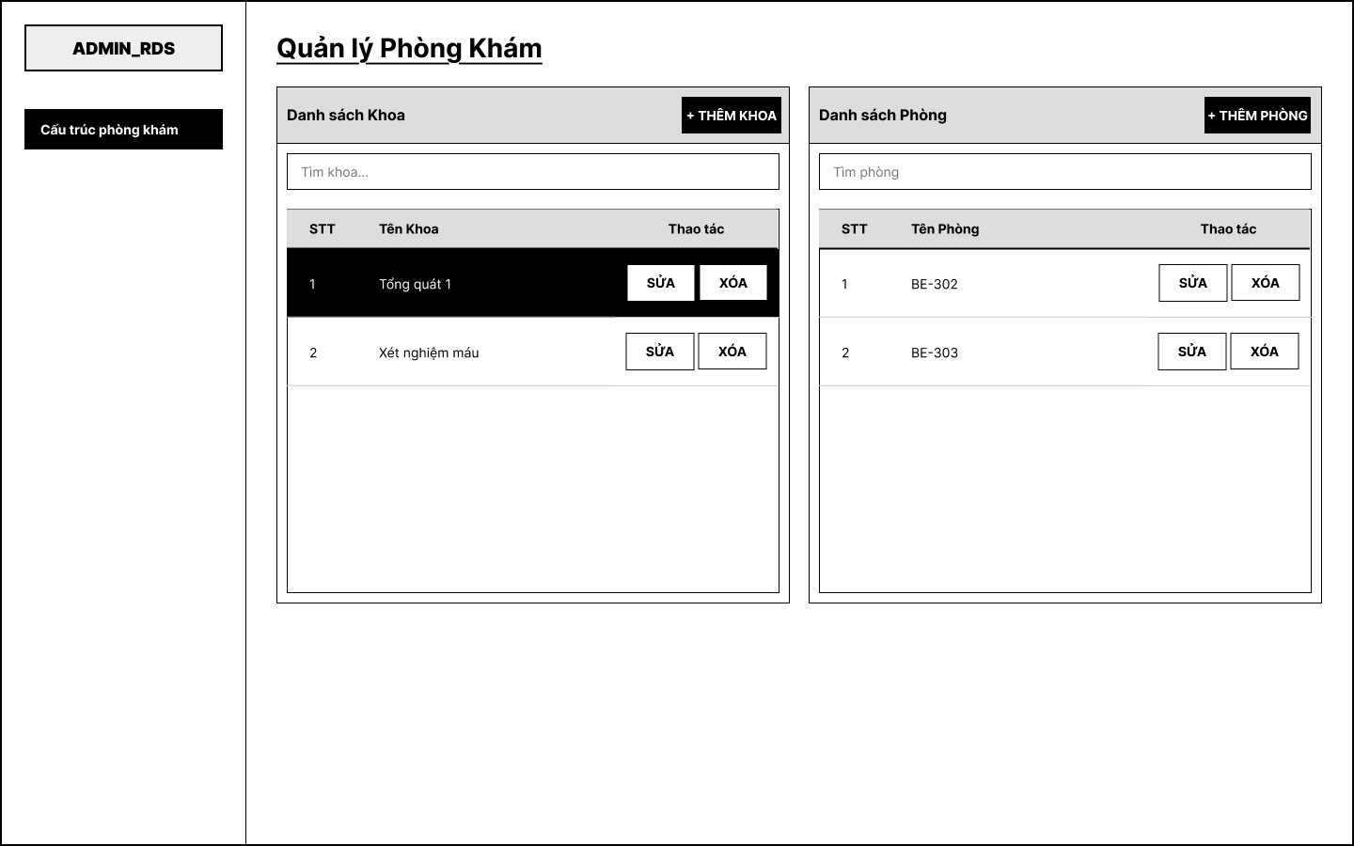
Figure 30: Clinical Department Structure List screen

UC ID and Name | UC-48 View Clinical Department Structure
Created By | NamNH | Date Created | February 1, 2026
Primary Actor | Admin | Secondary Actors | N/A
Description | Screen Analysis: Clinical Department List  - UI Layout: Displays the list of available clinical departments and rooms in a Grid/Tree view.  - Search Bar (Input): Optional field. Maximum length: 255 characters.  - Data Columns: STT (No. ), Department/Room Name, Type, and Actions.  - Validation: Read-only data display screen. No special input validations required.
Trigger | The Admin navigates to the "Clinical Department Structure" section from the sidebar menu.
Preconditions | PRE-1: The user is authenticated and logged into the system.  PRE-2: The user has Admin role.
Postconditions | POST-1: The system displays the full department structure tree.  POST-2: No data is modified.
Normal Flow | 1. The Admin accesses the Clinical Department Structure screen.  2. The system calls GET /api/admin/departments/list.  3. The system retrieves and displays all department blocks in a tree-view layout.  4. Each parent block (e.g., Clinical Block, Para-clinical Block, Administrative Block) is shown with an expand/collapse control.  5. Each child department (e.g., Internal Medicine, Surgery) is shown indented under its parent block with capacity information.  6. Each department entry displays Edit and Delete action buttons.  7. The Admin can search departments using the search input field.  8. The Admin can click "+ Add Department" to create a new department (see UC-11).
Alternative Flows | A1 – Empty structure If no departments exist, the system displays an empty state message.
Exceptions | E1 – Load failure If the API fails to retrieve department data, the system displays an error message and prompts the Admin to retry.
Priority | High
Frequency of Use | Medium
Business Rules | BR-Dept-01: Only Admin can access the Clinical Department Structure module.  BR-Dept-02: Department structure is displayed as a hierarchical tree grouped by block type (Clinical, Para-clinical, Administrative).  BR-Dept-03: Each department displays its capacity information where applicable.
Other Information | The tree view supports expand/collapse per block. Search filters by department name or staff name.
Assumptions | At least one department block exists in the system at the time of access.
Table 26: View clinical department structure list function description

3.5.2 Create Clinical Department Structure
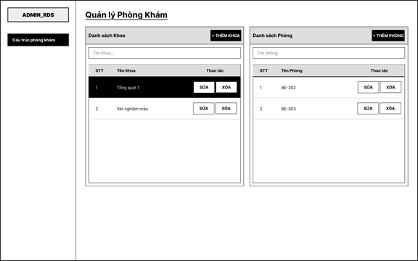
Table 3.4.4a: Screen Definition for Update Staff Hours
# | Field Name | Type | Mandatory | Max Length | Description
1 | Tìm khoa | Text | No | 100 | Search khoa trong danh sách Danh sách Khoa
2 | Tên Khoa | Label | No | - | Display tên khoa (VD: Tổng quát 1, Xét nghiệm máu)
3 | + Thêm Khoa | Button | No | - | Mở popup tạo mới khoa
4 | Sửa (Khoa) | Button | No | - | Chỉnh sửa thông tin khoa được chọn
5 | Xóa (Khoa) | Button | No | - | Delete selected department from the list
6 | Tìm phòng | Text | No | 100 | Search phòng trong danh sách Danh sách Phòng
7 | Tên Phòng | Label | No | - | Display tên/mã phòng (VD: BE-302, BE-303)
8 | + Thêm Phòng | Button | No | - | Mở popup tạo mới phòng khám
9 | Sửa (Phòng) | Button | No | - | Chỉnh sửa thông tin phòng được chọn
10 | Xóa (Phòng) | Button | No | - | Delete selected room from the list

3.4.4.2 Use Case Description
Table 3.4.4b: Use Case Details for Update Staff Hours
UC ID and Name | UC-57 – Update Staff Hours
Created By | NamNH | Date Created | March 23, 2026
Primary Actor | Admin | Secondary Actors | System
Description | Allows Admin to modify existing working hours records for a staff member, including adjusting check-in and check-out times.
Trigger | Admin clicks “Chỉnh sửa” on a working hours record in the list.
Preconditions | PRE-1: Admin is authenticated. PRE-2: The working hours record exists in the system.
Postconditions | POST-1: The updated working hours are saved. POST-2: The list reflects the changes.
Normal Flow
Step | Actor | Action
1 | Admin | Selects a working hours record from the list and clicks “Chỉnh sửa”.
2 | System | Displays the Update Staff Hours form with existing check-in and check-out times.
3 | Admin | Modifies the check-out time as needed.
4 | Admin | Clicks “Save” to save the changes.
5 | System | Validates the time range and updates the record.
Alternative Flows | N/A
Exceptions | N/A
Priority | High
Frequency of Use | Medium
Business Rules | N/A
Other Information | N/A
Assumptions | N/A

Table 27: Create clinical department structure function description

3.5.3 Update Clinical Department Structure
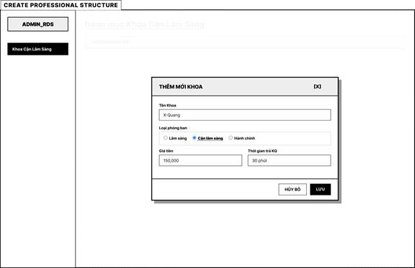
Table 3.4.5a: Screen Definition for Delete Staff Hours
# | Field Name | Type | Mandatory | Max Length | Description
1 | Tên Khoa | Text | Yes | 100 | Enter tên khoa mới (Example: X-Ray)
2 | Loại phòng ban | Radio Button | Yes | - | Select loại: Clinical / Paraclinical / Administrative
3 | Giá tiền | Number | No | 15 | Enter giá dịch vụ của khoa (Example: 150,000)
4 | Thời gian trả KQ | Text | No | 50 | Enter thời gian trả kết quả (Example: 30 minutes)
5 | Hủy bỏ | Button | No | - | Hủy thao tác và đóng popup
6 | Lưu | Button | No | - | Save thông tin khoa mới vào hệ thống
7 | [X] | Button | No | - | Close Add New Department popup

3.4.5.2 Use Case Description
Table 3.4.5b: Use Case Details for Delete Staff Hours
UC ID and Name | UC-58 – Delete Staff Hours
Created By | NamNH | Date Created | March 23, 2026
Primary Actor | Admin | Secondary Actors | System
Description | Allows Admin to delete an existing working hours record for a staff member from the system.
Trigger | Admin clicks “Xóa” on a selected working hours record.
Preconditions | PRE-1: Admin is authenticated. PRE-2: The working hours record exists.
Postconditions | POST-1: The record is deleted. POST-2: The list is refreshed.
Normal Flow
Step | Actor | Action
1 | Admin | Selects a working hours record from the list and clicks “Xóa”.
2 | System | Displays a confirmation dialog asking the Admin to confirm the deletion.
3 | Admin | Clicks “Confirm” to proceed.
4 | System | Deletes the selected working hours record and refreshes the list.
Alternative Flows | N/A
Exceptions | N/A
Priority | High
Frequency of Use | Medium
Business Rules | N/A
Other Information | N/A
Assumptions | N/A

Table 28: Update clinical department structure function description

3.5.4 Create Room

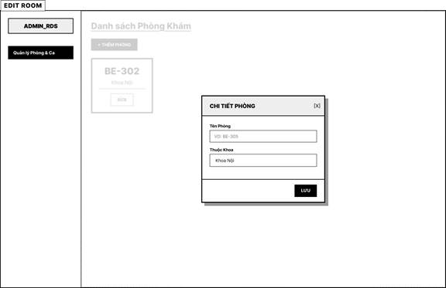
Table 3.3.5a: Screen Definition for Create Clinical Room
# | Field Name | Type | Mandatory | Max Length | Description
1 | Tên Phòng | Text | Yes | 50 | Enter new clinic room name, placeholder: Example: BE-305
2 | Thuộc Khoa | Text | Yes | 100 | Enter tên khoa mà phòng trực thuộc
3 | Lưu | Button | No | - | Save thông tin chi tiết phòng mới
4 | [X] | Button | No | - | Close Room Details popup

3.3.5.2 Use Case Description
Table 3.3.5b: Use Case Details for Create Clinical Room
UC ID and Name | UC-49 – Create Clinical Room
Created By | NamNH | Date Created | March 23, 2026
Primary Actor | Administrator | Secondary Actors | System
Description | Allows Admin to create a new clinical department or room entry.
Trigger | Admin clicks 'Add Room'.
Preconditions | Admin authorized.
Postconditions | New room entry created.
Normal Flow
Step | Actor | Action
1 | Admin | Clicks Add Room.
2 | Admin | Enters metadata.
3 | Admin | Clicks Save.
Alternative Flows | A1: Cancel.
Exceptions | E1: Duplicate Name.
Priority | High
Frequency of Use | Low
Business Rules | None.
Other Information | None.
Assumptions | None.

Table 29: Create room function description

3.5.6 Update Room
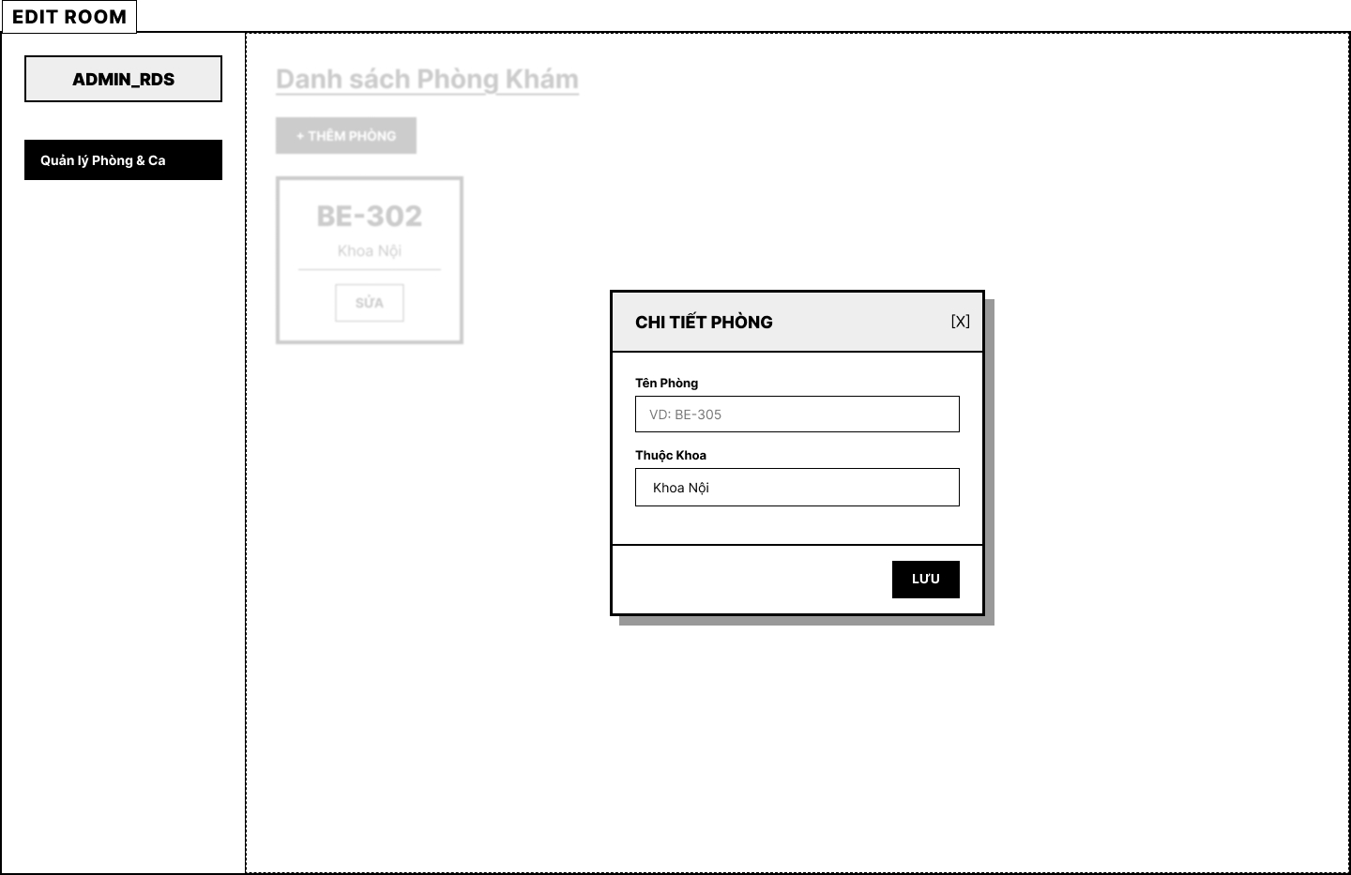
Figure 34: Update Room module

UC ID and Name | UC-53 Update room
Created By | NamNH | Date Created | February 1, 2026
Primary Actor | Admin | Secondary Actors | N/A
Description | Screen Analysis: Update Room  - Room Name (Input): Mandatory field. Maximum length: 255 characters.  - Department (Dropdown): Mandatory selection.  - Notes (Text Area): Optional field. Unlimited characters.
Trigger | The Admin selects a room from the tree list on the Room Management screen, then modifies and saves the details in the right-hand detail panel.
Preconditions | PRE-1: The user is authenticated and logged into the system.  PRE-2: The user has Admin role.  PRE-3: At least one room exists in the system.
Postconditions | POST-1: The room information is updated successfully.  POST-2: If the Admin does not save, the original data remains unchanged.
Normal Flow | 1. The Admin selects a room from the tree list (e.g., BE-302).  2. The system calls GET /api/admin/rooms/detail/{roomId} and displays the room details in the right panel.  3. The right panel shows editable fields: Room Code, Department, Status, and Notes.  4. The Admin modifies the desired fields.  5. The Admin clicks "Save Changes".  6. The system calls PUT /api/admin/rooms/update/{roomId}.  7. The system validates the updated data.  8. The system saves the changes and refreshes the room list.
Alternative Flows | A1 – No changes made If the Admin clicks "Save Changes" without modifying any field, the system still submits the request but no data changes occur.
Exceptions | E1 – Duplicate room code If the updated room code conflicts with another room, the system displays a validation error.  E2 – Room not found If the selected room no longer exists, the system displays an error and refreshes the list.
Priority | High
Frequency of Use | Low
Business Rules | BR-Room-04: Room code must remain unique after update.  BR-Room-05: Room status can be set to Active or Locked.  BR-Room-06: Only Admin can update room details.
Other Information | The room detail is displayed inline in the right panel of a split-view layout. No separate modal is used for editing.
Assumptions | The department dropdown is populated from existing departments in the Clinical Department Structure module.
Table 30: Update room function description

3.6 Work Shift Management

3.6.1 View List Work Shifts
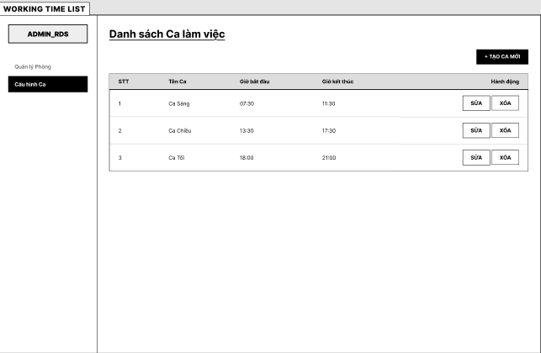
Figure 35: View Working time slot screen

# | Field Name | Type | Mandatory | Max Length | Description
1 | STT | Label | No | 3 | Số thứ tự ca làm việc
2 | Tên Ca | Text | Yes | 50 | Tên của ca làm việc (Ca sáng, Ca chiều, Ca tối...)
3 | Giờ bắt đầu | Time | Yes | 5 | Thời gian bắt đầu ca làm việc
4 | Giờ kết thúc | Time | Yes | 5 | Thời gian kết thúc ca làm việc
5 | Sửa | Button | No |  | Mở màn hình chỉnh sửa ca làm việc
6 | Xóa | Button | No |  | Xóa ca làm việc khỏi hệ thống
7 | Tạo ca mới | Button | No |  | Mở popup tạo ca làm việc mới

UC ID and Name | UC-55 – View List Work Shifts
Created By | MinhMT | Date Created | February 1, 2026
Primary Actor | Admin | Secondary Actors | System
Description | This use case allows Admin to view the list of configured working shifts.  The system displays shift name, start time, end time, and available actions.
Trigger | The Admin selects “Cấu hình Ca” from the menu.
Preconditions | PRE-1: The Admin is authenticated.  PRE-2: The Admin has permission to manage working time configuration.
Postconditions | POST-1: The system displays the working shift list.  POST-2: Admin may choose to create, edit, or delete a shift.
Normal Flow | - The Admin opens the Working Time List screen.  - The system retrieves configured shifts.  - The system displays:  - STT  - Shift Name  - Start Time  - End Time  - Action (Sửa / Xóa)  - The Admin may click:  - “+ Tạo ca mới”  - “Sửa”  - “Xóa”
Alternative Flows
Exceptions | E1 – No Shift Configured  If no working shifts exist:  The system displays empty state message.
Priority | High
Frequency of Use | Medium
Business Rules
Other Information | Shifts are used for doctor schedule configuration.  Shift time must follow 24-hour format or system-defined time format.
Assumptions | Working shifts are global configuration applied to scheduling module.
Table 31.

3.6.2 Create Work Shift
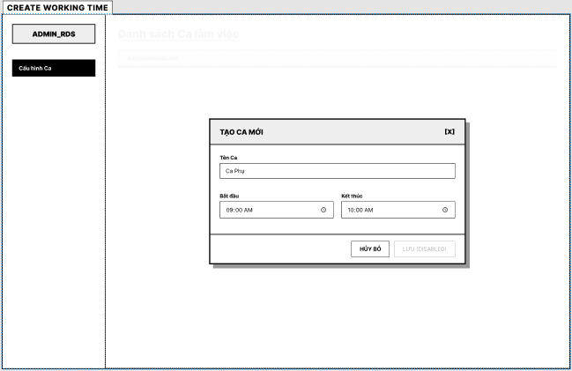
Figure 36.

# | Field Name | Type | Mandatory | Max Length | Description
1 | Tên Ca | Text | Yes | 50 | Nhập tên ca làm việc
2 | Bắt đầu | Time Picker | Yes | 5 | Chọn thời gian bắt đầu ca
3 | Kết thúc | Time Picker | Yes | 5 | Chọn thời gian kết thúc ca
4 | Hủy bỏ | Button | No |  | Đóng popup và không lưu dữ liệu
5 | Lưu | Button | Yes |  | Lưu ca làm việc mới

UC ID and Name | UC-56 – Create Working Shift
Created By | MinhMT | Date Created | February 1, 2026
Primary Actor | Admin | Secondary Actors | System
Description | This use case allows Admin to create a new working shift by specifying shift name, start time, and end time.
Trigger | The Admin clicks “+ Tạo ca mới”
Preconditions | PRE-1: Admin is authenticated.  PRE-2: Admin has permission to configure working shifts.
Postconditions | POST-1: A new working shift is created.  POST-2: The shift appears in the Working Time List.
Normal Flow | - The Admin opens Create Working Shift popup.  - The system displays fields:  - Shift Name  - Start Time  - End Time  - The Admin enters required information.  - The Admin clicks “Lưu”.  - The system validates:  - Required fields  - Start Time < End Time  - No overlapping shift conflict (if policy applied)  - The system saves shift.  - The system displays confirmation message.  - The popup closes and list refreshes.
Alternative Flows | A1 – Cancel  Admin clicks “Hủy bỏ”.  Popup closes without saving.
Exceptions | E1 – Invalid Time  If Start Time ≥ End Time:  System displays validation error.  E2 – Duplicate Shift Name  If shift name already exists:  System displays error message.
Priority | High
Frequency of Use | Medium
Business Rules | BR-WShift-01: Start Time must be earlier than End Time.  BR-WShift-02: Shift time cannot overlap with existing shifts (if configured as exclusive).
Other Information | Shift duration may be used to calculate appointment slots.
Assumptions | Time format follows system standard (HH:mm).
Table 32.

3.6.3 Update working time slot list
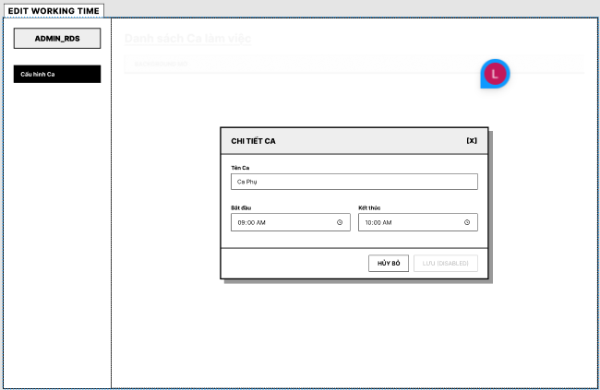
Figure 37.

# | Field Name | Type | Mandatory | Max Length | Description
1 | Tên Ca | Text | Yes | 50 | Hiển thị và cho phép chỉnh sửa tên ca
2 | Bắt đầu | Time Picker | Yes | 5 | Chỉnh sửa giờ bắt đầu ca
3 | Kết thúc | Time Picker | Yes | 5 | Chỉnh sửa giờ kết thúc ca
4 | Hủy bỏ | Button | No |  | Đóng popup mà không lưu thay đổi
5 | Lưu | Button | Yes |  | Lưu ca làm việc mới

UC ID and Name | UC-57 – Update Working Shift
Created By | MinhMT | Date Created | February 1, 2026
Primary Actor | Admin | Secondary Actors | System
Description | This use case allows Admin to modify existing working shift information.
Trigger | The Admin clicks “Sửa” from Working Time List.
Preconditions | PRE-1: Admin is authenticated.  PRE-2: Selected shift exists.
Postconditions | POST-1: Shift information is updated successfully.  POST-2: Updated shift is reflected in the Working Time List.
Normal Flow | - Admin selects a shift and clicks “Sửa”.  - System displays Edit Shift popup with existing data.  - Admin modifies shift name and/or time.  - Admin clicks “Lưu”.  - System validates data.  - System updates shift in database.  - System displays success message.  - Popup closes and list refreshes.
Alternative Flows | A1 – Cancel Update  Admin clicks “Hủy bỏ”.  Popup closes without saving.
Exceptions | E1 – Invalid Time Range  If Start Time ≥ End Time:  System displays validation error.  E2 – Shift In Use  If shift is assigned to existing schedules:  System may prevent editing or restrict time modification.
Priority | High
Frequency of Use | Medium
Business Rules | BR-WShift-01: Start Time must be earlier than End Time.  BR-WShift-02: Shift time cannot overlap with existing shifts (if configured as exclusive).  BR-WShift-03: If doctors and nurses have already been assigned shifts, then after the revision, the revised times will be based on the new schedule, while the old times will remain unchanged.
Other Information | Shift duration may be used to calculate appointment slots.
Assumptions | Time format follows system standard (HH:mm).
Table 33.

3.7 Patient Visit Scheduling

3.7.1 View customer accounts list
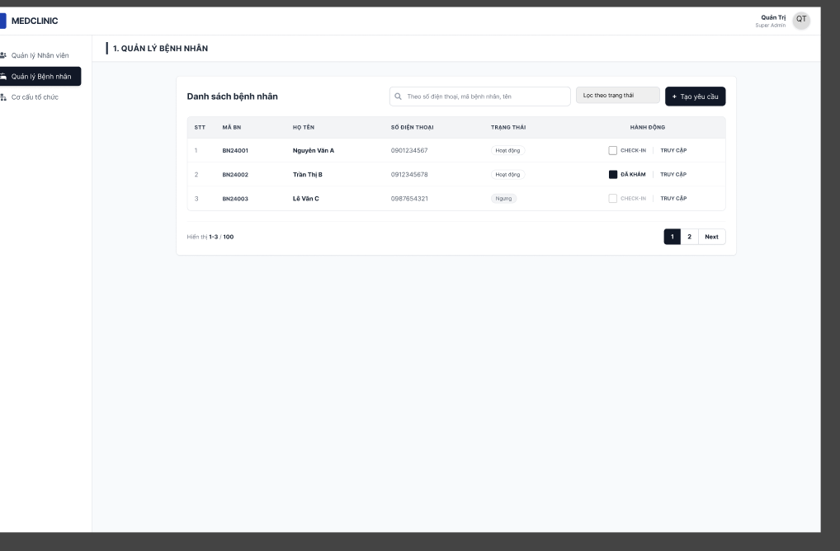
Figure 38.

# | Field Name | Type | Mandatory | Max Length | Description
1 | Danh sách bệnh nhân | Page Title | No |  | Displays the title of the patient list screen.
2 | Theo số điện thoại, mã bệnh nhân, tên | Search Textbox | No | 255 | This field allows the user to search patient records by số điện thoại, mã bệnh nhân, or tên. The system shall trim leading and trailing spaces before searching.
3 | Lọc theo trạng thái | Dropdown / Filter | No |  | This field allows the user to filter the patient list by status.
4 | + Tạo yêu cầu | Button | No |  | Opens the function or form to create a new request for the selected workflow.
5 | STT | Table Column | No |  | Displays the sequential number of each patient record in the list.
6 | MÃ BN | Table Column | No |  | Displays the patient code of each record.
7 | HỌ TÊN | Table Column | No |  | Displays the full name of the patient.
8 | SỐ ĐIỆN THOẠI | Table Column | No |  | Displays the phone number of the patient.
9 | TRẠNG THÁI | Status Badge / Table Column | No |  | Displays the current patient status, such as Hoạt động, ĐÃ KHÁM, CHECK-IN, or Ngưng.
10 | Checkbox | Checkbox | No |  | Allows the user to select a patient record for further action if applicable.
11 | TRUY CẬP | Button | No |  | Redirects the user to the detailed information screen of the selected patient.
12 | Hiển thị 1-3 / 100 | Label | No |  | Displays the current visible record range and total number of records in the list.
13 | 1 / 2 / ... | Pagination Index | No |  | Displays the current page number and allows the user to navigate to a specific page.
14 | Next | Pagination Button | No |  | Moves to the next page of the patient list.

UC ID and Name | UC-08 View customer accounts list
Created By | Giang | Date Created | March 10, 2026
Primary Actor | Cashier, Receptionist | Secondary Actors | Admin
Description | This use case allows Cashier and Receptionist to view, search, and manage the list of registered patients. The system displays patient ID, full name, phone number, status, and available actions (Check-in, Access).
Trigger | The user selects “Quản lý Bệnh nhân” from the menu.
Preconditions | PRE-1: The user is authenticated.  PRE-2: The user has Cashier or Receptionist role
Postconditions | POST-1: The system displays the paginated customer accounts list.  POST-2: No data is modified until a specific action is selected.
Normal Flow | 1. The user opens the Customer Management screen.  2. The system retrieves registered customer records.  3. The system displays the data grid: STT, Mã BN, Họ tên, Số điện thoại, Trạng thái.  4. The system displays action controls: CHECK-IN checkbox, TRUY CẬP button, and "+ Tạo yêu cầu" button.  5. The user can search via "Ô tìm kiếm" or filter via "Lọc trạng thái".
Alternative Flows | A1 – Pagination: The user clicks the "Phân trang" controls to view more records. The system fetches and displays the corresponding page data.
Exceptions | E1 – No Customer Found  If no records match the search or filter criteria: The system displays an empty state message.
Priority | High
Frequency of Use | High
Business Rules | BR-Cust-01: Only Cashier and Receptionist can view and interact with this list.
Other Information | "Ô tìm kiếm" is limited to 255 characters.
Assumptions
Table 34: View customer accounts list function description

3.7.2 Update appointment and customer information
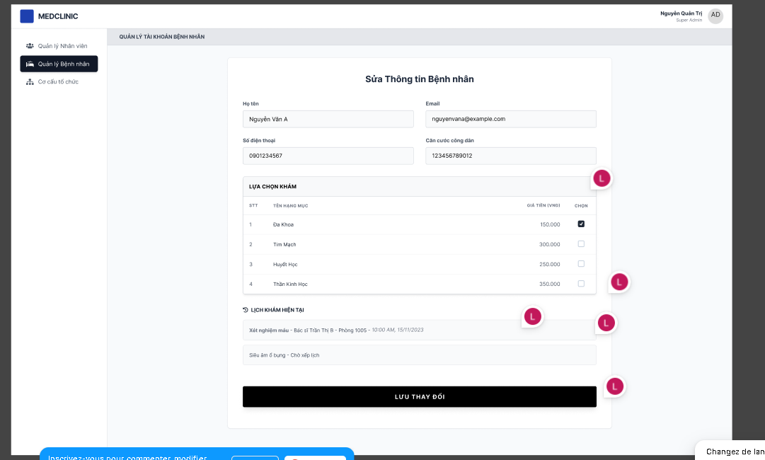
Figure 39.

# | Field Name | Type | Mandatory | Max Length | Description
1 | Sửa Thông tin Bệnh nhân | Page Title | No |  | Displays the title of the patient update screen.
2 | Họ tên | Text | Yes | 255 | This field is mandatory. The system shall trim leading and trailing spaces before validation and saving. The value must not be blank or contain only spaces. The field shall not exceed 255 characters. The field shall only accept valid personal name format. If the value contains numeric characters or invalid special characters, the system shall display a format validation error.
3 | Email | Text | Yes | 30 | This field is mandatory. The system shall trim leading and trailing spaces before validation and saving. The system accepts only valid email format. If the format is invalid, the system shall display “Email không đúng định dạng”.
4 | Số điện thoại | Text | Yes | 11 | This field is mandatory. The system accepts only valid Vietnamese phone numbers. The system shall remove spaces and normalize country code when needed. If the value contains letters, invalid special characters, does not start with 0 after normalization, or has fewer than 9 digits or more than 11 digits, the system shall display “Số điện thoại không hợp lệ”.
5 | Căn cước công dân | Text | Yes | 12 | This field is mandatory. The field accepts digits only and must contain exactly 12 digits. If the value contains letters or special characters, the system shall display a numeric-only validation error. If the length is not equal to 12 digits, the system shall display “CCCD phải gồm 12 chữ số”.
6 | LỰA CHỌN KHÁM | Section | No |  | Displays the examination/service selection list for the patient.
7 | STT | Table Column | No |  | Displays the sequential number of each examination item.
8 | TÊN HẠNG MỤC | Table Column | No |  | Displays the examination or service name.
9 | GIÁ TIỀN (VNĐ) | Table Column | No |  | Displays the price of each examination or service item in VND.
10 | CHỌN | Checkbox Column | No |  | Allows the user to select or unselect examination/service items for the patient.
11 | LỊCH KHÁM HIỆN TẠI | Section | No |  | Displays the patient’s current examination schedule or the current booking status of selected services.
12 | Lưu thay đổi | Button | No |  | Saves all updated patient information and selected examination items when the entered data is valid. The system shall validate all editable fields before saving.

UC ID and Name | UC-10 Update appointment and customer information
Created By | Giang | Date Created | March 10, 2026
Primary Actor | Cashier, Receptionist | Secondary Actors | Admin
Description | This use case allows the user to update patient personal information, select examination rooms, and perform check-in. The system displays an input form, available rooms, total amount, and current schedule.
Trigger | The Cashier or Receptionist clicks the "Truy cập" button for a selected customer from the Customer List screen.
Preconditions | PRE-1: The user is authenticated and logged into the system. PRE-2: The user has Cashier or Receptionist role.
Postconditions | POST-1: The customer's information and selected examination rooms are updated in the database. POST-2: The patient is checked in and their record is pushed to the Cashier queue (if applicable).odified.
Normal Flow | 1. The user opens the Customer Detail screen.  2. The system retrieves the patient's data and available examination services.  3. The system displays: Họ tên, Email, Số điện thoại, Căn cước công dân, Bảng dịch vụ (STT, TÊN HẠNG MỤC, GIÁ TIỀN, CHỌN), LỊCH KHÁM HIỆN TẠI.  4. The user updates personal information if needed.  5. The user selects examination services via checkboxes.  6. The user clicks the "LƯU THAY ĐỔI" button.  7. The system validates and saves the data.
Alternative Flows | A1 – Cancel Update: The user navigates away from the screen without clicking "LƯU THAY ĐỔI". The system discards all changes.
Exceptions | E1 – Missing Mandatory Fields  If the user leaves Họ tên, Email, or Số điện thoại blank: The system displays validation error messages.
Priority | High
Frequency of Use | High
Business Rules | BR-Appt-01: Time slots and queue numbers are auto-assigned by the system upon service selection.
Other Information | Email is limited to 30 characters, Phone must be 10 digits.
Assumptions | Examination service configurations are active in the system.
Table 35: Update appointment and customer information function description

3.7.3 Create Forward Examination Request to Doctor
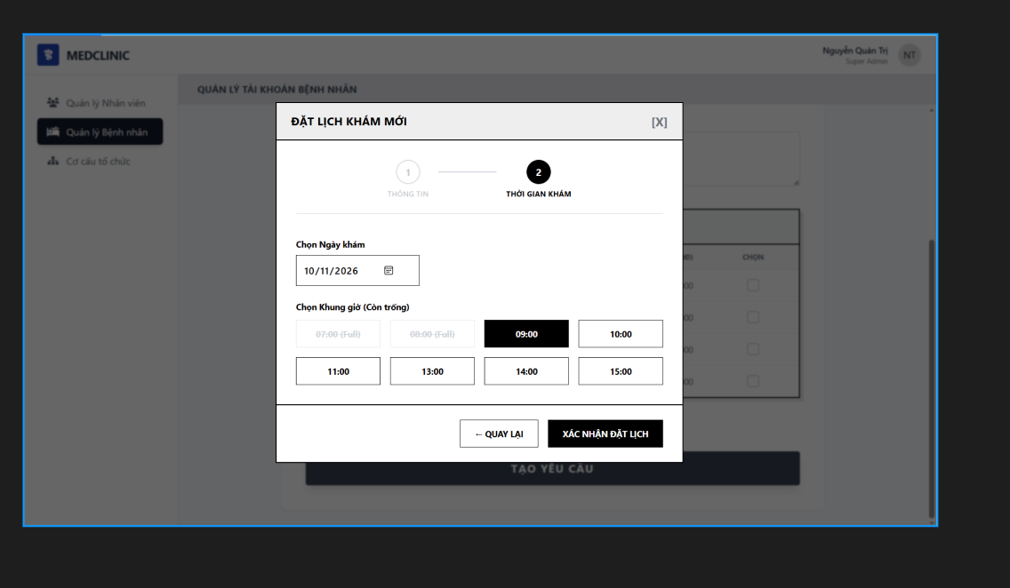
Figure 40.

# | Field Name | Type | Mandatory | Max Length | Description
1 | ĐẶT LỊCH KHÁM MỚI | Modal Title | No |  | Displays the title of the appointment booking modal.
2 | [X] | Icon Button | No |  | Closes the modal without saving or confirming the appointment.
3 | THÔNG TIN | Step Indicator | No |  | Displays the previous step in the booking process.
4 | THỜI GIAN KHÁM | Step Indicator | No |  | Displays the current step of the booking process for selecting examination date and time.
5 | Chọn Ngày khám | Date | Yes | 10 | This field is mandatory. The user selects the examination date using the date picker. The displayed format shall be dd/MM/yyyy.
6 | Chọn Khung giờ (Còn trống) | Time Slot Selection | Yes |  | This field is mandatory. The system displays available time slots for the selected examination date. The user can select only one available time slot at a time. Unavailable or fully booked time slots shall be displayed as disabled and cannot be selected.
7 | 07:00 (Full) / 08:00 (Full) / 09:00 / 10:00 / 11:00 / 13:00 / 14:00 / 15:00 | Time Slot Button | No |  | Displays each available or unavailable examination time slot. Full slots are disabled. Selected slot is highlighted and used for appointment confirmation.
8 | ← QUAY LẠI | Button | No |  | Returns the user to the previous step without confirming the selected appointment time.
9 | XÁC NHẬN ĐẶT LỊCH | Button | No |  | Confirms the appointment booking using the selected date and time slot. The system shall only allow confirmation when all required information is valid and a time slot has been selected.

UC ID and Name | UC-11 Create Forward Examination Request to Doctor
Created By | Giang | Date Created | March 10, 2026
Primary Actor | Receptionist | Secondary Actors | N/A
Description | This use case allows the user to register a new appointment for a patient. The system displays an input form with mandatory indicators (*), reason for visit, service selection, and an optional manual scheduling popup.
Trigger | The Cashier or Receptionist clicks the "+ Tạo yêu cầu" (Create Request) button from the Customer List screen.
Preconditions | PRE-1: The user is authenticated and logged into the system. PRE-2: The user has Cashier or Receptionist role.
Postconditions | POST-1: A new appointment and patient record (if new) are successfully created in the database. POST-2: The patient is placed in the corresponding examination queue.
Normal Flow | 1. The user opens the Create Medical Appointment screen.  2. The system retrieves available examination categories and rooms.  3. The system displays: Họ và tên, Email, SĐT, Số CCCD, Lý do khám, Lựa chọn khám, Checkbox "Chọn thời gian khám".  4. The user fills in the required personal details and selects examination rooms.  5. The user clicks “TẠO YÊU CẦU” (with "Chọn thời gian khám" unchecked).  6. The system auto-schedules and saves the appointment.
Alternative Flows | A1 – Manual Time Selection: The user checks "Chọn thời gian khám" and clicks "TẠO YÊU CẦU". The system opens a popup. The user selects "Chọn Ngày khám" and an available "Khung giờ", then clicks "XÁC NHẬN ĐẶT LỊCH".
Exceptions | E1 – No Service Selected  If the user does not select any service: The system displays an error message requiring selection.
Priority | High
Frequency of Use | High
Business Rules | BR-Create-01: Họ tên, Email, Số điện thoại, and at least one service are strictly mandatory.
Other Information | "Lý do khám" is a text area with no character limits.
Assumptions | Master data for examination categories and active rooms is correctly configured in the backend.
Table 36: Create medical appointment function description

3.7.4 Collect Prepayment for General Examination (cash/QR)

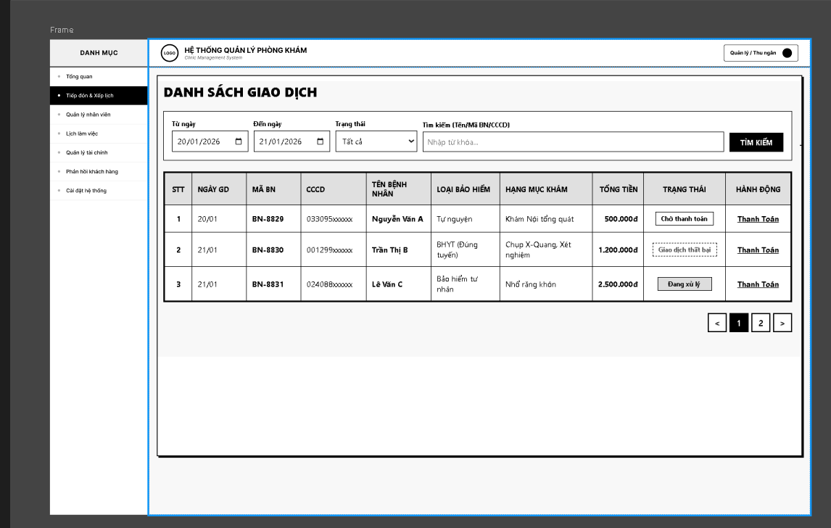
Figure 41.

# | Field Name | Type | Mandatory | Max Length | Description
1 | Từ ngày | Date | No | 10 | This field allows the user to select the start date for filtering transaction records. The displayed format shall be dd/MM/yyyy.
2 | Đến ngày | Date | No | 10 | This field allows the user to select the end date for filtering transaction records. The displayed format shall be dd/MM/yyyy.
3 | Trạng thái | Dropdown / Filter | No |  | This field allows the user to filter transaction records by payment status, such as Tất cả, Chờ thanh toán, Đang xử lý, or Giao dịch thất bại.
4 | Tìm kiếm (Tên/Mã BN/CCCD) | Search Textbox | No | 255 | This field allows the user to search transaction records by Tên bệnh nhân, Mã BN, or CCCD. The system shall trim leading and trailing spaces before searching.
5 | TÌM KIẾM | Button | No |  | Executes the search and filtering function based on the entered conditions.
6 | STT | Table Column | No |  | Displays the sequential number of each transaction record in the list.
7 | NGÀY GD | Table Column | No |  | Displays the transaction date of each record.
8 | MÃ BN | Table Column | No |  | Displays the patient code of each transaction record.
9 | CCCD | Table Column | No |  | Displays the patient identification number of each record.
10 | TÊN BỆNH NHÂN | Table Column | No |  | Displays the full name of the patient.
11 | LOẠI BẢO HIỂM | Table Column | No |  | Displays the insurance type applied to the transaction, such as Tự nguyện, BHYT, or Bảo hiểm tư nhân.
12 | HẠNG MỤC KHÁM | Table Column | No |  | Displays the examination or service items included in the transaction.
13 | TỔNG TIỀN | Currency / Table Column | No |  | Displays the total payment amount of the transaction in VND.
14 | TRẠNG THÁI | Status Badge / Table Column | No |  | Displays the current payment status of the transaction, such as Chờ thanh toán, Đang xử lý, or Giao dịch thất bại.
15 | Thanh Toán | Button | No |  | Redirects the user to the payment processing screen or payment detail flow for the selected transaction.
16 | < | Pagination Button | No |  | Moves to the previous page of the transaction list.
17 | 1 / 2 / ... | Pagination Index | No |  | Displays the current page number and allows the user to navigate to a specific page.
18 | > | Pagination Button | No |  | Moves to the next page of the transaction list.

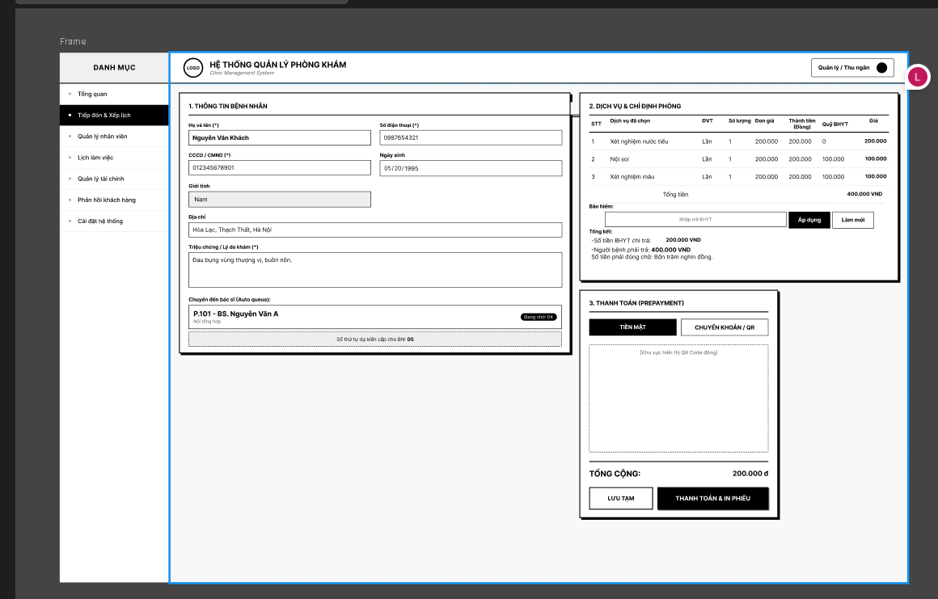
Figure 42.

# | Field Name | Type | Mandatory | Max Length | Description
1 | 1. THÔNG TIN BỆNH NHÂN | Section Title | No |  | Displays the patient information section used for review during payment processing.
2 | Họ và tên | Text | Yes | 100 | Displays the patient full name. This field accepts valid name format only and shall not exceed 100 characters.
3 | Số điện thoại (*) | Text | Yes | 11 | Displays the patient phone number. This field accepts only valid Vietnamese phone number format.
4 | CCCD / CMND (*) | Text | Yes | 12 | Displays the patient identification number. This field accepts digits only and must contain exactly 12 digits.
5 | Ngày sinh | Date | Yes | 10 | Displays the patient date of birth. The displayed format shall be dd/MM/yyyy.
6 | Giới tính | Dropdown / Text | Yes |  | Displays the patient gender. Allowed values are Nam, Nữ, or Khác.
7 | Địa chỉ | Text | No | 255 | Displays the patient address information. Maximum length is 255 characters.
8 | Triệu chứng / Lí do đến viện (*) | Textarea | Yes | 255 | Displays the symptom or reason for visit. This field is required and shall not exceed 255 characters.
9 | Chuyển đến bác sĩ (Queue request) | Card / Info Display | No |  | Displays the assigned doctor or target examination room information for the current queue request.
10 | 2. DỊCH VỤ VÀ CHI PHÍ PHÒNG | Section Title | No |  | Displays the service list and fee calculation section.
11 | STT | Table Column | No |  | Displays the sequential number of each service item.
12 | Dịch vụ điều trị | Table Column | No |  | Displays the treatment or examination service name.
13 | ĐVT | Table Column | No |  | Displays the unit of measurement of each service item.
14 | Số lượng | Table Column | No |  | Displays the quantity of each service item.
15 | Đơn giá | Currency / Table Column | No |  | Displays the unit price of each service item in VND.
16 | Thành tiền (Đồng) | Currency / Table Column | No |  | Displays the calculated subtotal amount of each service item in VND.
17 | Giảm BHYT | Currency / Table Column | No |  | Displays the insurance-covered discount amount applied to each service item.
18 | Giá | Currency / Table Column | No |  | Displays the final payable amount of each service item after discount.
19 | Tổng tiền | Currency Label | No |  | Displays the total service amount before or after insurance calculation, depending on applied rules.
20 | Bảo hiểm | Section Label | No |  | Displays the insurance application area for fee adjustment.
21 | Mã thẻ BHYT | Text | No | 255 | Allows the user to enter the health insurance card number for benefit calculation.
22 | Áp dụng | Button | No |  | Applies the entered insurance information and recalculates the payment amount.
23 | Làm mới | Button | No |  | Clears or resets the insurance information and recalculates the original payment amount.
24 | Tổng viện phí trước BHYT | Summary Label | No |  | Displays the total amount before insurance is applied.
25 | Số tiền BHYT chi trả | Summary Label | No |  | Displays the amount covered by insurance.
26 | Số tiền phải đóng của bệnh nhân | Summary Label | No |  | Displays the remaining amount that the patient must pay.
27 | 3. THANH TOÁN (PAYMENT METHOD) | Section Title | No |  | Displays the payment method selection and confirmation area.
28 | TIỀN MẶT | Button / Payment Method Tab | No |  | Selects cash as the payment method.
29 | CHUYỂN KHOẢN / QR | Button / Payment Method Tab | No |  | Selects bank transfer or QR payment as the payment method.
30 | QR Code Display Area | QR Display / Placeholder | No |  | Displays the dynamic QR code and transfer content when CHUYỂN KHOẢN / QR is selected.
31 | TỔNG CỘNG | Currency Label | No |  | Displays the final total payment amount.
32 | LƯU TẠM | Button | No |  | Saves the current payment record temporarily without finalizing the transaction.
33 | THANH TOÁN & IN PHIẾU | Button | No |  | Completes the payment transaction and prints the payment receipt.

UC ID and Name | UC-12 Collect Prepayment for General Examination (cash/QR)
Created By | Giang | Date Created | March 10, 2026
Primary Actor | Cashier | Secondary Actors
Description | This use case allows the user to view, search, and filter the list of patient transactions (pending or paid). The system displays patient ID, name, service, total amount, and status.
Trigger | The user selects the Transaction Management (Quản lý giao dịch) section from the menu.
Preconditions | POST-1: The system displays the paginated list of transactions.  POST-2: The user can select a pending transaction to proceed with payment.
Postconditions | POST-1: The transaction status is updated to "Paid" in the database. POST-2: The system generates a printable medical receipt/invoice.
Normal Flow | 1. The user opens the Transaction List screen.  2. The system retrieves the list of transactions.  3. The system displays: STT, Mã BN, Họ và tên, Dịch vụ, Tổng tiền, Trạng thái, and the "Thanh toán" button.  4. The user may search using the "Ô tìm kiếm" or filter by status/date.  5. The user clicks "Thanh toán" on a pending transaction to open the payment detail screen.
Alternative Flows | A1 – Empty List: If no transactions match the search/filter criteria, the system displays an empty state message.
Exceptions | E1 – Load Failure  If the system fails to retrieve data, an error message is displayed.
Priority | High
Frequency of Use | High
Business Rules | BR-Trans-01: Only Cashier and Receptionist can access this list.
Other Information | Search input is limited to 255 characters.
Assumptions
Table 37: General examination payment function description

3.8 Appointment Management

3.9 Send General Feedback to Clinic

3.10 Payments & Receipts

3.11 Daily Patient Queue Management

3.11.1 View List of Appointments for the Day
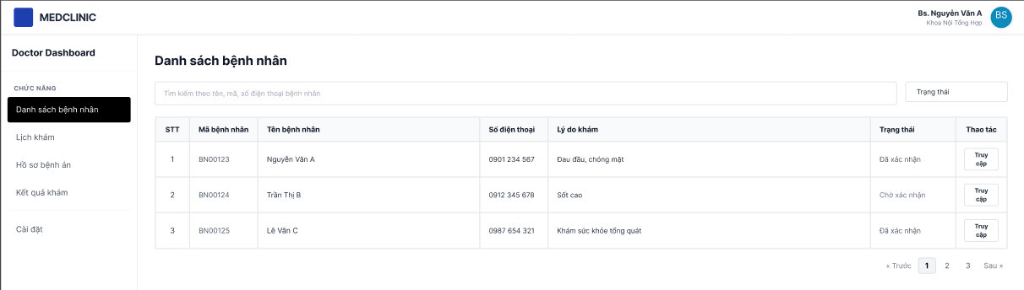
Figure 43.

# | Field Name | Type | Mandatory | Max Length | Description
1 | Thanh tìm kiếm bệnh nhân | Text |  | 100 | Filter by patient name, Patient ID, or phone number
2 | Lọc theo trạng thái | Dropdown |  |  | Filters list by appointment status (e.g. Confirmed, Pending)
3 | Bảng danh sách bệnh nhân | Display |  |  | Columns: STT, Patient ID (Mã BN), Patient Name, Phone, Reason for visit, Status, Action
4 | Trạng thái lịch hẹn | Display |  |  | Shows "Đã xác nhận" (Confirmed) or "Chờ xác nhận" (Pending confirmation)
5 | Truy cập hồ sơ bệnh nhân | Button |  |  | Redirects the doctor to the patient's specific medical record / examination interface
6 | Điều hướng phân trang | Button |  |  | Interactive "Trước" / "Sau" links and page numbers (1, 2, 3…)

UC ID and Name | UC-24 View List of Appointments for the Day
Created By | DangNTH | Date Created | February 1, 2026
Primary Actor | Specialist doctor, clinical doctor, nurse | Secondary Actors
Description | Section 1: Search & Filter Controls  - Search Bar: Text input. Allows searching by patient name, Patient ID, or phone number.  - Filter by Status ("Trạng thái"): Dropdown menu. Filters the list based on appointment statuses.  Section 2: Patient Data Table  - Table Columns: No. (STT), Patient ID (Mã bệnh nhân), Patient Name (Tên bệnh nhân), Phone Number (Số điện thoại), Reason for visit (Lý do khám), Status (Trạng thái), and Action (Thao tác).  - Status Column: Display text indicating current state (e.g., "Đã xác nhận", "Chờ xác nhận").  - "Truy cập" Button: Action button. Redirects the doctor to the patient's specific medical record/examination interface.  Section 3: Pagination Control  - Pagination Links: Interactive text links ("Trước", "Sau") and page numbers ("1", "2", "3") allowing navigation through multiple pages of patients.
Trigger | The user selects the "Danh sách bệnh nhân" option from the "CHỨC NĂNG" sidebar menu on the Doctor Dashboard.
Preconditions | - PRE-1: The user is authenticated and logged into the system with a Doctor role.  - PRE-2: The system has synchronized the appointment schedule for the current date.
Postconditions | POST-1: The system displays the patient list matching the doctor's assignment and any active filters.
Normal Flow | - The user logs into the Doctor Dashboard.  - The system displays the "Danh sách bệnh nhân" screen by default or upon selection.  - The system lists patients in a table with the following columns: No. (STT), Patient ID (Mã bệnh nhân), Patient Name (Tên bệnh nhân), Phone Number (Số điện thoại), Reason for visit (Lý do khám), Status (Trạng thái), and Action (Thao tác).  - The system displays specific appointment statuses such as "Đã xác nhận" (Confirmed) or "Chờ xác nhận" (Pending confirmation).  - The user can use the search bar to find a patient by name, ID, or phone number.  - The user can filter patients by status using the "Trạng thái" dropdown menu.  - The user clicks the "Truy cập" button to open a specific patient's medical record.  - The user navigates through multiple pages using the pagination control (e.g., "Trước", "1", "2", "3", "Sau").
Alternative Flows | A1 – Search Patient: The user enters a specific Patient ID (e.g., "BN00123") in the search bar; the system filters the table in real-time.
Exceptions | - E1 – No Appointments: If no patients are scheduled for the day, the system displays a "No data available" message in the table area.
Priority | High
Frequency of Use | High
Business Rules | BR-DOC-01: The list must only display patients assigned to the currently logged-in Doctor (e.g., "Bs. Nguyễn Văn A").  BR-DOC-02: Clicking "Truy cập" must redirect the user to the "Hồ sơ bệnh án" (Medical Record) for that specific patient.
Other Information | The sidebar includes other related functions: "Lịch khám" (Schedule), "Hồ sơ bệnh án" (Medical Records), "Kết quả khám" (Examination Results), and "Cài đặt" (Settings).
Assumptions | The system automatically refreshes the status of appointments as they are updated by the reception desk.
Table 38.

3.11.2 View examination order details
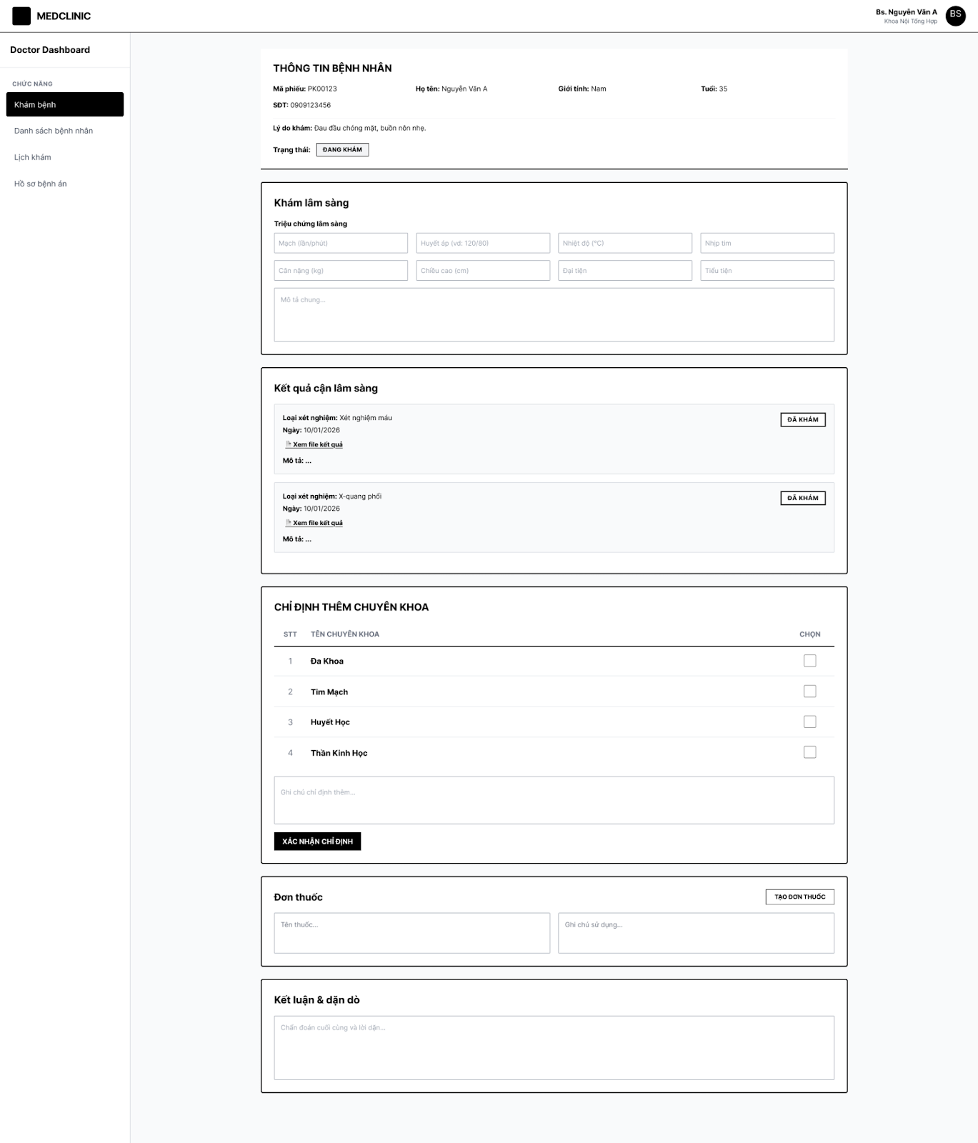
Figure 44.

# | Field Name | Type | Mandatory | Max Length | Description
1 | Mã phiếu | Display |  |  | Read-only patient visit identifier
2 | Họ tên / Giới tính / Tuổi / SĐT / Lý do khám | Display |  |  | Read-only patient demographics (Section 1)
3 | Trạng thái lượt khám | Display |  |  | "Trạng thái: ĐANG KHÁM" tag
4 | Chỉ số sinh tồn (Mạch, Huyết áp, Nhiệt độ, Nhịp tim, Cân nặng, Chiều cao, Đại tiện, Tiểu tiện) | Text / Numeric |  | 20 | Input fields for clinical examination values (Section 2)
5 | Mô tả chung | Text |  | 500 | Text area for qualitative clinical observations
6 | Thông tin xét nghiệm cận lâm sàng | Display |  |  | Shows test type, date, and status badge "ĐÃ KHÁM"
7 | Xem file kết quả | Link |  |  | Opens attached diagnostic files (e.g. X-ray images)
8 | Danh sách chuyên khoa chỉ định thêm | Checkbox |  |  | Multi-select for additional departments (e.g. Đa Khoa, Tim Mạch, Thần Kinh Học…)
9 | Ghi chú chỉ định thêm | Text |  | 500 | Text area for referral instructions
10 | Xác nhận chỉ định | Button |  |  | Submits selected specialty referrals
11 | Tên thuốc | Text |  | 200 | Prescription input field for medicine name
12 | Ghi chú sử dụng thuốc | Text |  | 500 | Directions for medication use
13 | Tạo đơn thuốc | Button |  |  | Generates prescription document (MSG-031)
14 | Chẩn đoán cuối cùng & dặn dò | Text |  | 1000 | Text area for final diagnosis and doctor's advice

UC ID and Name | View examination order details.
Created By | DangNTH | Date Created | February 1, 2026
Primary Actor | Specialist doctor, nurse | Secondary Actors | NA
Description | Section 1: Patient Information ("THÔNG TIN BỆNH NHÂN")  - Personal Details: Read-only display of Patient Code (Mã phiếu), Full Name (Họ tên), Gender (Giới tính), Age (Tuổi), Phone Number (SĐT), and Reason for visit (Lý do khám).  - Status Badge: Display tag indicating the current session status (e.g., "Trạng thái: ĐANG KHÁM").  Section 2: Clinical Examination ("Khám lâm sàng")  - Vital Signs: Text/Numeric input fields for Pulse, Blood pressure, Temperature, Heart rate, Weight, Height, Bowel, and Urinary functions.  - General Description ("Mô tả chung"): Text area for qualitative observations.  Section 3: Paraclinical Results ("Kết quả cận lâm sàng")  - Test Information: Display text showing the test type and date.  - Status Badge: Read-only tag (e.g., "ĐÃ KHÁM") indicating completion.  - "Xem file kết quả" Link: Action link. Opens attached diagnostic files (e.g., X-ray images).  Section 4: Specialty Referrals ("CHỈ ĐỊNH THÊM CHUYÊN KHOA")  - Specialty List: Checkbox inputs for selecting additional departments (e.g., "Đa Khoa", "Tim Mạch").  - Notes ("Ghi chú chỉ định thêm"): Text area for referral instructions.  - "XÁC NHẬN CHỈ ĐỊNH" Button: Primary action button. Submits the selected referrals.  Section 5: Prescription & Conclusion  - Prescription Inputs: Text areas for entering Medicine names ("Tên thuốc") and Usage instructions ("Ghi chú sử dụng").  - "TẠO ĐƠN THUỐC" Button: Action button to generate the prescription.  - Conclusion ("Chẩn đoán cuối cùng..."): Text area for final diagnosis and doctor's advice.
Trigger | The user clicks the "Truy cập" button for a patient in the "Danh sách bệnh nhân" screen or selects "Khám bệnh" from the sidebar.
Preconditions | - PRE-1: The user is authenticated and logged in as a Doctor.  - PRE-2: A patient has been selected for examination.
Postconditions | POST-1: The medical examination data is updated and saved to the patient's electronic health record upon confirmation.
Normal Flow | - The system displays the THÔNG TIN BỆNH NHÂN (Patient Information) section including Patient Code (Mã phiếu), Full Name (Họ tên), Gender (Giới tính), Age (Tuổi), Phone Number (SĐT), Reason for visit (Lý do khám), and current status (Trạng thái: ĐANG KHÁM).  - The Doctor views and inputs data into the Khám lâm sàng (Clinical Examination) section:  - Vital signs: Respiratory rate, Blood pressure, Temperature, Heart rate, Weight, Height, BMI.  - General description (Mô tả chung).  - The Doctor reviews the Kết quả cận lâm sàng (Paraclinical Results) section, which displays test types (e.g., Xét nghiệm máu, X-quang phổi), dates, and status (ĐÃ KHÁM).  - The Doctor can click "Xem file kết quả" to view attached diagnostic files.  - The Doctor select additional referrals in the CHỈ ĐỊNH THÊM CHUYÊN KHOA section (e.g., Đa Khoa, Tim Mạch, Huyết Học, Thần Kinh Học) and adds notes.  - The Doctor clicks "XÁC NHẬN CHỈ ĐỊNH" to finalize specialty referrals.  - The Doctor enters medication details in the Đơn thuốc (Prescription) section and clicks "TẠO ĐƠN THUỐC".  - The Doctor provides the final assessment in the Kết luận & dặn dò (Conclusion & Advice) text area.
Alternative Flows | A1 – Skip sections: The Doctor may leave non-mandatory fields blank if they are not applicable to the current examination.
Exceptions | - E1 – Missing required data: If mandatory vital signs or conclusions are missing when saving, the system prompts the user to complete the fields.
Priority | High
Frequency of Use | High
Business Rules | BR-EX-01: Paraclinical results must be marked as "ĐÃ KHÁM" before they can be reviewed in this screen.  BR-EX-02: Patient status must remain "ĐANG KHÁM" (Examining) until the final conclusion is saved and the session is closed.
Other Information | The interface includes a sidebar with navigation to "Danh sách bệnh nhân", "Lịch khám", and "Hồ sơ bệnh án".
Assumptions | - Paraclinical data is automatically synced from the laboratory and imaging departments.
Table 39.

3.11.3 Upload file examination result
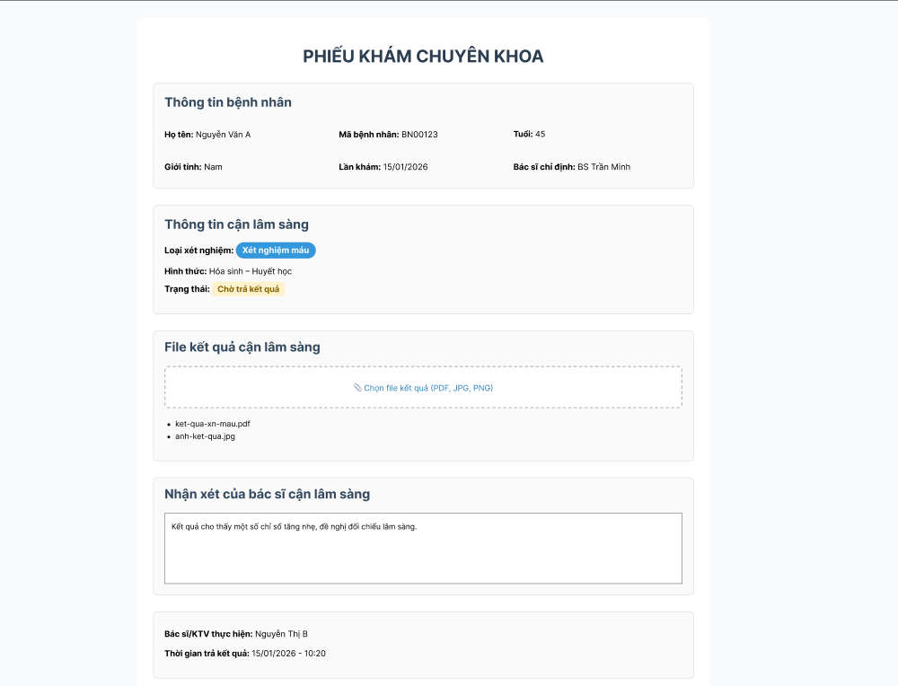

# | Field Name | Type | Mandatory | Max Length | Description
1 | Họ tên / Mã BN / Tuổi / Giới tính / Lần khám / Bác sĩ chỉ định | Display |  |  | Read-only patient information (Section 1)
2 | Loại xét nghiệm | Display |  |  | Read-only e.g. "Xét nghiệm máu"
3 | Hình thức xét nghiệm | Display |  |  | Read-only e.g. "Hóa sinh – Huyết học"
4 | Trạng thái | Display |  |  | "Chờ trả kết quả" — current paraclinical service status
5 | Vùng tải file kết quả | File Upload |  | 10MB/file | Interactive dashed-border box with action link "Chọn file kết quả (PDF, JPG, PNG)" to trigger file selection from the local device
6 | Danh sách file đã tải lên | Display |  |  | Dynamic list showing uploaded file names (e.g. "ket-qua-xn-mau.pdf", "anh-ket-qua.jpg")
7 | Nhận xét của bác sĩ cận lâm sàng | Text |  | 2000 | Large text area for entering detailed diagnostic comments or findings
8 | Bác sĩ / KTV thực hiện | Display |  |  | Read-only auto-populated name of the performing staff
9 | Thời gian trả kết quả | Display |  |  | Read-only auto-populated date and time when results were returned

UC ID and Name | Upload file examination result / Update examination result
Created By | DangNTH | Date Created | February 1, 2026
Primary Actor | Doctor | Secondary Actors | NA
Description | Section 1: Patient Information ("Thông tin bệnh nhân"): Read-only display of Full Name (Họ tên), Patient ID (Mã bệnh nhân), Age (Tuổi), Gender (Giới tính), Visit Date (Lần khám), and Referring Doctor (Bác sĩ chỉ định).  Section 2: Paraclinical Information ("Thông tin cận lâm sàng"): Read-only display of Test Type (Loại xét nghiệm - e.g., "Xét nghiệm máu"), Form (Hình thức - e.g., "Hóa sinh – Huyết học"), and Status Badge (Trạng thái - e.g., "Chờ trả kết quả").  Section 3: Result File Upload ("File kết quả cận lâm sàng"):  - Upload Area: Interactive dashed-border box with an action link "Chọn file kết quả (PDF, JPG, PNG)" to trigger file selection from the local device.  - File List: Dynamic list showing uploaded file names (e.g., "ket-qua-xn-mau.pdf", "anh-ket-qua.jpg").  Section 4: Medical Observations ("Nhận xét của bác sĩ cận lâm sàng"):  - Observations Text Area: Large text input field for entering detailed diagnostic comments or findings.  Section 5: Verification Details:  - Technician Information: Read-only display of the performing staff's name (Bác sĩ/KTV thực hiện).  - Timestamp: Read-only display of the date and time when results were returned (Thời gian trả kết quả).
Trigger | The user clicks on a paraclinical service requiring result input from the examination detail screen.
Preconditions | - PRE-1: The user is authenticated and has the role of Doctor or Technician.  - PRE-2: The paraclinical service has been ordered and is in "Chờ trả kết quả" status.
Postconditions | POST-1: The result files and observations are successfully saved to the patient's record.  POST-2: The service status changes to "Đã khám".
Normal Flow | - The system displays the patient and test information sections.  - The user clicks "Chọn file kết quả" to upload one or more diagnostic files.  - The system displays the names of the selected files.  - The user enters diagnostic comments in the "Nhận xét" text area.  - The system automatically populates the technician's name and the current timestamp.  - The user confirms and saves the data.
Alternative Flows | A1 – File Removal: The user removes a file from the list before final submission.
Exceptions | E1 – Unsupported File Format: System denies upload for files other than PDF, JPG, or PNG
Priority | High
Frequency of Use | High
Business Rules | BR-UP-01: Only .pdf, .jpg, and .png file formats are permitted.  BR-UP-02: Completion of this form must trigger a status update to "ĐÃ KHÁM" in the main examination order view.
Other Information | Distinction is maintained between the referring doctor (Bác sĩ chỉ định) and the technician (Bác sĩ/KTV thực hiện).
Assumptions | Stable server connection is available for file storage during upload.

Created By | DangNTH | Date Created | February 1, 2026
Primary Actor | Doctor | Secondary Actors | NA
Description | Section 1: Patient Information ("Thông tin bệnh nhân"): Read-only display of Full Name (Họ tên), Patient ID (Mã bệnh nhân), Age (Tuổi), Gender (Giới tính), Visit Date (Lần khám), and Referring Doctor (Bác sĩ chỉ định).  Section 2: Paraclinical Information ("Thông tin cận lâm sàng"): Read-only display of Test Type (Loại xét nghiệm - e.g., "Xét nghiệm máu"), Form (Hình thức - e.g., "Hóa sinh – Huyết học"), and Status Badge (Trạng thái - e.g., "Chờ trả kết quả").  Section 3: Result Files ("File kết quả cận lâm sàng"):  - Upload/Display Area: Interactive box showing action link "Chọn file kết quả (PDF, JPG, PNG)".  - File List: Display of attached file names (e.g., "ket-qua-xn-mau.pdf", "anh-ket-qua.jpg").  Section 4: Medical Observations ("Nhận xét của bác sĩ cận lâm sàng"):  - Observations Text Area: Input field containing diagnostic comments (e.g., "Kết quả cho thấy một số chỉ số tăng nhẹ...").  Section 5: Finalization and Export:  - Staff Details: Read-only display of Performing Staff (Bác sĩ/KTV thực hiện) and Return Timestamp (Thời gian trả kết quả).  - "Xác nhận & trả kết quả" Button: Primary action button. Submits the final results and triggers the export/report generation process.
Trigger | The user completes the diagnostic findings and clicks the "Xác nhận & trả kết quả" button.
Preconditions | - PRE-1: The user is authenticated as a Doctor or Technician.  - PRE-2: At least one result file has been uploaded or an observation has been entered.
Postconditions | POST-1: The examination status is updated to "ĐÃ KHÁM" in the main system.  POST-2: A formal examination report is generated and available for printing or patient access
Normal Flow | - The user reviews the patient and test information displayed on the screen.  - The user ensures result files are correctly listed in the upload area.  - The user reviews or completes the diagnostic observations in the text area.  - The user verifies the performing staff name and timestamp.  - The user clicks the "Xác nhận & trả kết quả" button.  - The system validates the data, saves the results, and generates the exportable report.
Alternative Flows | A1 – Update Observations: The user modifies the text in the Observations area before clicking the confirmation button.
Exceptions | E1 – Submission Error: If the system cannot save the data due to a connection issue, it displays an error and remains on the current screen.
Priority | High
Frequency of Use | High
Business Rules | BR-EXP-01: The "Xác nhận & trả kết quả" button is only enabled when required fields (files or observations) are present.  BR-EXP-02: Clicking the confirmation button must lock the record from further editing by the performing technician.
Other Information | The interface uses a distinct green color for the final confirmation button to distinguish it from standard input actions.
Assumptions | The system automatically generates a PDF version of the final report upon confirmation.

3.12 Prescription Management
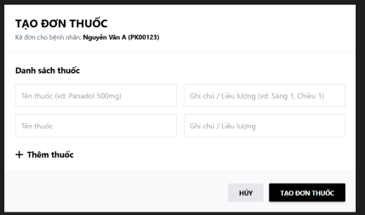
Figure 15: Create prescription screen

# | Field Name | Type | Mandatory | Max Length | Description
1 | Screen Title | Label | No | 255 | Hiển thị tiêu đề "TẠO ĐƠN THUỐC"
2 | Patient Information | Lable | No | 255 | Display patient name and code (e.g., Nguyen Van A - PK00123)
3 | Medication Name (line 1) | Text | Yes | 255 | Enter the medication name (e.g., Panadol 500mg)
4 | Notes / Dosage (line 1) | Text | Yes | 255 | Enter the dosage (e.g., Morning 1, Afternoon 1)
5 | Medication Name (line 2) | Text | No | 255 | Enter additional medication names
6 | Notes / Dosage (line 2) | Text | No | 255 | Enter the dosage for the corresponding medication
7 | Add Medication | Button | No |  | Add a new medication entry line
8 | Cancel | Button | No |  | Cancel the prescription creation operation
9 | Create Prescription | Button | Yes |  | Confirm and create the prescription

UC ID and Name | UC-03 – Create prescription
Created By | HaPN | Date Created | February 1, 2026
Primary Actor | Admin | Secondary Actors | Doctor, Nurse
Description | This screen allows doctors to create a prescription for a patient after examination. The interface shows the patient information at the top and a medication list section where the doctor can add multiple medicines with dosage instructions. The user can dynamically add more medicines using the “+ Thêm thuốc” action. At the bottom, action buttons allow cancelling or confirming the prescription creation.
Trigger | The doctor selects the "Create Prescription" function from the examination screen or patient record.
Preconditions | PRE-1: The user is logged into the system.  PRE-2: The user has Doctor or Prescription privileges.  PRE-3: Patient information already exists in the system.  PRE-4: The patient's medical record is currently open.
Postconditions | POST-1: If successful, the prescription is saved to the system. The prescription is linked to the patient and the appointment. A complete list of medications is recorded.  POST-2: If unsuccessful, no data is saved and the system displays an error message.
Normal Flow | - The doctor opens the "Create Prescription" screen.  - The system displays patient information.  - The doctor enters:  - Drug Name.  - Notes/Dosage.  - The doctor selects "Add Drug" if they want to add a new drug.  - The doctor reviews the drug list.  - The doctor clicks "Create Prescription".  - The system checks for data validity.  - The system successfully saves the prescription.  - A "Prescription created successfully" message is displayed.
Alternative Flows | A1 – Add more medication  - At step 4, the doctor clicks Add medication.  - The system creates a new medication entry line.  - Return to step 3.  A2 – Cancel prescription  - The doctor clicks the Cancel button.  - The system closes the screen.  - No data is saved.
Exceptions | E1 – Missing Drug Information  - If the drug name is blank:  The system displays a warning:  - "Vui lòng nhập tên thuốc"  - Saving is not allowed.  E2 – System Error  - If an error occurs while saving data:  - An error message is displayed.  - The user is asked to try again.
Priority | High
Frequency of Use | Very frequently
Business Rules | BR-Staff-10: Each prescription must belong to one patient.  BR-Staff-11:Prescriptions must include at least one medication.  BR-Staff-12: Dosage must be clearly entered.  BR-Staff-13:Only doctors are authorized to create prescriptions.  BR-Staff-14:Prescriptions cannot be created without selecting a patient.
Other Information | The system can integrate a drug catalog for automatic suggestions.  The prescription printing function can be expanded.
Assumptions | The drug catalog already exists in the system.  The database connection is stable.  Users have been trained to use the system.

3.13 Medical Record Management
3.13.1 View examined customer history list
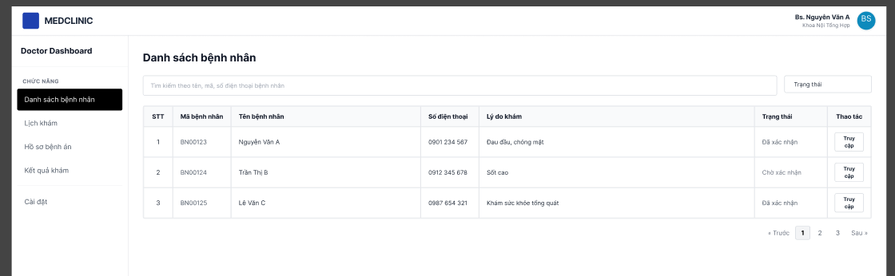
Figure 16: View examined customer history list

# | Field Name | Type | Mandatory | Max Length | Description
1 | Screen name | Label | No | 255 | Display the title "List of Patients"
2 | Doctor's name | Label | No | 255 | Display the logged-in doctor's name.
3 | Search bar | Text | No | 255 | Search by patient name, patient code, or phone number.
4 | State filter | Dropdown | No | 50 | Filter the list by status (Confirmed, Awaiting Confirmation, Examined, etc.)
5 | STT | Label | No | 3 | Patient number
6 | Patient ID | Label | No | 20 | Display patient code (e.g., BN00123)
7 | Patient's name | Label | No | 255 | Display the patient's full name.
8 | Phone number | Label | No | 10 | Display the patient's phone number.
9 | Lý do khám | Label | No | 255 | Show the reason for the visit.
10 | Status | Label | No | 50 | Display examination status (Confirmed, Awaiting Confirmation, Examined)
11 | Operation (Access) | Button |  |  | Open the file details or perform the examination.
12 | Pagination | Button | No |  | Navigate between pages (Previous, 1, 2, 3, Next)
13 | Navigation menu | Button | No |  | Navigate to the functions (Patient List, Appointment Schedule, Medical Records, Examination Results, Settings)

UC ID and Name | UC-03 – View examined customer history list
Created By | HaPN | Date Created | February 1, 2026
Primary Actor | Doctor, Nurse | Secondary Actors | Doctor, Nurse
Description | UI Layout:  This screen is part of the Doctor Dashboard and allows doctors to view and manage the list of patients who have registered for examination. The interface includes a navigation sidebar, a search/filter area, and a main table displaying patient information and examination status. Doctors can view patient details or proceed with examination actions from this screen.
Trigger | This use case is triggered when a Doctor or Nurse accesses the Patient List function from the system control panel.
Preconditions | PRE-1: The doctor or nurse has logged into the system.  PRE-2: The user has access to the patient list.  PRE-3: Patient information and medical history already exist in the system.
Postconditions | POST-1: If the list of patients already examined is displayed, the Doctor or Nurse can select a patient to view their examination details.  POST-2: If patient data is unavailable, the system displays an appropriate message.
Normal Flow | 1. The doctor or nurse opens the Patient List function.  2. The system displays the patient list including:  - Serial Number  - Patient Code  - Patient Name  - Phone Number  - Reason for Examination  - Examination Status  3. The user can enter search information (name, patient code, phone number).  4. The system filters the list by search information.  5. The doctor or nurse selects Access to open the patient's medical record.
Alternative Flows | A1 – Patient Search  1. The user enters a search keyword.  2. The system displays a list of patients matching the keyword.  A2 – View Other Pages  1. If the list is long:  2. The user selects the next or previous page.
Exceptions | E1 – Data Not Found  1. The system displays the message: “No patient records found”.  E2 – System Error  1. If an error occurs while loading data:  - The system displays an error message.  - The user can reload the page.
Priority | High
Frequency of Use | Very frequently
Business Rules | BR-Staff-1: Only authorized Doctors and Nurses can view the patient list.  BR-Staff-2: Each patient must have a unique patient ID.  BR-Staff-3: The patient list is searchable and paginationable.  BR-Staff-4: The displayed information must accurately reflect the data in the system.
Other Information | The system supports searching by patient name, patient code, or phone number.  The system supports pagination when the patient list is large.
Assumptions | Patient data has been stored in the database.  The system is stable and has a network connection.  Users have been granted access to the system.

3.13.2 View medical record details
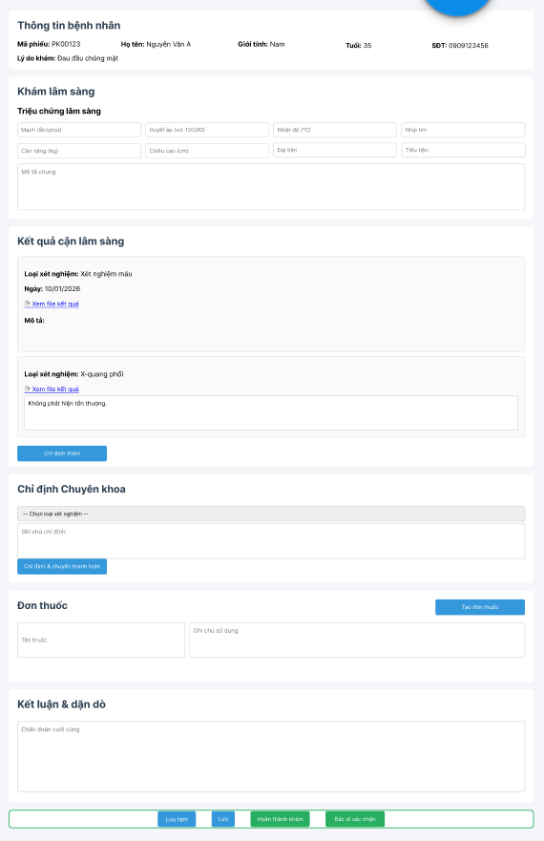
Figure 17: View medical record details

# | Field Name | Type | Mandatory | Max Length | Description
1 | Ticket code | Label | No | 20 | Display the examination ticket code (e.g., PK00123)
2 | Full name | Label | No | 255 | Display patient name
3 | Sex | Label | Yes | 10 | Display gender
4 | Year old | Label | No | 3 | Display patient's age
5 | Phonenumber | Label | No | 10 | Display phone number
6 | Reason for examination | Label | No | 255 | Show the reason for the visit.

UC ID and Name | UC-03 – View medical record details
Created By | HaPN | Date Created | February 1, 2026
Primary Actor | Doctor | Secondary Actors | Nurse
Description | This screen allows the doctor to view patient information, record clinical examination data, review laboratory results, prescribe tests or medicines, and finalize the medical examination. The interface is divided into multiple sections including patient information, clinical examination, laboratory results, specialist orders, prescription, and final diagnosis. At the bottom, action buttons allow saving or completing the examination process.
Trigger | The use case is triggered when Doctor selects "Access a patient's medical record" from the patient list.
Preconditions | PRE-1: The doctor has logged into the system.  PRE-2: The doctor has permission to update the patient's medical record.  PRE-3: The patient's medical record has been created.  PRE-4: The patient's information exists in the system.
Postconditions | 1. Success:  - Patient examination information is saved to the system.  - Patient records are updated with the latest data.  2. Failure:  - Data is not saved if an error occurs.  - The system displays an error message.
Normal Flow | 1. The doctor accesses the patient list.  2. The doctor selects the patient to be examined.  3. The system displays the patient's information and medical record.  4. The doctor enters clinical symptom information, including:  - Pulse  - Blood pressure  - Temperature  - Heart rate  - Weight  - Height  - Medical history  - General description  5. The doctor views or updates the laboratory test results.  6. The doctor enters specialist orders (if needed).  7. The doctor creates a prescription for the patient.  8. The doctor enters the conclusion and treatment instructions.  9. The doctor selects one of the following actions:  - Save temporarily  - Save  - Complete examination  10. The system saves the information to the database.  11. The system displays a save success message.
Alternative Flows | A1 – Save temporarily only  - Doctor selects Save temporarily.  - The system has not saved the information completely.  A2 – Order additional tests  - Doctor selects Order additional tests.  - The system creates a new test request.  A3 – Create prescription  - Doctor selects Create prescription.  - The system opens the screen for entering the list of medications.
Exceptions | E1 – Missing Required Information  - If important data is missing:  The system displays a message requesting input.  E2 – System Error  - If an error occurs while saving data:  The system displays an error message.  Doctor, please try again.
Priority | High
Frequency of Use | Very frequently
Business Rules | Each medical record must be linked to a patient.  Only doctors can update medical records.  Nurses can only view or assist in data entry according to their permissions.  Medical records must have a conclusion before the examination is completed.
Other Information | The system can integrate test data from the lab system.  Prescriptions can be printed or sent to the pharmacy system.
Assumptions | Patient data already exists in the system.  The user permission system is functioning correctly.  The database connection is stable.

3.14 Financial Management
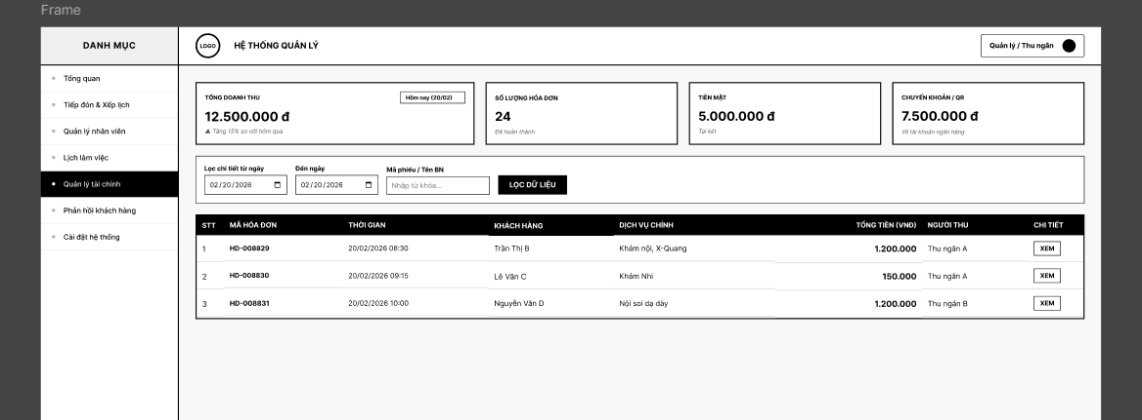
Figure 1: View Financial list

# | Field Name | Type | Mandatory | Max Length | Description
1 | Total revenue | Label | No | 20 | Display total revenue for the selected date.
2 | Select a date | Date | No |  | Select a date to view statistics
3 | Number of invoices | Label | No | 10 | Display the total invoice amount
4 | Cash | Label | No | 20 | Total amount payable in cash
5 | Bank Transfer / QR Code | Label | No | 20 | Total payment via bank transfer or QR code
6 | From the date | Date | No |  | Select the start date for data filtering.
7 | Until the day | Date | No |  | Select the data filtering end date.
8 | Invoice Code / Customer Name | Text | No | 255 | Search by invoice number or patient name
9 | Filter data | Button | No |  | Perform list filtering.
10 | STT | Label | No | 3 | Numerical order
11 | Invoice code | Label | No | 20 | Display invoice code
12 | Time | Label | No | 20 | Payment time
13 | Client | Label | No | 255 | Patient's name
14 | Main services | Label | No | 255 | Service usage
15 | Total amount (VNĐ) | Label | No | 20 | Total amount (VNĐ)
16 | Collector | Label | No | 255 | Cashier
17 | See details | Button | No |  | Open the invoice details screen.
18 | Pagination | Button | No |  | Navigate between pages

UC ID and Name | UC-12 – View Working Time List
Created By | HAPN | Date Created | February 1, 2026
Primary Actor | Admin | Secondary Actors | Cashier
Description | This screen allows administrators or receptionists to monitor and manage clinic financial transactions. The interface consists of a left navigation menu, summary financial statistics, filter/search controls, and a table displaying invoice records. Users can view transaction details and track revenue information for clinic services.
Trigger | The use case is triggered when the user selects "View invoice details" from the financial list.
Preconditions | PRE-1: The user is logged into the system.  PRE-2: The user has permission to view financial information.  PRE-3: The invoice to be viewed exists in the system.
Postconditions | Success  - The invoice details are displayed in full.  Failure  - The system displays a message if the invoice does not exist.
Normal Flow | 1. The user opens the financial list.  2. The user selects a specific invoice.  3. The user clicks View.  4. The system displays the invoice details, including:  - Invoice code  - Payment time  - Customer information  - List of services used  - Total amount  - Payment method  - Payer  5. The user views the invoice information.
Alternative Flows | .A1 – Return to list  The user returns to the invoice list to select a different invoice.
Exceptions | E1 – Invoice does not exist  The system displays the message: “Invoice not found”.  E2 – Data loading error  The system displays an error message when the invoice details cannot be loaded.
Priority | High
Frequency of Use | Frequent
Business Rules | Invoices cannot be modified after payment.  Financial information must be stored accurately.
Other Information | The system supports invoice printing.  Invoices can be exported as PDFs.
Assumptions | The invoice data has been saved in the system.  The access control system is functioning correctly.

3.15 Feedback Management
3.16 Staff Working Hours Management
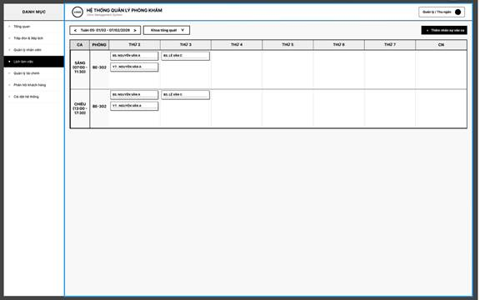
Table 3.3.6a: Screen Definition for Update Clinical Room
# | Field Name | Type | Mandatory | Max Length | Description
1 | Điều hướng tuần (<, >) | Button | No | - | Chuyển sang tuần trước hoặc tuần tiếp theo
2 | Tuần hiển thị | Label | No | - | Display khoảng thời gian tuần hiện tại (VD: Tuần 05: 01/02 – 07/02/2026)
3 | Khoa tổng quát | Dropdown | No | - | Lọc lịch theo khoa
4 | + Thêm nhân sự vào ca | Button | No | - | Mở popup xếp ca trực mới
5 | CA | Label | No | - | Display shift name trực (Sáng, Chiều) kèm khung giờ
6 | PHÒNG | Label | No | - | Display mã phòng khám (VD: BE-302)
7 | Thứ 2 – CN | Grid Column | No | - | Display lịch phân công BS/YT theo từng ngày trong tuần
8 | Tag nhân sự (BS./YT.) | Label | No | - | Display tên bác sĩ hoặc y tá được phân công trong ô lịch

3.3.6.2 Use Case Description
Table 3.3.6b: Use Case Details for Update Clinical Room
UC ID and Name | UC-50 – Update Clinical Room
Created By | NamNH | Date Created | March 23, 2026
Primary Actor | Admin | Secondary Actors | System
Description | Modify existing room details.
Trigger | Clicks 'Edit' on room.
Preconditions | Room exists.
Postconditions | Data updated.
Normal Flow
Step | Actor | Action
1 | Admin | Selects an existing clinical room and clicks “Sửa”.
2 | System | Displays the Update Clinical Room form pre-filled with current data.
3 | Admin | Modifies the room name and clicks “Save”.
4 | System | Validates the input and saves the updated room information.
Alternative Flows | N/A
Exceptions | N/A
Priority | High
Frequency of Use | Medium
Business Rules | N/A
Other Information | N/A
Assumptions | N/A
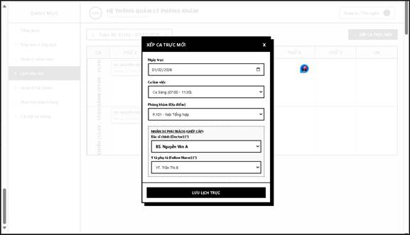
Table 3.4.1a: Screen Definition for Staff Working Hours List
# | Field Name | Type | Mandatory | Max Length | Description
1 | Ngày trực | Date Picker | Yes | - | Select ngày xếp ca trực mới
2 | Ca làm việc | Dropdown | Yes | - | Select ca làm việc (VD: Ca Sáng 07:00 – 11:30)
3 | Phòng khám (Địa điểm) | Dropdown | Yes | - | Select phòng khám thực hiện ca (VD: P.101 – Nội Tổng hợp)
4 | Bác sĩ chính (Doctor) | Dropdown | Yes | - | Select bác sĩ phụ trách (VD: BS. Nguyễn Văn A)
5 | Y tá phụ tá (Follow Nurse) | Dropdown | Yes | - | Select y tá ghép cặp hỗ trợ (VD: YT. Trần Thị B)
6 | Lưu lịch trực | Button | No | - | Confirm and save new shift to the system
7 | [X] | Button | No | - | Close Schedule New Shift popup

3.4.1.2 Use Case Description
Table 3.4.1b: Use Case Details for Staff Working Hours List
UC ID and Name | UC-54 – Staff Working Hours List
Created By | NamNH | Date Created | March 23, 2026
Primary Actor | Admin | Secondary Actors | System
Description | Allows Admin to view the working hours and attendance records of all staff members. The system displays a searchable list with staff name, check-in time, check-out time, and working status.
Trigger | Menu select.
Preconditions | Authorized.
Postconditions | List displayed.
Normal Flow
Step | Actor | Action
1 | Admin | Selects “Quản lý giờ làm việc” from the menu.
2 | System | Retrieves working hours records from the database.
3 | System | Displays the list with staff name, check-in time, check-out time, and status.
4 | Admin | Optionally searches or filters the list by staff name or date.
Alternative Flows | N/A
Exceptions | N/A
Priority | High
Frequency of Use | Medium
Business Rules | N/A
Other Information | N/A
Assumptions | N/A

4. Non-Functional Requirements

4.1 External Interfaces
The system is designed to ensure reliable interaction between users, external services, and underlying infrastructure components in accordance with the project’s technical stack.

4.1.1 User Interfaces
- The system shall be accessed through modern web browsers, primarily Google Chrome and Microsoft Edge, which are officially supported.
- The user interface shall be developed using NextJS, ensuring a responsive design that adapts smoothly to desktop, tablet, and mobile screen sizes.
- All system modules (User Management, Project Management, Class Management, Contest Management, Payment, and Notification modules) shall follow a unified UI design guideline to ensure visual consistency and usability.
- Navigation elements, buttons, and forms shall maintain consistent placement and behavior across all screens to reduce the learning curve for users.

4.1.2 External Systems and Services
- Payment Integration:
The system shall integrate with an external online payment gateway (e.g., VNPay) to support secure and reliable payment transactions for project enrollment and related services.
- Email and Notification Services:
The system shall connect to email service providers (e.g., Google Mail) to send system notifications such as account verification, password recovery, payment confirmations, and administrative announcements.
- Authentication Services:
The system shall support integration with third-party authentication providers (e.g., Google Sign-In) to allow users to authenticate using Single Sign-On (SSO) mechanisms.

4.1.3 Hardware and Deployment Interfaces
- The system shall be deployed on a cloud-based infrastructure using Amazon Web Services (AWS).
- The deployment architecture shall support:
  - Load balancing to distribute traffic evenly.
  - Horizontal scaling to handle increasing numbers of users.
  - High availability to ensure system stability and minimal downtime.
- The backend services shall be capable of running on virtualized or containerized environments (e.g., Docker) to improve portability and scalability.

4.1.4 Data Interfaces
- The system shall support importing data from standard file formats such as CSV and Microsoft Excel (XLSX) for administrative operations.
- The primary database management system shall be MySQL, used for storing user data, project information, class data, contest results, and transaction records.
- All data access operations shall ensure transactional integrity and consistency.
- Automated backup and recovery mechanisms shall be implemented to minimize the risk of data loss.

4.2 Quality Attributes

4.2.1 Usability
- The system shall provide an intuitive and user-friendly interface that can be easily understood by users without technical backgrounds.
- New users shall be able to perform basic operations (such as browsing projects, enrolling in classes, and managing profiles) without requiring formal training.
- The system shall provide clear visual cues, descriptive labels, and logical menu structures to help users understand available functionalities.
- The web application shall be fully compatible with Google Chrome and Microsoft Edge browsers.
- User experience shall remain consistent across all modules and devices.

4.2.2 Reliability
- The system shall implement strong security mechanisms, including authentication, authorization, and data protection.
- Users shall be required to authenticate using passwords that meet minimum complexity requirements (at least 8 characters, including uppercase letters, lowercase letters, numbers, and special characters).
- User passwords shall be securely encrypted using BCrypt or SHA-512 hashing algorithms.
- When a password reset is requested, the system shall send a verification code or reset link to the user’s registered email address.
- All user inputs shall be validated and sanitized to prevent common security vulnerabilities such as SQL injection and cross-site scripting (XSS).
- The system shall enforce role-based access control to ensure that users can only access functions and data appropriate to their roles.
- Token-based authentication using JSON Web Tokens (JWT) with refresh tokens shall be used to manage user sessions securely.

4.2.3 Performance
The system shall meet the following performance requirements to ensure smooth operation under expected workloads. Performance testing shall be conducted using tools such as Apache JMeter.
Page Load Time
- All web pages shall load within 5 seconds under normal network conditions.
- Core pages such as Login, Dashboard, Project List, Class Detail, and Contest Detail shall prioritize fast rendering.
Data Processing and API Response Time
- Data retrieval operations shall complete within 4 seconds after a user request is submitted.
- Backend APIs shall be optimized using appropriate indexing and query optimization techniques.
Response Time Targets
- Login, search, and dashboard operations:
  - Average response time ≤ 1 second.
  - Maximum response time ≤ 2 seconds under normal load.
- Payment confirmation responses shall be returned within 1 second under standard conditions.
Throughput and Capacity
- The system shall support at least 25 concurrent transactions per second, including learning activities, quiz submissions, and contest-related actions.
- The initial deployment shall support approximately:
  - 5,000 registered users.
  - 200–400 concurrent active users, depending on usage patterns.

4.2.4 Maintainability
- The backend codebase shall follow clean coding standards and best practices for Java Spring Boot development.
- The system shall provide comprehensive technical documentation and user manuals.
- The architecture shall be modular, allowing new features to be added with minimal impact on existing components.
- System monitoring and visualization tools (e.g., Grafana dashboards) may be integrated to support maintenance and operational oversight.

4.2.5 Scalability
- The system shall support horizontal scaling to accommodate future growth in user numbers and system load.
- The database design shall allow for replication or sharding if required.
- The system architecture shall be prepared for future integration with mobile applications.

4.2.6 Portability
- The system shall be deployable on Windows Server environments.
- The web application shall be compatible with multiple modern browsers.
- The system shall be cloud-ready and optimized for deployment on AWS infrastructure.

5. Requirement Appendix

5.1 Business Rules

ID | Rule Definition
BR-01 | Users must be authenticated before accessing protected functions.
BR-02 | Only accounts with Active status are allowed to log in successfully.
BR-03 | Passwords must contain at least 8 characters, including at least 1 uppercase letter, 1 lowercase letter, 1 number, and 1 special character.
BR-04 | Passwords must be encrypted/hashed when stored in the system.
BR-05 | The system must create and maintain a valid session/token while the user is active and must invalidate it on logout.
BR-06 | After successful login, the system must assign permissions and redirect the user to the appropriate screen based on role.
BR-07 | The Forgot Password flow may continue only after the OTP sent to the registered email has been successfully verified.
BR-08 | Self-registration applies only to Customers; other roles cannot self-register from the Register screen.
BR-09 | Unique registration data such as Email / Phone Number / Citizen ID must not be duplicated.
BR-10 | The Change Password flow while logged in must validate the current password correctly.
BR-11 | New Password and Confirm Password must match in the change password/reset password flows.
BR-Register-01 | The Register screen is only used to create a Customer account.
BR-Register-02 | Full Name, Email, Phone Number, Citizen ID, Password, and Confirm Password are all required.
BR-Register-03 | Full Name accepts only letters and spaces; numbers and special characters are not allowed.
BR-Register-04 | Email must be in a valid format, contain @ and a valid domain, must not contain consecutive dots, and must have a total length of 6 to 30 characters.
BR-Register-05 | Phone Number must be a valid Vietnamese phone number; after normalization, it must start with 0 and contain 9–11 digits.
BR-Register-06 | Phone Number may be normalized by removing internal spaces and converting the +84 prefix to 0.
BR-Register-07 | Citizen ID must contain exactly 12 digits, start with 0, and must not contain letters, spaces, or special characters.
BR-Register-08 | Password is masked by default, supports show/hide, and must comply with password strength rules.
BR-Register-09 | Confirm Password must exactly match Password.
BR-Register-10 | The Register button is enabled only when all field-level validations pass.
BR-Register-11 | Email, Phone Number, and Citizen ID must be unique in the system.
BR-Register-12 | If Email, Phone Number, or Citizen ID already exists, the system must block registration and display the corresponding warning.
BR-Register-13 | After successful registration, the account is created with Unverified status and the system sends an OTP to the registered email.
BR-Register-14 | OTP is required to activate the account; the registration OTP is valid for 5 minutes.
BR-Register-15 | The Resend Code button is disabled when the OTP screen first opens and is only enabled again after the current OTP expires.
BR-Register-16 | If the user has not yet verified the account and logs in again, the system must require OTP verification and automatically send a new OTP.
BR-Register-17 | Clicking the X icon on the Register or OTP screen must return the user to Login and clear unsaved temporary data.
BR-Profile-01 | Required fields on the Profile screen must not be left blank.
BR-Profile-02 | Email on the Profile screen must be valid and unique.
BR-Profile-03 | Phone Number on the Profile screen must match the system-defined format.
BR-Profile-04 | Only authenticated users may update their own profile.
BR-Emp-01 | Only Admin, Manager, and Cashier can access the Employee List screen.
BR-Emp-02 | Available actions on the employee list depend on the logged-in user's role/permissions.
BR-Emp-03 | Staff accounts with Locked status are not allowed to access the system.
BR-Emp-04 | Employee search must support Employee ID / Name / Email.
BR-Emp-05 | All fields in the Create Employee popup are required.
BR-Emp-06 | Staff Email and Citizen ID must be unique in the system.
BR-Emp-07 | The system must generate a random password for newly created staff accounts.
BR-Emp-08 | The generated password must be sent to the registered email of the employee.
BR-Staff-10 | Admin can view and update information for all staff accounts.
BR-Staff-11 | Manager and Cashier can only view/update their own account information.
BR-Staff-12 | Doctor and Nurse accounts must be displayed using the profile screen, not the staff detail popup.
BR-Staff-13 | When accessing a staff profile from the Employee Management module, Change Password must not be displayed.
BR-Patient-01 | Only Admin can access the Patient Management screen.
BR-Patient-02 | The patient list must support search by Patient Code / Name / Email / Citizen ID.
BR-Patient-03 | The patient list must support filtering by Account Status.
BR-Patient-04 | Only Admin can create patient accounts.
BR-Patient-05 | Patient Email, Phone Number, and Citizen ID must be unique.
BR-Patient-06 | The system must automatically generate a unique Patient Code for each patient.
BR-Patient-07 | The system must generate a random password and send it to the patient by email after successful account creation.
BR-Patient-08 | Only Admin can view and update patient profiles.
BR-Patient-09 | Required fields when updating a patient include: Full Name, Gender, Date of Birth, Citizen ID, Phone Number, Email, Address.
BR-Dept-01 | Only Admin can access the Clinical Department Structure module.
BR-Dept-02 | The department structure must be displayed in a hierarchical tree by block: Clinical / Para-clinical / Administrative.
BR-Dept-03 | Each department must display capacity information where applicable.
BR-Dept-04 | Department name must be unique in the system.
BR-Dept-05 | If the department type is Para-clinical, the corresponding specialty must be selected from the predefined list.
BR-Dept-06 | Only Admin can create a new department.
BR-Dept-07 | When updating, the department name must still remain unique.
BR-Dept-08 | Only Admin can edit department information.
BR-Dept-09 | Changing the department type may affect the visibility/required status of the Para-clinical specialty field.
BR-Room-01 | Room code must be unique across the system.
BR-Room-02 | Each room must belong to exactly one department.
BR-Room-03 | Only Admin can create rooms.
BR-Room-04 | When updating, room code must still remain unique.
BR-Room-05 | Room status may only be set to the statuses supported by the system, which in the current document are Active / Locked.
BR-Room-06 | Only Admin can update room information.
BR-WShift-01 | Start Time must be earlier than End Time.
BR-WShift-02 | Work shifts must not overlap with existing shifts if the system is configured with an exclusive scheduling mechanism.
BR-WShift-03 | If a shift has already been assigned to a doctor/nurse, after editing, the old schedule remains under the old time and the new schedule applies according to the updated time.
BR-CustList-01 | Only Cashier and Receptionist can access the customer accounts list in the scheduling module.
BR-CustList-02 | Cashier and Receptionist can both fully use the functions Search / Filter / Check-in / Create Request / Access Details on this screen.
BR-CustList-03 | The default list must be sorted by the most recently created/updated records in descending order.
BR-CustDet-01 | Only Cashier and Receptionist can access and update the Customer Detail & Appointment Update screen.
BR-CustDet-02 | Examination time and queue number must be auto-scheduled by the system; users are not allowed to enter or edit them manually.
BR-CustDet-03 | The Check-in action is required to save any changes on this screen.
BR-Appt-01 | Only Cashier and Receptionist can create medical appointment requests.
BR-Appt-02 | The user must select at least one examination room/service to create a valid request.
BR-Appt-03 | The system must check real-time slot availability to avoid double-booking when scheduling manually.
BR-Pay-01 | Only Cashier and Receptionist can access and process the general examination payment screen.
BR-Pay-02 | Total Patient Pays must not be negative after applying health insurance.
BR-Pay-03 | The user must select a payment method before the Pay & Print Receipt button is enabled.
BR-DOC-01 | The daily patient list must display only patients assigned to the currently logged-in doctor.
BR-DOC-02 | The Access button in the patient list must open the correct medical record of that patient.
BR-EX-01 | Paraclinical results can only be viewed on the examination screen when they are in COMPLETED status.
BR-EX-02 | The patient status must remain IN EXAMINATION until the final conclusion is saved and the examination session is closed.

Table 40.

5.2 Common Requirements
- The system shall provide full support for the Vietnamese language, ensuring that all user interface elements, system messages, notifications, and instructional content are displayed consistently in Vietnamese.
- Date and time information shall be processed using the server’s standardized timezone (UTC+7). When presented to users, date and time values shall be displayed accurately according to this timezone to ensure consistency across the system.
- User passwords shall comply with defined complexity rules, requiring a minimum length of 8 characters, including at least one uppercase letter, one lowercase letter, one numeric digit, and one special character.
- System error messages shall be designed to be clear and understandable for end users, while avoiding the disclosure of internal system details or sensitive technical information that could compromise security.

5.3 Application Messages List
# | Message code | Message Type | Context | Content
1 | MSG-001 | Error | Login – invalid credentials | Đăng nhập thất bại. Vui lòng kiểm tra lại email/tên đăng nhập hoặc mật khẩu.
2 | MSG-002 | Error | Login – account locked | Tài khoản của bạn đã bị khóa. Vui lòng liên hệ quản trị hệ thống.
3 | MSG-003 | Success | Login – login successful | Đăng nhập thành công.
4 | MSG-004 | Success | Create shift – successful | Tạo ca làm việc thành công.
5 | MSG-005 | Success | Update shift – successful | Cập nhật ca làm việc thành công.
6 | MSG-006 | Success | Delete shift – successful | Xóa ca làm việc thành công.
7 | MSG-007 | Error | Create shift – invalid time | Thời gian bắt đầu phải nhỏ hơn thời gian kết thúc.
8 | MSG-008 | Error | Create shift – duplicate name | Tên ca làm việc đã tồn tại. Vui lòng chọn tên khác.
9 | MSG-009 | Info | Shift list – empty state | Chưa có ca làm việc nào được cấu hình.
10 | MSG-010 | Success | Appointment – step 1 saved | Thông tin đặt lịch đã được lưu tạm thời.
11 | MSG-011 | Error | Appointment – missing required field | Vui lòng điền đầy đủ thông tin bắt buộc.
12 | MSG-012 | Success | Appointment – created | Đặt lịch khám thành công.
13 | MSG-013 | Info | Payment history – empty | Không có lịch sử thanh toán.
14 | MSG-014 | Error | System – data retrieval error | Hệ thống gặp lỗi khi tải dữ liệu. Vui lòng thử lại sau.
15 | MSG-015 | Error | Medical record – not found | Không tìm thấy hồ sơ khám.
16 | MSG-016 | Info | Health record – empty | Không có dữ liệu hồ sơ khám bệnh.
17 | MSG-017 | Success | File download | Tải tệp thành công.
18 | MSG-018 | Error | File download error | Không thể tải tệp. Vui lòng thử lại.
19 | MSG-PRES-001 | Error | Form Validation | Vui lòng nhập đầy đủ các thông tin thuốc và liều lượn
20 | MSG-PRES-002 | Error | Medicine Name Validation | Tên thuốc không được để trống.
21 | MSG-PRES-003 | Error | Dosage Validation | Vui lòng nhập liều lượng hoặc ghi chú cho thuốc.
22 | MSG-PRES-004 | Error | Medicine List | Vui lòng thêm ít nhất một loại thuốc vào đơn thuốc.
23 | MSG-PRES-005 | Error | Input Length | Nội dung nhập vượt quá số ký tự cho phép.
24 | MSG-PRES-006 | Success | Create Prescription | Tạo đơn thuốc thành công.
25 | MSG-PRES- | Confirmation | Cancel Action | Bạn có chắc chắn muốn hủy tạo đơn thuốc không? Mọi dữ liệu chưa lưu sẽ bị mất.
26 | MSG-PAT-001 | Error | Search Validation | Từ khóa tìm kiếm không hợp lệ.
27 | MSG-PAT-002 | Error | Patient Access | Không thể truy cập hồ sơ bệnh nhân.
28 | MSG-PAT-003 | Error | Data Loading | Vui lòng nhập liều lượng hoặc ghi chú cho thuốc.
29 | MSG-PAT-004 | Warning | Empty Result | Không tìm thấy bệnh nhân phù hợp với điều kiện tìm kiếm.
30 | MSG-PAT-005 | Success | Access Patient Record | Truy cập hồ sơ bệnh nhân thành công.
31 | MSG-PAT-006 | Info | Pagination | Không còn dữ liệu ở trang tiếp theo.
32 | MSG-EXAM-001 | Error | Form Validation | Vui lòng nhập đầy đủ thông tin khám cần thiết.
33 | MSG-EXAM-002 | Error | Vital Signs Validation | Giá trị sinh hiệu không hợp lệ. Vui lòng kiểm tra lại.
34 | MSG-EXAM-003 | Error | Test Order | Không thể tạo đơn thuốc.Không thể tạo chỉ định xét nghiệm.
35 | MSG-EXAM-004 | Error | Prescription | Không thể tạo đơn thuốc.
36 | MSG-EXAM-005 | Warning | Missing Diagnosis | Vui lòng nhập chẩn đoán trước khi hoàn thành khám
37 | MSG-EXAM-006 | Success | Save Draft | Lưu tạm hồ sơ khám thành công..
38 | MSG-EXAM-007 | Success | Save Record | Lưu hồ sơ khám thành công.
39 | MSG-EXAM-008 | Success | Complete Examination | Hoàn thành khám bệnh thành công.
40 | MSG-EXAM-009 | Confirmation | Doctor Confirmation | Bạn có chắc chắn muốn xác nhận hồ sơ khám này không?
41 | MSG-FIN-001 | Error | Date Validation | VNgày kết thúc phải lớn hơn hoặc bằng ngày bắt đầu.
42 | MSG-FIN--002 | Error | Search Validation | Từ khóa tìm kiếm không hợp lệ.
43 | MSG-FIN--003 | Error | Data Loading | Không thể tải dữ liệu tài chính. Vui lòng thử lại sau.
44 | MSG-FIN--004 | Warning | Empty Result | Không tìm thấy hóa đơn phù hợp với điều kiện tìm kiếm.
45 | MSG-FIN--005 | Success | Filter Data | Lọc dữ liệu tài chính thành công.
46 | MSG-FIN--006 | Success | View Invoice | Mở chi tiết hóa đơn thành công.
47 | MSG-FIN--007 | Info | Permission | Bạn không có quyền truy cập vào chức năng này.
48 | MSG-PRES-001 | Error | Form Validation | Vui lòng nhập đầy đủ các thông tin thuốc và liều lượn
49 | MSG-PRES-002 | Error | Medicine Name Validation | Tên thuốc không được để trống.
50 | MSG-PRES-003 | Error | Dosage Validation | Vui lòng nhập liều lượng hoặc ghi chú cho thuốc.
51 | MSG-PRES-004 | Error | Medicine List | Vui lòng thêm ít nhất một loại thuốc vào đơn thuốc.
52 | MSG-PRES-005 | Error | Input Length | Nội dung nhập vượt quá số ký tự cho phép.
53 | MSG-PRES-006 | Success | Create Prescription | Tạo đơn thuốc thành công.
54 | MSG-PRES- | Confirmation | Cancel Action | Bạn có chắc chắn muốn hủy tạo đơn thuốc không? Mọi dữ liệu chưa lưu sẽ bị mất.
55 | MSG-013 | Success | Upload result – successful | Tải tệp kết quả và cập nhật nhận xét thành công.
56 | MSG-014 | Error | Upload result – invalid format | Định dạng tệp không hỗ trợ. Vui lòng chọn tệp PDF, JPG hoặc PNG.
57 | MSG-015 | Error | Upload result – file too large | Kích thước tệp quá lớn. Vui lòng tải tệp dưới 10MB.
58 | MSG-016 | Success | Update result – successful | Cập nhật thông tin nhận xét cận lâm sàng thành công.
59 | MSG-017 | Success | Export result – successful | Xuất phiếu khám và trả kết quả thành công.
60 | MSG-018 | Error | Export result – missing data | Không thể xuất kết quả. Vui lòng tải tệp hoặc nhập nhận xét của bác sĩ.
61 | MSG-019 | Success | Add specialty order – successful | Thêm chỉ định chuyên khoa mới thành công.
62 | MSG-020 | Info | Specialty list – no selection | Chưa có chuyên khoa nào được chọn để thêm chỉ định.
63 | MSG-021 | Success | Update specialty order – saved | Thay đổi danh sách chỉ định chuyên khoa đã được lưu.
64 | MSG-022 | Success | Create review – successful | Gửi đánh giá và phản hồi thành công.
65 | MSG-023 | Success | Reply review – successful | Phản hồi đánh giá của khách hàng thành công.
66 | MSG-024 | Info | Revenue list – no data | Không tìm thấy hóa đơn nào trong khoảng thời gian đã chọn.
67 | MSG-025 | Success | Export receipt – successful | Xuất hóa đơn (phiếu thu khách) thành công.
68 | MSG-026 | Error | Export receipt – e-invoice failure | Lỗi kết nối hệ thống hóa đơn điện tử. Vui lòng thử lại.
69 | MSG-027 | Info | Patient list – empty state | Không có bệnh nhân nào trong danh sách khám hôm nay.
70 | MSG-028 | Success | Examination – data saved | Lưu thông tin khám lâm sàng và kết luận thành công.
71 | MSG-029 | Success | Prescription – created | Tạo đơn thuốc cho bệnh nhân thành công.
72 | MSG-030 | Error | System – access denied | Bạn không có quyền thực hiện chức năng này.
73 | MSG-031 | Info | Examination list – sort applied | Đã sắp xếp danh sách: Ưu tiên bệnh nhân chưa khám và đang khám.
74 | MSG-001 | Error | Login - invalid credentials | Đăng nhập thất bại. Vui lòng kiểm tra lại email/tên đăng nhập hoặc mật khẩu.
75 | MSG-002 | Error | Login - account locked | Tài khoản của bạn đã bị khóa. Vui lòng liên hệ quản trị hệ thống.
76 | MSG-003 | Success | Login - login successful | Đăng nhập thành công.
77 | MSG-004 | Error | View staff accounts list | Không thể tải danh sách tài khoản. Vui lòng kiểm tra lại kết nối.
78 | MSG-005 | Success | Create staff account - success | Thêm mới tài khoản nhân viên thành công.
79 | MSG-006 | Error | Create staff account - duplicate data | Email, CCCD hoặc Số điện thoại đã tồn tại trên hệ thống.
80 | MSG-007 | Error | Create staff account - missing data | Vui lòng điền đầy đủ các thông tin bắt buộc.
81 | MSG-008 | Success | Update staff account - success | Cập nhật thông tin tài khoản nhân viên thành công.
82 | MSG-009 | Error | Update staff account - validation fail | Cập nhật thất bại. Vui lòng kiểm tra lại dữ liệu vừa nhập.
83 | MSG-010 | Success | Delete staff account - success | Xóa tài khoản nhân viên thành công.
84 | MSG-011 | Error | Delete staff account - in use | Không thể xóa tài khoản này do có dữ liệu (lịch trực, hóa đơn) liên quan trong hệ thống.
85 | MSG-012 | Success | Lock account - success | Thay đổi trạng thái khóa/mở khóa tài khoản thành công.
86 | MSG-013 | Error | View staff working hours list | Không thể tải danh sách phân công lịch làm việc. Vui lòng thử lại.
87 | MSG-014 | Error | View staff working hours details | Không thể tải chi tiết lịch làm việc của nhân viên này.
88 | MSG-015 | Success | Add staff to shift - success | Xếp ca làm việc cho nhân viên thành công.
89 | MSG-016 | Error | Add staff to shift - conflict | Nhân viên này đã được phân công vào một ca làm việc khác bị trùng thời gian.
90 | MSG-017 | Success | Update staff working hours - success | Cập nhật ca làm việc của nhân viên thành công.
91 | MSG-018 | Success | Delete staff working hours - success | Xóa ca làm việc của nhân viên thành công.
92 | MSG-019 | Success | Add nurse follow doctor - success | Phân công y tá theo dõi bác sĩ thành công.
93 | MSG-020 | Error | Add nurse follow doctor - duplicate | Y tá này đã được phân công theo dõi bác sĩ được chọn từ trước.
94 | MSG-021 | Success | Assign members to room - success | Phân công nhân viên vào phòng làm việc thành công.
95 | MSG-022 | Error | Assign members to room - conflict | Nhân viên đã được phân công vào một phòng khác cùng thời điểm.
96 | MSG-023 | Error | View clinical department structure list | Không thể tải danh sách cơ cấu chuyên khoa.
97 | MSG-024 | Success | Create clinical department structure - success | Thêm mới thông tin khoa thành công.
98 | MSG-025 | Error | Create clinical department structure - duplicate | Bị trùng mã khoa hoặc tên khoa đã tồn tại.
99 | MSG-026 | Success | Update clinical department structure - success | Cập nhật thông tin khoa thành công.
100 | MSG-027 | Success | Delete clinical department structure - success | Xóa thông tin khoa thành công.
101 | MSG-028 | Error | Delete clinical department structure - in use | Không thể xóa do khoa này đang chứa phòng chức năng hoặc đang có nhân viên trực thuộc.
102 | MSG-029 | Success | Create room - success | Thêm phòng làm việc mới thành công.
103 | MSG-030 | Error | Create room - duplicate | Mã phòng hoặc số phòng đã tồn tại trong khoa này.
104 | MSG-031 | Success | Update room - success | Cập nhật thông tin phòng thành công.
105 | MSG-032 | Success | Delete room - success | Xóa phòng làm việc thành công.
106 | MSG-033 | Error | Delete room - in use | Không thể xóa do phòng này đang có thông tin phân công hoạt động.
107 | MSG-PAY-001 | Error | BHYT Code | Mã BHYT không hợp lệ, không khớp bệnh nhân hoặc đã hết hạn.
108 | MSG-PAY-002 | Error | Payment Method | Vui lòng chọn phương thức thanh toán (Tiền mặt hoặc Chuyển khoản/QR) trước khi tiến hành.
109 | MSG-PAY-003 | Success | Checkout | Thanh toán thành công. Đang tiến hành xuất hóa đơn...
110 | MSG-PAY-004 | Success | Save Draft | Lưu tạm thông tin giao dịch thành công.
111 | MSG-SYS-001 | Error | System | Giao dịch thất bại do lỗi kết nối hệ thống. Vui lòng thử lại.
112 | MSG-CUST-001 | Error | Form Validation | Vui lòng nhập đầy đủ các thông tin bắt buộc (Họ tên, Email, Số điện thoại).
113 | MSG-CUST-002 | Error | Email Validation | Định dạng email không hợp lệ. Vui lòng kiểm tra lại.
114 | MSG-CUST-003 | Error | Phone Validation | Số điện thoại không hợp lệ. Vui lòng nhập đủ 10 chữ số và bắt đầu bằng số 0.
115 | MSG-CUST-004 | Error | Room Selection | Vui lòng chọn ít nhất một phòng khám hoặc dịch vụ.
116 | MSG-CUST-005 | Error | Time Selection | Khung giờ này đã có người đặt hoặc đã đầy. Vui lòng chọn khung giờ khác.
117 | MSG-CUST-006 | Success | Create Request | Tạo yêu cầu khám bệnh và đặt lịch thành công.
118 | MSG-CUST-001 | Error | Form Validation | Vui lòng nhập đầy đủ các thông tin bắt buộc (Họ tên, Email, Số điện thoại).
119 | MSG-CUST-002 | Error | Email Validation | Định dạng email không hợp lệ. Vui lòng kiểm tra lại.
120 | MSG-CUST-003 | Error | Phone Validation | Số điện thoại không hợp lệ. Vui lòng nhập đủ 10 chữ số và bắt đầu bằng số 0.
121 | MSG-CUST-007 | Success | Check-in | Check-in thành công. Thông tin đã được chuyển sang bộ phận Thu ngân.
122 | MSG-SYS-001 | Error | System | API lỗi hoặc không thể kết nối đến máy chủ. Vui lòng thử lại sau.
123 | MSG-CUST-008 | Warning | Search | Không tìm thấy bệnh nhân nào khớp với thông tin tìm kiếm.
124 | MSG-SYS-001 | Error | System | Mất kết nối đến máy chủ hoặc có lỗi hệ thống xảy ra. Vui lòng thử lại sau.

Table 41 : Application Messages Description

5.4 Other Requirements…

